S3.1 – Continuous random variables

Presenter example worked solution
Suppose you choose a real number X from the interval $[0, 10]$ or $0≤x≤10$ with a Probability Density Function $f(x) = Cx(x - 10).$
- Find 𝐶 and hence state the function $f(x)$.
$$\int_{-∞}^{∞}{f\left(x\right)dx}=1 \\ \int_{0}^{10}{Cx\left(x-10\right)dx}=1 \\ C\int_{0}^{10}{\left(x^{2}-10x\right)dx}=1 \\ {C\left[\frac{x^{3}}{3}-5x^{2}\right]}_{0}^{10}=1 \\ C\left(\frac{{10}^{3}}{3}-5{×10}^{2}-0\right)=1 \\ C\left(\frac{1000}{3}-500\right)=1 \\ \frac{-500}{3}C=1 \\ C=\frac{-3}{500} \\ f\left(x\right)=\frac{-3x^{2}}{500}+\frac{3x}{50}$$

- Find $P(X≤4).$
$$P\left(X≤x\right)=\int_{a}^{x}{f\left(x\right)dx} \\ =\int_{0}^{4}{\frac{-3x^{2}}{500}+\frac{3x}{50}}dx \\ ={\left[\frac{-x^{3}}{500}+\frac{3x^{2}}{100}\right]}_{0}^{4} \\ =\left(\frac{-1×4^{3}}{500}+\frac{3×4^{2}}{100}\right)-0 \\ =\frac{44}{125} or 0.352$$
- Find the mode of the distribution.
This is the $x$ value corresponding the maximum value of the probability density function.
This can be observed to be 5 from a graph of f(x).
$$f\left(x\right)=\frac{-3x^{2}}{500}+\frac{3x}{50} \\ f'\left(x\right)=\frac{-3x}{250}+\frac{3}{50} \\ Solve f^{'}\left(x\right)=0 \\ 0=\frac{-3x}{250}+\frac{3}{50} \\ \frac{3x}{250}=\frac{3}{50} \\ 3x=15 \\ x=5$$
Check $x=5$ is a maximum turning point.
$$f''(x)=\frac{-3}{250}$$
$$f^{''}\left(5\right)=\frac{-3}{250}<0$$
$x=5$ is a maximum turning point and is the mode of the distribution.
Note: Ensure any maximum turning point is within the domain of the functions and consider the endpoints that the function is defined.

- Find the mean or expected value of $x$.
𝐸$\left(X\right)=μ= \int_{a}^{b}{xf\left(x\right)dx}$
$$= \int_{0}^{10}{x\left(\frac{-3x^{2}}{500}+\frac{3x}{50}\right)dx} \\ =\int_{0}^{10}{\frac{-3x^{3}}{500}+\frac{3x^{2}}{50}dx} \\ {=\left[\frac{-{3x}^{4}}{2000}+\frac{x^{3}}{50}\right]}_{0}^{10} \\ =\frac{-{3×10}^{4}}{2000}+\frac{{10}^{3}}{50}-0 \\ =\frac{-30000}{2000}+\frac{1000}{50} \\ =-15+20 \\ =5$$
Note: This equals the median and mode because the distribution is symmetrical over the domain.
- Find $Var(X)$ and hence the standard deviation.
$Var\left(X\right)=E\left({\left(X-μ\right)}^{2}\right)=E\left(X^{2}\right)-μ^{2}$, 𝐸$\left(X^{2}\right)= \int_{a}^{b}{x^{2}f\left(x\right)dx}$
$$Var\left(X\right)=\int_{0}^{10}{x^{2}\left(\frac{-3x^{2}}{500}+\frac{3x}{50}\right)dx}-5^{2} \\ =\int_{0}^{10}{\left(\frac{-3x^{4}}{500}+\frac{3x^{3}}{50}\right)dx}-25 \\ {=\left[\frac{-{3x}^{5}}{2500}+\frac{{3x}^{4}}{200}\right]}_{0}^{10}-25$$
$$=\frac{-{3×10}^{5}}{2500}+\frac{{3×10}^{4}}{200}-0-25 \\ =\frac{-300000}{2500}+\frac{30000}{200}-25$$
$$=5 \\ σ=\sqrt{Var(X)}$$
$$=\sqrt{5}$$
$$≈2.236 (3 dp)$$

- Find the median of the distribution.
Method 1: From the cumulative distribution function (CDF):
$$CDF=\int_{a}^{x}{f\left(x\right)dx}$$
$$=\int_{0}^{x}{\frac{-3x^{2}}{500}+\frac{3x}{50}}dx$$
$$={\left[\frac{-x^{3}}{500}+\frac{3x^{2}}{100}\right]}_{0}^{x}$$
$$=\frac{-x^{3}}{500}+\frac{3x^{2}}{100}$$
Graph of the cumulative distribution function:
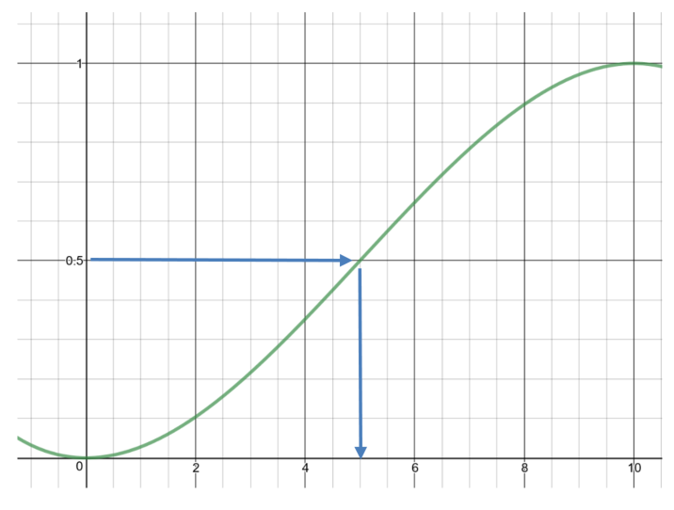
Median = 5
Method 2: By integration
The $x$ value where the area under the curve from the lower bound is equal to 0.5.
Solve $\int_{a}^{x}{f\left(x\right)dx}=0.5$
$$\int_{0}^{x}{\frac{-3x^{2}}{500}+\frac{3x}{50}}dx=0.5 \\ {\left[\frac{-x^{3}}{500}+\frac{3x^{2}}{100}\right]}_{0}^{x}=0.5 \\ \frac{-x^{3}}{500}+\frac{3x^{2}}{100}=0.5 \\ -x^{3}+15x^{2}=250 \\ -x^{3}+15x^{2}-250=0 \\ (x-5)(-x^{2}+10x-50)=0 \\ x=5$$
Median = 5
This can also be observed from the graph of $f\left(x\right)=-x^{3}+15x^{2}-250$, where $f\left(x\right)=0.$

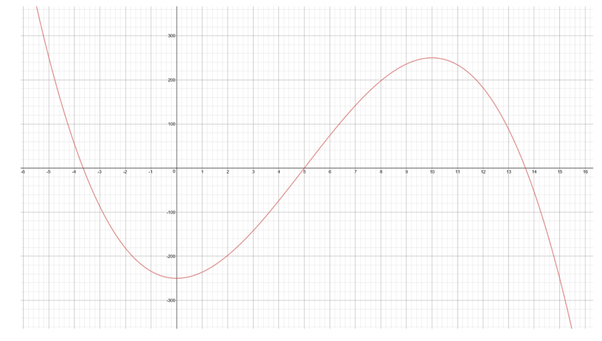
- Find the 10th percentile of the distribution
Method 1: From the cumulative distribution function:
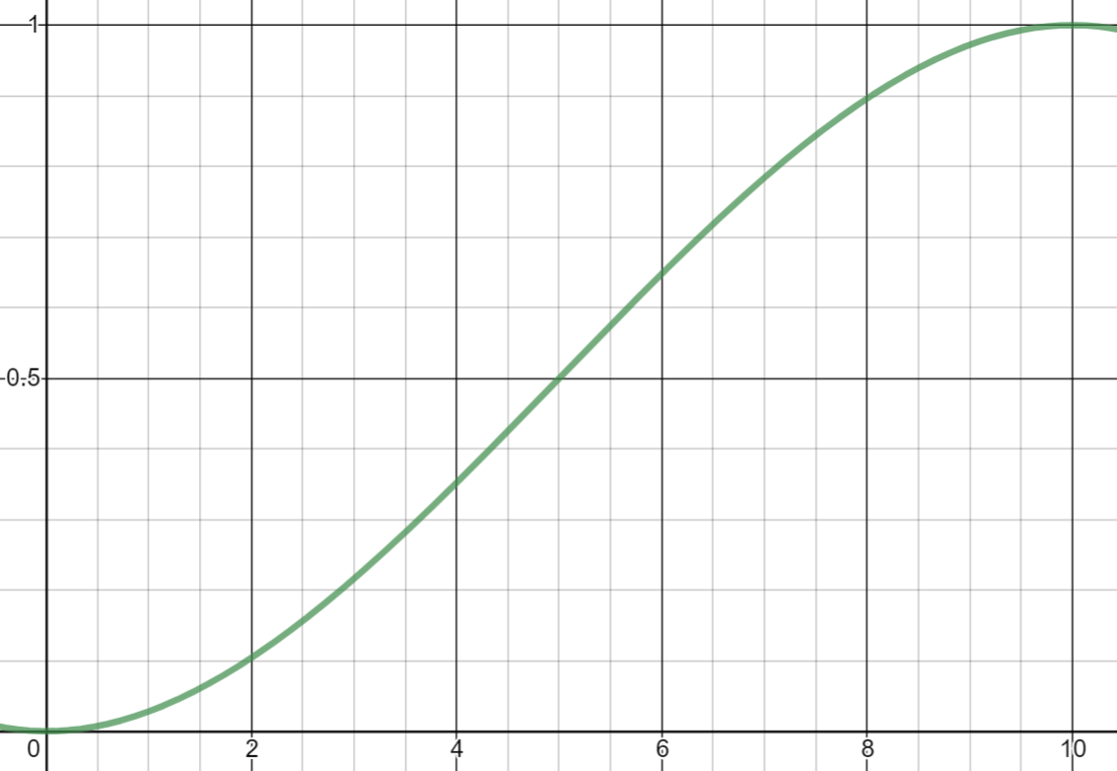

10th percentile is approximately 2.
Method 2: By integration
Solve $\int_{a}^{x}{f\left(x\right)dx}=0.1$
$$\int_{0}^{x}{\frac{-3x^{2}}{500}+\frac{3x}{50}}dx=0.1 \\ {\left[\frac{-x^{3}}{500}+\frac{3x^{2}}{100}\right]}_{0}^{x}=0.1 \\ \frac{-x^{3}}{500}+\frac{3x^{2}}{100}=0.1 \\ -x^{3}+15x^{2}=50 \\ -x^{3}+15x^{2}-50=0 \\ x≈1.958$$
This can also be observed from the graph of $f\left(x\right)=-x^{3}+15x^{2}-50$, where $f\left(x\right)=0.$
