Steps to Construct a Normal Distribution in Microsoft Excel
- Input your possible x values into column A. The example below uses values 1 to 100
- Using your value for the standard deviation, evaluate the constant for the fraction in the formula: $\frac{1}{σ\sqrt{2π}}$. For our calculations moving forward, we will use 0.04(Standard Deviation of 10).

- Evaluate the denominator in the power, ${2σ}^{2}$. In our example, this value will be 200.

- In cell B2, type the formula using these two values. For our example, this will be “=0.04*EXP(-((A2-60)^2)/200)”
In this example, 60 is the mean, and A2 is the first x value.

- Drag these values down in the y-column until every x value has a y value.

- As these are very small probabilities, expect your values to be very small.

- Highlight all of column A and B. Select the “Insert” Tab, and click on the scatter plot in the charts.
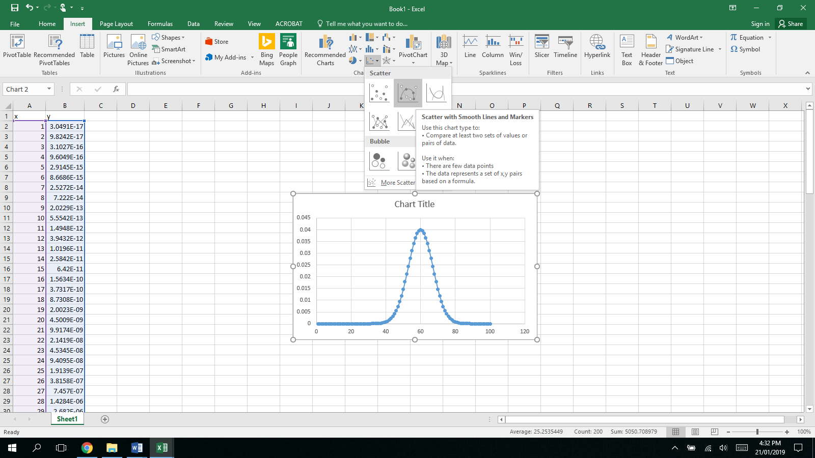
Click on “Scatter with Smooth Lines and Markers”.
The graph can then be cut and pasted into a word document or other location.

- To compare your collected data with this model, input your own data as relative frequencies in other columns.
- Right click on the graph and click on “Select Data”.
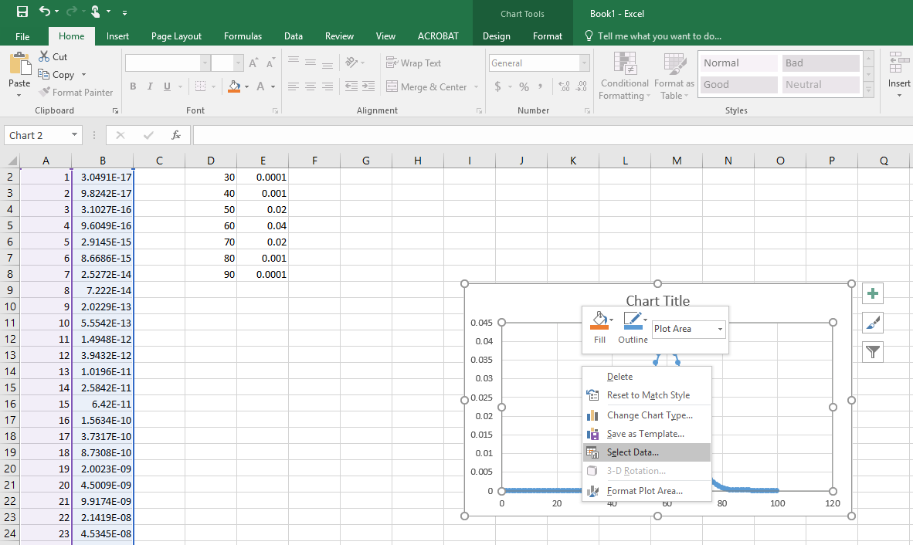
- Click on “Add”. Give the new data a title, such as “Histogram”.

- Click on “Series X Values” and highlight the scores from your actual data.
- Click on “Series Y Values” and highlight your relative frequencies. You may need to delete what is already in this cell.

- Click ok. You should now have your results on the same axes as a standard normal distribution.

