Modelling relationships using Desmos
This is a teacher guide on utilising Desmos to model relationships between variables.
All outcomes referred to in this unit come from Mathematics Advanced Syllabus
© NSW Education Standards Authority (NESA) for and on behalf of the Crown in right of the State of New South Wales, 2017

Activity 1 – fit a line of best fit by eye using technology
Syllabus link:
- model a linear relationship by fitting an appropriate line of best fit to a scatterplot and using it to describe and quantify associations AAM
  - fit a line of best fit to the data by eye and using technology (ACMEM141, ACMEM142)
Steps:
- Open Desmos.
- Make a table to insert your data.
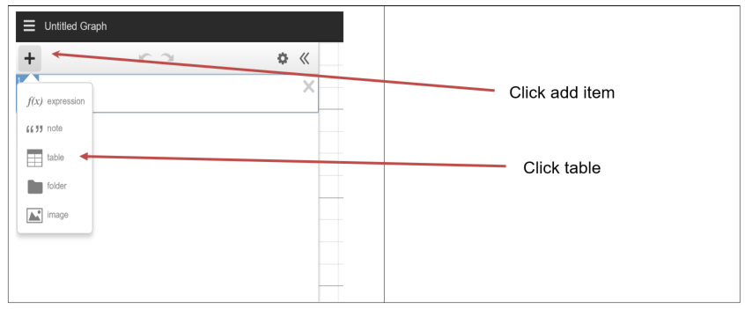

- Enter the x and y values for a data set.
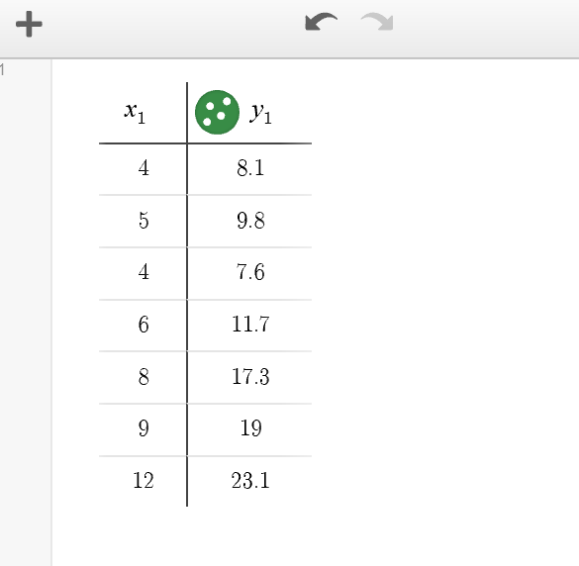
- As you enter values the points will automatically appear on the number plane. You may need to adjust the range of values displayed on each axis to view the points. Select settings.
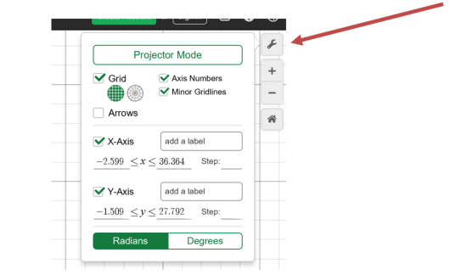

- Add the line y = ax + b and sliders for all. This will become our line of best fit.
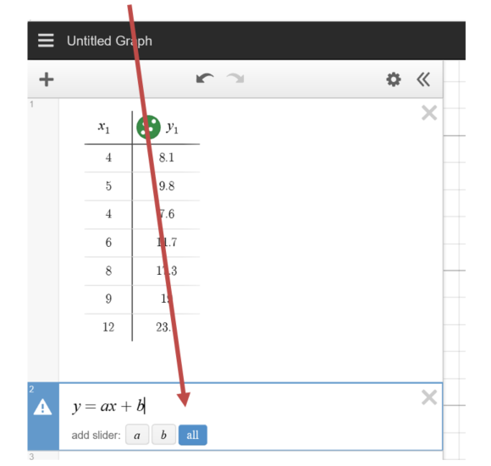
- You can now use the sliders to fit the line of best fit by eye.

Activity 2 – fit a least-squares regression line using technology
Syllabus link:
- model a linear relationship by fitting an appropriate line of best fit to a scatterplot and using it to describe and quantify associations AAM
  - fit a least-squares regression line to the data using technology (ACMGM057)
- Add a set of data to Desmos using the method above, steps 1 to 4.
- Fit a least-squares regression line by typing in the input: y1~ax1+b. Note:
  - y₁ and x₁ were used as these were the column headings in the table when the points were plotted.
  - y₁ is typed in as y1, Desmos will automatically subscript the 1.

