Displaying data

Question 1
The ages (in months) at which 50 children were first enrolled in a preschool are listed below.

38 | 40 | 30 | 35 | 39 | 40 | 48 | 36 | 31 | 36
47 | 35 | 34 | 43 | 41 | 36 | 41 | 43 | 48 | 40
32 | 34 | 41 | 30 | 16 | 35 | 40 | 30 | 46 | 37
55 | 39 | 33 | 32 | 32 | 45 | 42 | 41 | 36 | 50
42 | 50 | 37 | 39 | 33 | 45 | 38 | 46 | 36 | 31

- Construct a stem and leaf display for the data.
- Construct a relative frequency histogram for these data. Start the lower boundary of the first class at 30 and use a class width of 5 months.
- Compare the graphs in parts a and b. Are there any significant differences that would cause you to choose one as the better method for displaying the data?

Question 2
Statistics of the world’s religions are only very rough approximations, since many religions do not keep track of their membership numbers. An estimate of these numbers (in millions) is shown in the table.

Religion | Members (millions)
Buddhism | 375
Christianity | 2100
Hinduism | 851
Islam | 1300
Judaism | 15
Sikhism | 25
Other | 21

- Construct a pie chart to describe the total membership in the world’s organised religions.
- Construct a bar chart to describe the total membership in the world’s organised religions.

- Order the religious groups from smallest to the largest number of members. Construct a Pareto chart to describe the data. Which of the three displays is most effective?.

Question 3
Education pays off, according to a snapshot provided in a report to the city of Riverside by the Riverside county Office of Education. The average annual incomes for six different levels of education are shown in the table.
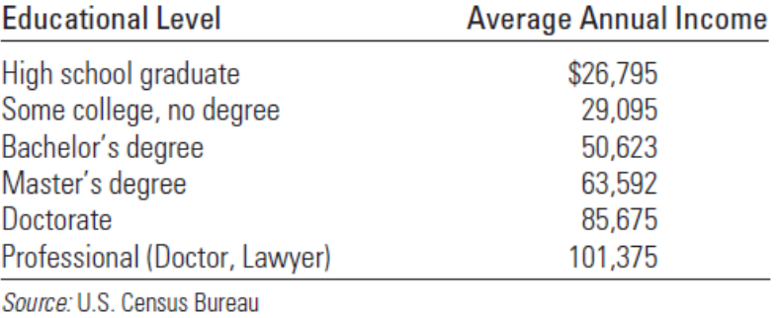
- What graphical methods could you use to describe the data?
- Select the method from question 1 that you think best describes the data.
- How would you summarise the information that you see in the graph

