nth term of an geometric sequence
The activities below lead students to discover the relationship between the n_{th} term, $T_{n}$, the first term, $a$, and the common ratio, $r$.

Activity 1 – using graphing software.
- Students to construct the first 5 terms of a geometric sequence by defining a first term, $a$, and a common ratio $r$.
Example: Let $a=2$ and $r=3$, then the sequence is 2, 6, 18, 54, 162…
n | 1 | 2 | 3 | 4 | 5
$$T_{n}$$ | 2 | 6 | 18 | 54 | 162
- Student to use graphing software to graph the 5 points represented by $T_{n}$ verse $n$.
Example: Using Desmos:
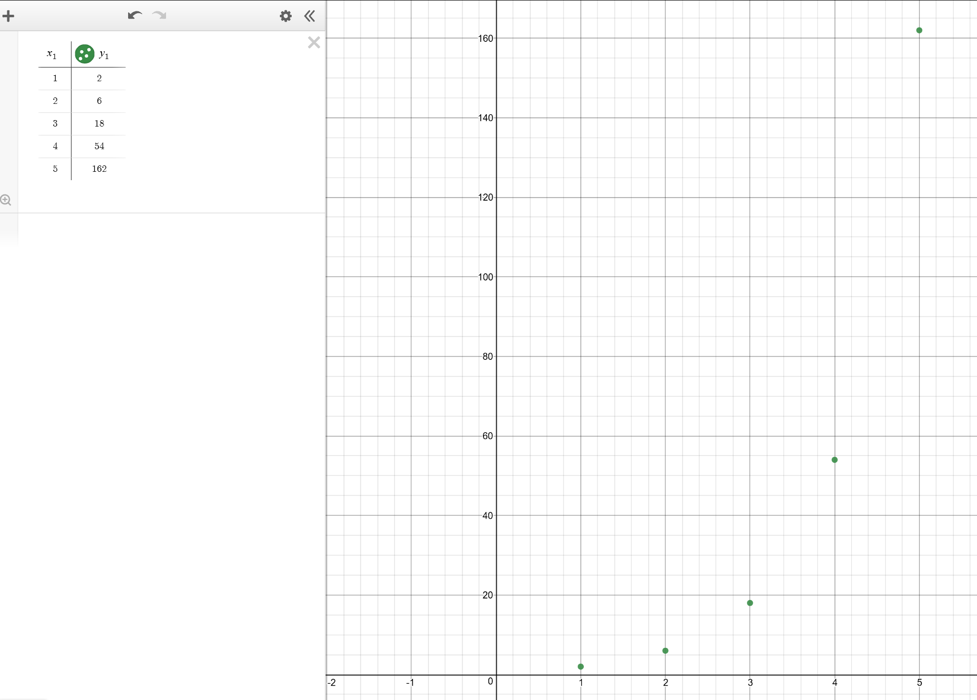
- Students to describe the relationship in terms of the shape of the graph.
- Students to input a curve through the points to express the relationship between $T_{n}$ and $n$.
y1~m*n^(x1-1)
Example:
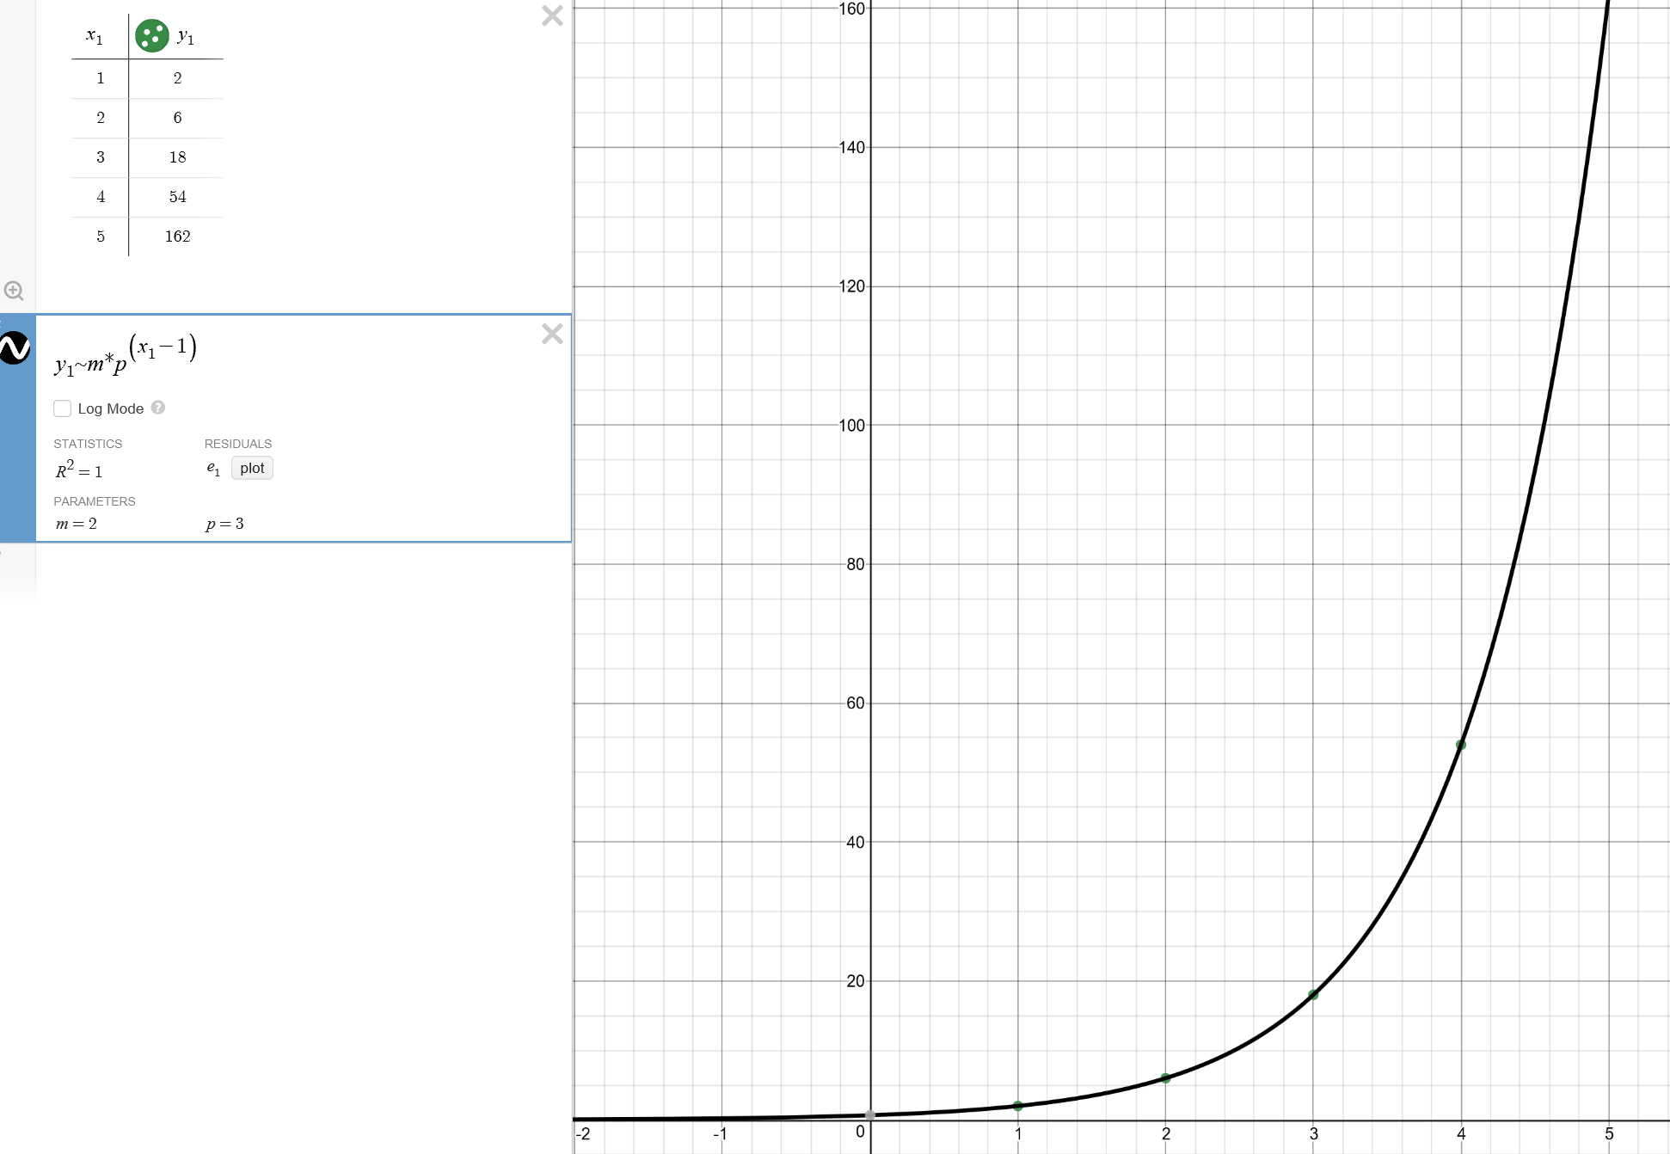
- Students to note the values of $m$ and $p$ and record the equation:
Example: $m = 2, p = 3$
$$y = 2×3^{x-1}$$
- Student to re-write this rule in terms of $T_{n}$, n, a and r.
Example: y = $T_{n}$, $n=x$, $r=3=p$, $a=2=m$
$$T_{n} = ar^{n-1}$$

Activity 2 – using a spreadsheet.
- Open the file: nth-term-geometric-sequence.XLSX
Students have two options,
- With formulas and graph (skip steps 3 and 4)
- Without formula and graph
- Students set a value for $a$ and $r$.
- Student use the definition of $Tn=rTn-1$ to complete the table of values for the first $10$ terms.
- Students are to graph the relationship between $Tn$ and $n$.
- Students to describe the relationship in terms of the shape of the graph.
- Students to come up with a new formula for $Tn$ using $a$, $r$ and $n$ without referencing the previous term. Write a formula to check the values in column D.

