Index law triangular jigsaw
Cut out each of the triangles. Shuffle the pieces and match the sides of the triangles using equivalent expressions.
Note: this resource was created using Tarsia software. You can download the free software using the following link: http://www.mmlsoft.com/index.php/products/tarsia
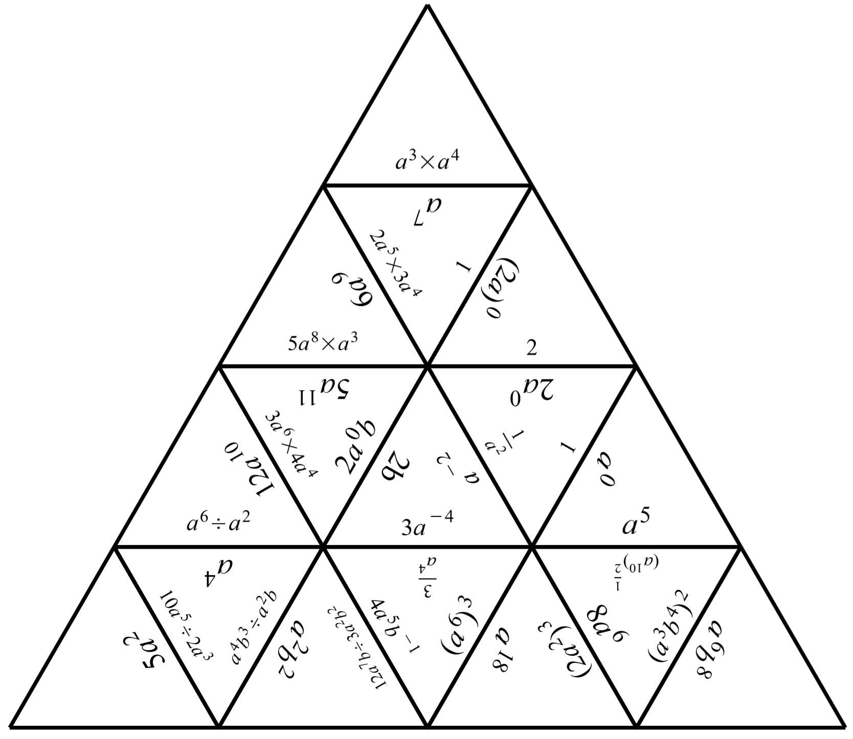

Outcome
Applies index laws to operate with algebraic expressions involving integer indices MA5.2-7NA
All outcomes referred to in this unit come from Mathematics K-10 Syllabus © NSW Education Standards Authority (NESA) for and on behalf of the Crown in right of the State of New South Wales, 2012

