Year 11 Mathematics Standard
MS-A2 Linear Relationships | Unit duration
Algebra involves the use of symbols to represent numbers or quantities and to express relationships, using mathematical models and applications.  Knowledge of algebra enables the modelling of a problem conceptually so that it is simpler to solve.  Study of algebra is important in developing students’ reasoning skills and logical thought processes, as well as their ability to represent and solve problems. | 2 weeks

Subtopic focus | Outcomes
The principal focus of this subtopic is the graphing and interpretation of practical linear and direct variation relationships.  Students develop fluency in the graphical approach to linear modelling and its representativeness in common facets of their life.  Within this subtopic, schools have the opportunity to identify areas of Stage 5 content which may need to be reviewed to meet the needs of students. | A student:  - uses algebraic and graphical techniques to compare alternative solutions to contextual problems MS11-1  - represents information in symbolic, graphical and tabular form MS11-2  - makes predictions about everyday situations based on simple mathematical models MS11-6  - uses appropriate technology to investigate, organize and interpret information in a range of contexts MS11-9  - justifies a response to a given problem using appropriate mathematical terminology and/or calculations MS11-10  Related Life Skills outcomes: MALS6-1, MALS6-7, MALS6-8, MALS6-13, MALS6-14

Prerequisite knowledge | Assessment strategies
The material in this topic builds on content from the Number and Algebra Strand of the K–10 Mathematics syllabus, including the Stage 5.2 sub-strands of Equations and Linear Relationships. Students should have completed the Stage 6 topic MS-A1 Formulae and Equations | Informal assessment could include exit tickets and Kahoot quizzes.  Investigative assessment: Students could collect data to prove a linear relationship exists and interprets gradient, y-intercepts and finds an equation. They could then discuss the limitations of the model and predict other values.
All outcomes referred to in this unit come from Mathematics Standard Stage 6 Syllabus
© NSW Education Standards Authority (NESA) for and on behalf of the Crown in right of the State of New South Wales, 2017

Glossary of terms
Term | Description
constant of variation | Also known as the constant of proportionality. See direct or inverse variation.
direct variation | Two variables are in direct variation if one is a constant multiple of the other. This can be represented by the equation 𝑦=𝑘𝑥, where 𝑘 is the constant of variation (or proportion). Also known as direct proportion, it produces a linear graph through the origin.
sketch | A sketch is an approximate representation of a graph, including labelled axes, intercepts and any other important relevant features. Compared to the corresponding graph, a sketch should be recognisably similar but does not need to be exact.

Lesson sequence | Content | Suggested teaching strategies and resources | Date and initial | Comments, feedback, additional resources used
Linear relationships  (2 lessons) | - model, analyse and solve problems involving linear relationships, including constructing a straight-line graph and interpreting features of a straight-line graph, including the gradient and intercepts AAM ◊  - review the linear function $y=mx+c$ and understand the geometrical significance of $m$ and $c$  - construct straight-line graphs both with and without the aid of technology (ACMGM040) | Review linear relationships  - Teacher defines linear relationships, the gradient and y-intercept of a graph.  Resource: Calculating gradient  - Teacher models how to calculate the gradient from a line. Questions to consider:  - How large a triangle is required to determine the gradient of a straight line?  - How can we determine if the gradient is positive or negative? Example: ‘uphill’ or ‘downhill’ when looking from left to right.  - How could we use the x and y intercepts to find the gradient?  Resource: Calculating gradient from intercepts  - Student activity: Students use technology to graph linear relationships to:  - explore the geometric significance of $m$ and $c$  - determine the gradient (or slope) of a straight line by forming a right angle triangle  Resource: Linking linear graphs and rules  investigating-linear-relationships.DOCX  - Teacher summarises student findings and reinforce concepts using technology.  Resource: Investigating the coefficients of a linear equation  - Teacher to model constructing straight line graphs using:  - the gradient intercept method  - a table of values  Resource: Plotting linear graphs from the equation  - Student activity: Students construct straight line graphs using the gradient intercept method and/or tables of values.  - NESA sample question: Which of the following is the graph of $y=2x-2$?  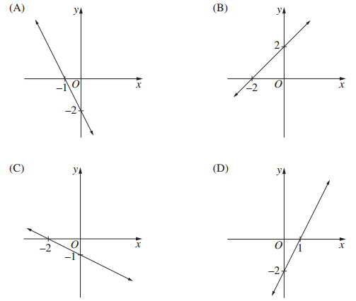  Resources: Linear Bundle – 8 Activities (Desmos)
Direct variation  (2 lessons) | - model, analyse and solve problems involving linear relationships, including constructing a straight-line graph and interpreting features of a straight-line graph, including the gradient and intercepts AAM ◊  - recognise that a direct variation relationship produces a straight-line graph  - determine a direct variation relationship from a written description, a straight-line graph passing through the origin, or a linear function in the form $y=mx$  - recognise the gradient of a direct variation graph as the constant of variation AAM | Introducing direct variation  - Teacher defines:  - Direct variation  - Constant of variation (or proportion)  The variables will increase or decrease in proportion to each other. i.e. If $x$ doubles $y$will also double.  - Student activity: Students model practical examples of direct variation.  Resource: investigating-direct-variation.DOCX  Note: This resource can easily be modified by changing the scenario. Two scenarios are provided.  After completing this activity student should be able to:  - recognise that a direct variation relationship produces a straight-line graph passing through the origin.  - determine a direct variation relationship from a written description, a straight-line graph or a linear function in the form $y=mx$  - recognise the gradient of a direct variation graph as the constant of variation  - Student activity: Solving problems involving direction variation.  Resources: Syllabus BITES Proportionality problems, Does the table represent a direct variation?
Applying linear models  (2 lessons) | - construct and analyse a linear model, graphically or algebraically, to solve practical direct variation problems, including the cost of filling a car with fuel or a currency conversion graph AAM ◊  - identify and evaluate the limitations of a linear model in a practical context | Applying linear models  - The teacher introduces the concept of linear models representing practical contexts as having limitations if terms of when or where the model is valid. Possible examples to lead conversations include:  - Fuel costs: What values are allowed for the amount of fuel?  - Height versus age graph: Is a linear model appropriate as you age? Will you continue to grow? What are the limitations?  - Student activity: Students construct and analyse linear models to solve problems involving direct variation and evaluate their limitations.  Resources: applying-linear-models.DOCX, Lego Prices  Note: This applying linear models resource also contains some problems which represent linear relationship which are not direct variation but are based on the NESA topic guidance.

Reflection and evaluation
Please include feedback about the engagement of the students and the difficulty of the content included in this section. You may also refer to the sequencing of the lessons and the placement of the topic within the scope and sequence. All ICT, literacy, numeracy and group activities should be recorded in the ‘Comments, feedback, additional resources used’ section.

