Coin flip investigation
If I flip a coin 20 times, what do you expect to get?
My Prediction: (What will the coin land on the most and why?)

Your Task:
- Flip a coin 20 times and record each flip in the tally bar below.

Tally coin flip results

 | TALLY | TOTAL
HEADS
TAILS

- Transfer the tally data into the graph below.

Graph
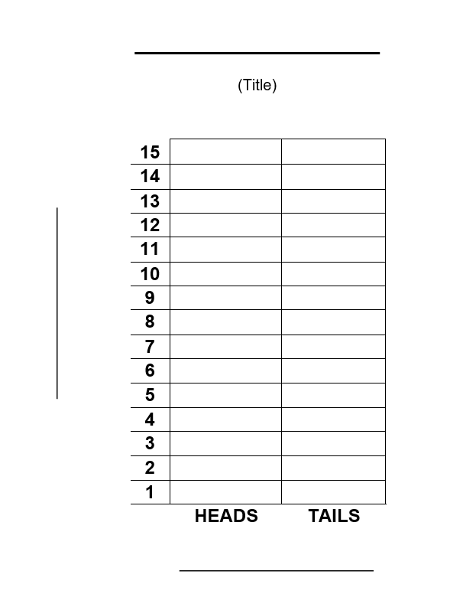

Results
- Compare your results with the person next to you. Are they the same as yours? Why/Why not?
- Compare your results with other people in the class. What was the average number of heads and tails?
- What do you think would happen if you flipped your coin 100 times? 500 times? 1000 times?

