M&M colour comparison

Step 1
Open your bag of M&M’s. DO NOT EAT THEM! Take out the M&M’s one at a time and record the colour in the table below. Place the M&M to one side (DO NOT put it back into the bag)

Colour | Tally | Total
Red

Yellow

Orange

Blue

Green

Brown

Step 2
- How many M&M’s were in your bag altogether?
- What was the most popular colour?
- What was the least popular colour?
- Draw an appropriate graph to show the number of each colour.

Step 3
Collect results from 5 of your friends and calculate the average number of each colour, and total.
Colour | Mine | 1 | 2 | 3 | 4 | 5 | Average
Red

Yellow

Orange

Blue

Green

Brown

Total in packet
Using Microsoft Excel, choose to suitable graph to show the average number of each colour. How does the shape of this graph compare to the shape of your original graph?

Step 4
Convert the number of each colour to a fraction of the bag, and then a decimal and percentage.

Colour | Fraction | Decimal | Percentage
Red

Yellow

Orange

Blue

Green

Brown

Use Microsoft Excel to draw a sector (pie) graph of your data.
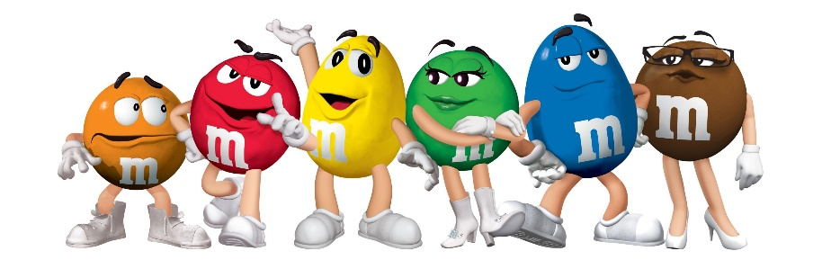

Step 5
In a bag of 100 M&M’s how many of each colour would you expect?

Colour | Number | Colour | Number
Red |  | Blue
Yellow |  | Green
Orange |  | Brown
Use Microsoft Excel to draw a suitable graph. How does the shape of this graph compare to your original graph.

