Using digital tools to create graphical displays
The use of technology can help students to visualise and explore data. Microsoft Excel can promote visual learning. Students can create multiple graphs for the same data in a much shorter time than it would take to explore the same visualisations through drawing by hand.
The following activity is designed to guide students in graphing data in Microsoft Excel. To assist students in developing these skills so that they are transferable to other spreadsheet tools, the emphasis should be on how to locate and interpret the ribbon, its icons and menus. Students who are unfamiliar with spreadsheets will need direct instruction on how to select cells individually and in groups, and how to distinguish features such as ‘the fill handle’. A simplified list of Spreadsheet Terminology may assist students to interpret instructions.
The data is taken from the Australian Car Sales Statistics on Budget Direct. Students use the data in the sample spreadsheet to graph three different datasets.
Teachers could lead students in discussions about which types of graphs would be most appropriate for the datasets and why. Students may need a refresher on the difference between categorical and quantitative or numerical data.

Graphing in Excel
Open the Australian car sales 2018 spreadsheet from the icon below. The spreadsheet contains three datasets: top selling car brands, passenger vehicles and new car sales.
Consider which would be the most appropriate graph to use to display the datasets. Why do you think so? Is there more than one option?

Steps
- Start with ‘top selling car brands’. Select all of the data, including the headings.
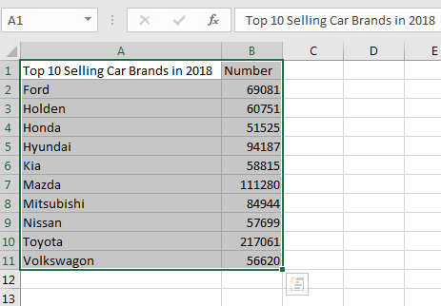
- Go up to the ribbon and select ‘Insert’. A number of graph options will appear.
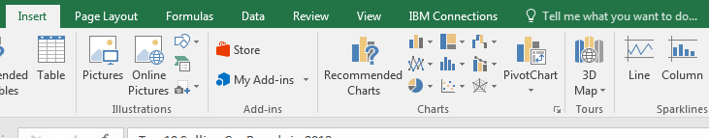
- Choosing the ‘Recommended Charts’ option provides some Excel recommendations based on the type of data in the dataset.
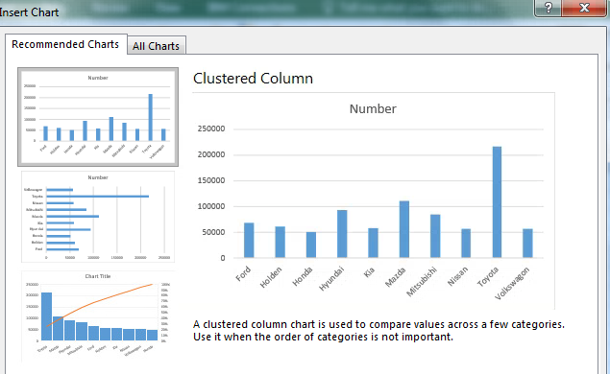
You can also choose your own type of graph. If you change your mind about the graph you’ve chosen, you can press the ‘Change Chart Type’ button to choose a different graph.
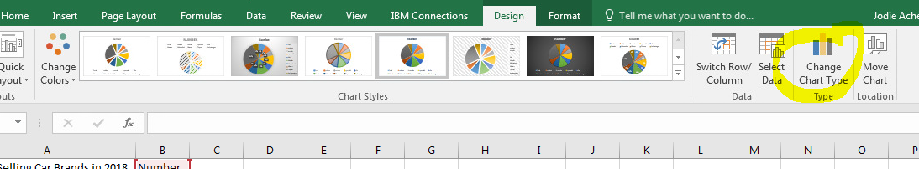
- Excel is quick to graph data but it usually requires some adjustments. The below is an example of a horizontal bar graph for the data.
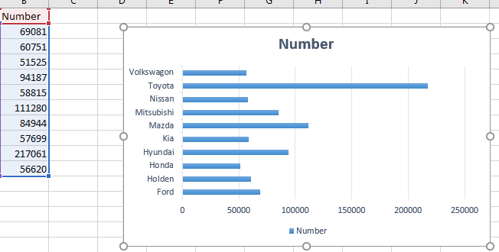
To change the graph title, click in the graph title and type the new title:
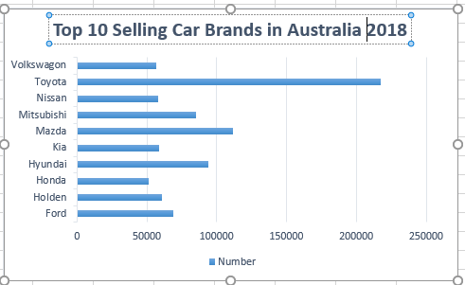
Excel has automatically provided a legend for your graph, at the bottom of the graph. Changing the cell B1, the heading for the number of cars, automatically changes the legend in the graph:
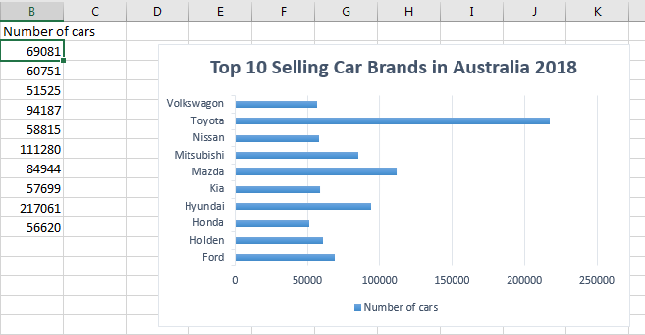
You can also change the colours of the bars and the background colour of the graph.
- It could be useful to sort the data in descending order, given that it is the top 10 selling car brands. This can be done by going up to the ribbon and choosing Data -> Sort. Sort by Number of Cars and Order Smallest to Largest. This will change your graph automatically.
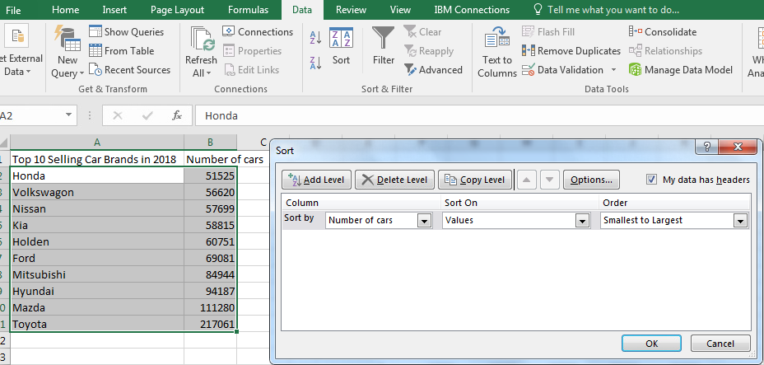
Now it is much easier to see which brand was the most popular and how the rest of the top 10 compared:
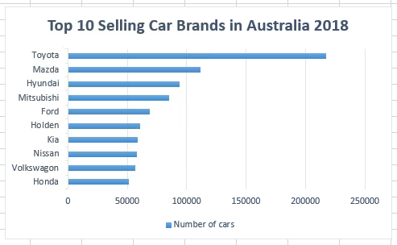
- Now create graphs for the other datasets: Passenger vehicles and New car sales.

