Navigating a shopping centre
This activity allows students to find locations on a shopping centre map.

Situation
Consider the shopping centre map below.
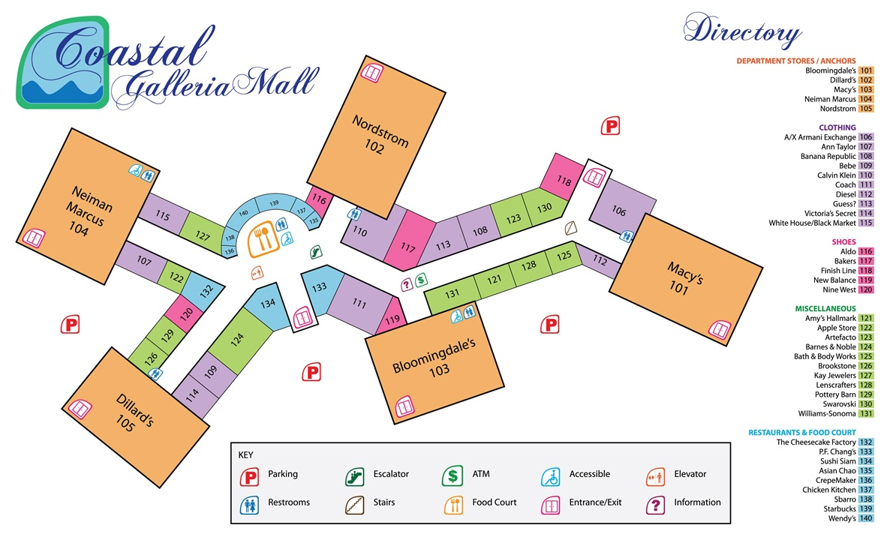

Problems
- What number is the Apple Store?

- If you are in Bloomingdales, what is the closest shoe shop?

- How many toilets are in the shopping centre?

- Which department store is Ann Taylor clothing shop near?

- What shops is Pottery Barn next to?

- You are currently shopping in Dillard’s. You remember that you entered from the carpark near Macy’s. Draw a line on the map showing the way you should leave the shopping centre.

- You park your car in the carpark between Dillard’s and Bloomingdale’s, and enter the shopping centre between shops 133 and 134. You want to go to all major shopping centres, Nordstrom, Dillard’s, Macy’s, Bloomingdale’s and Niemen Marcus. What order would you visit these stores in to walk the shortest distance around the centre?

