Measuring local pathways
This task allows students to use an online map tool to explore different routes between places, and consider the best route to walk.

Method
- Students to go to the Spatial Map Viewer at the NSW Government Spatial Services website. Type in the name of your local suburb in the search field.
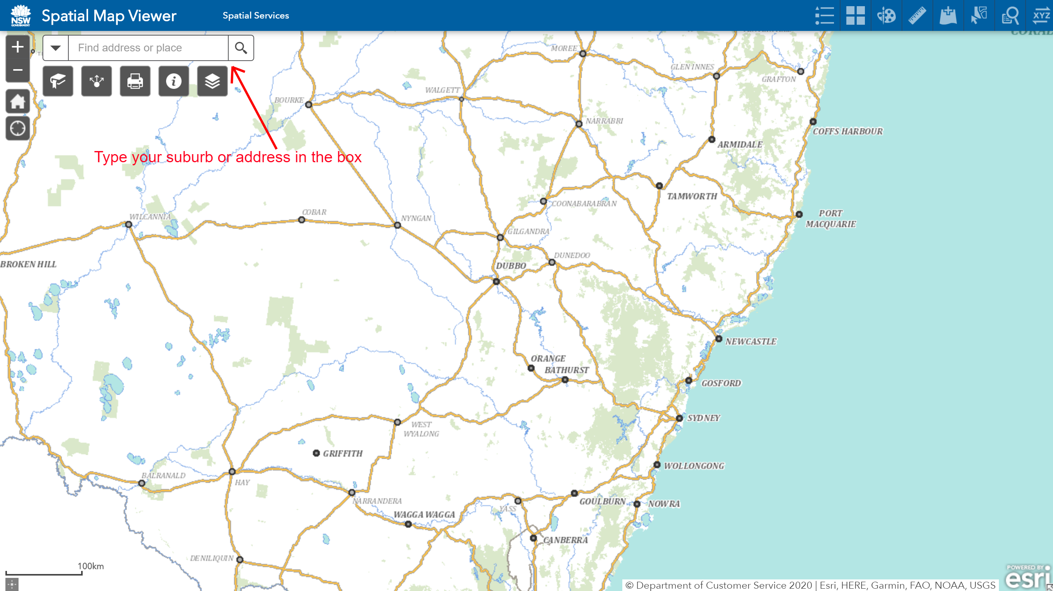

- Once you have found your suburb, drag around the screen and zoom in to find key locations. You can mark these locations using the “draw” tool in the top right corner of the map.
Students can locate their:
- Home
- School
- Local shops
- Friend’s house
- Local sports field
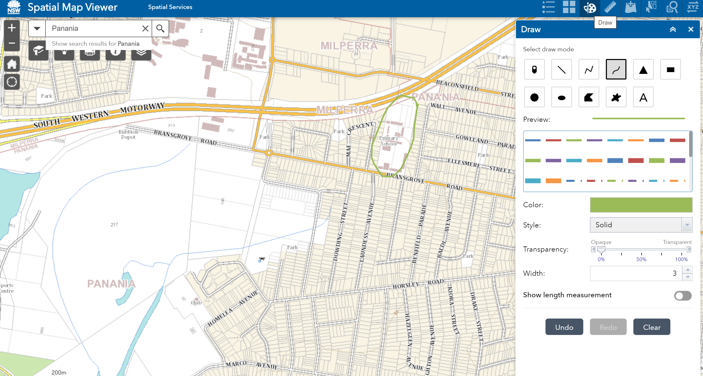

- By clicking on the ruler in the top right of screen, students can map out a path from one location to another.
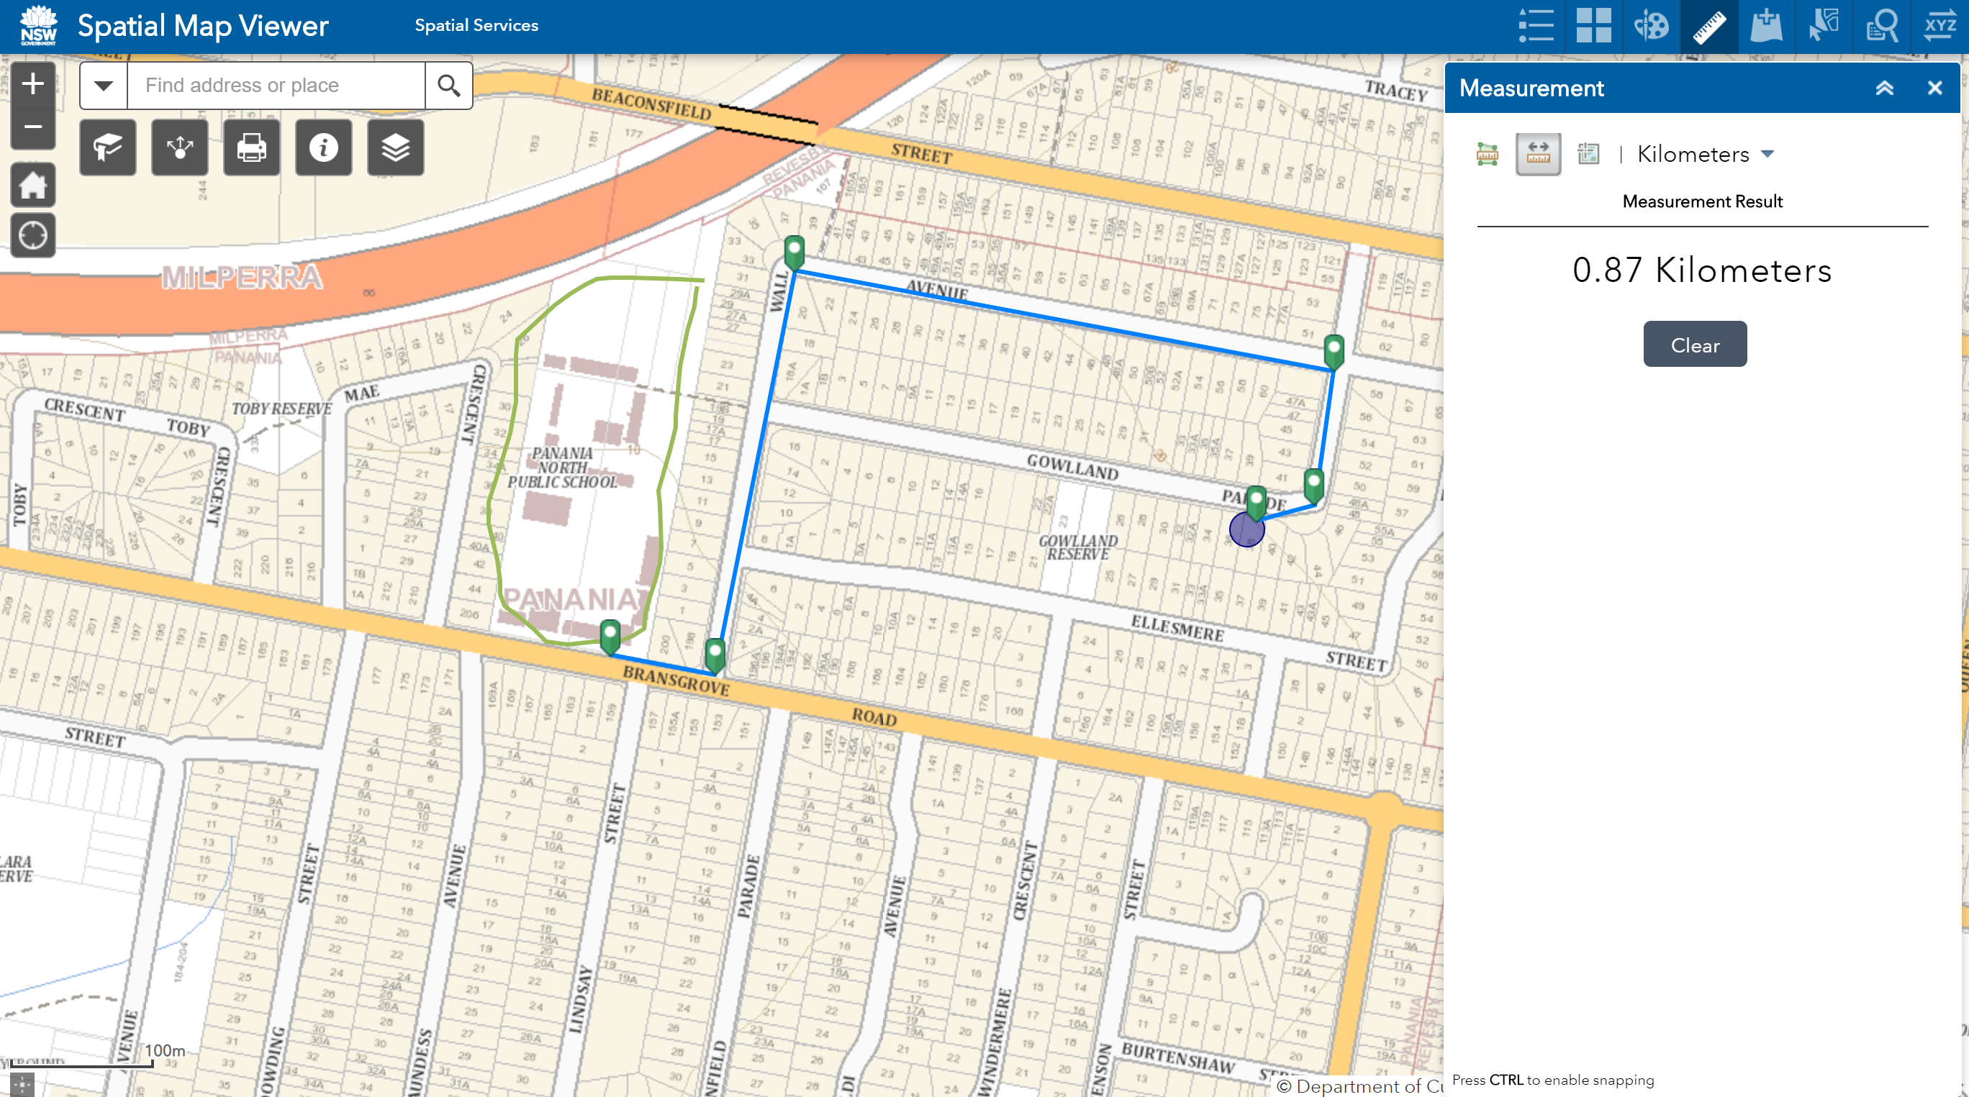
This route from school to home is 0.87 kilometres long and could be described as following Bransgrove Road, then turning left onto Wall Avenue, then continuing right along Wall Avenue, then turning right onto Gowlland Parade.

Activities
- For each of the pairs of locations below, describe two routes you could take. Which route do you believe is the best way to go?
  - Home to school

  - Home to a friend’s house

  - Home to the local shops

Extension activities
- Is the shortest route always the best?
  - Consider the example below. There are two ways to get from my house to my friend’s house. The first route is just 0.19 km.
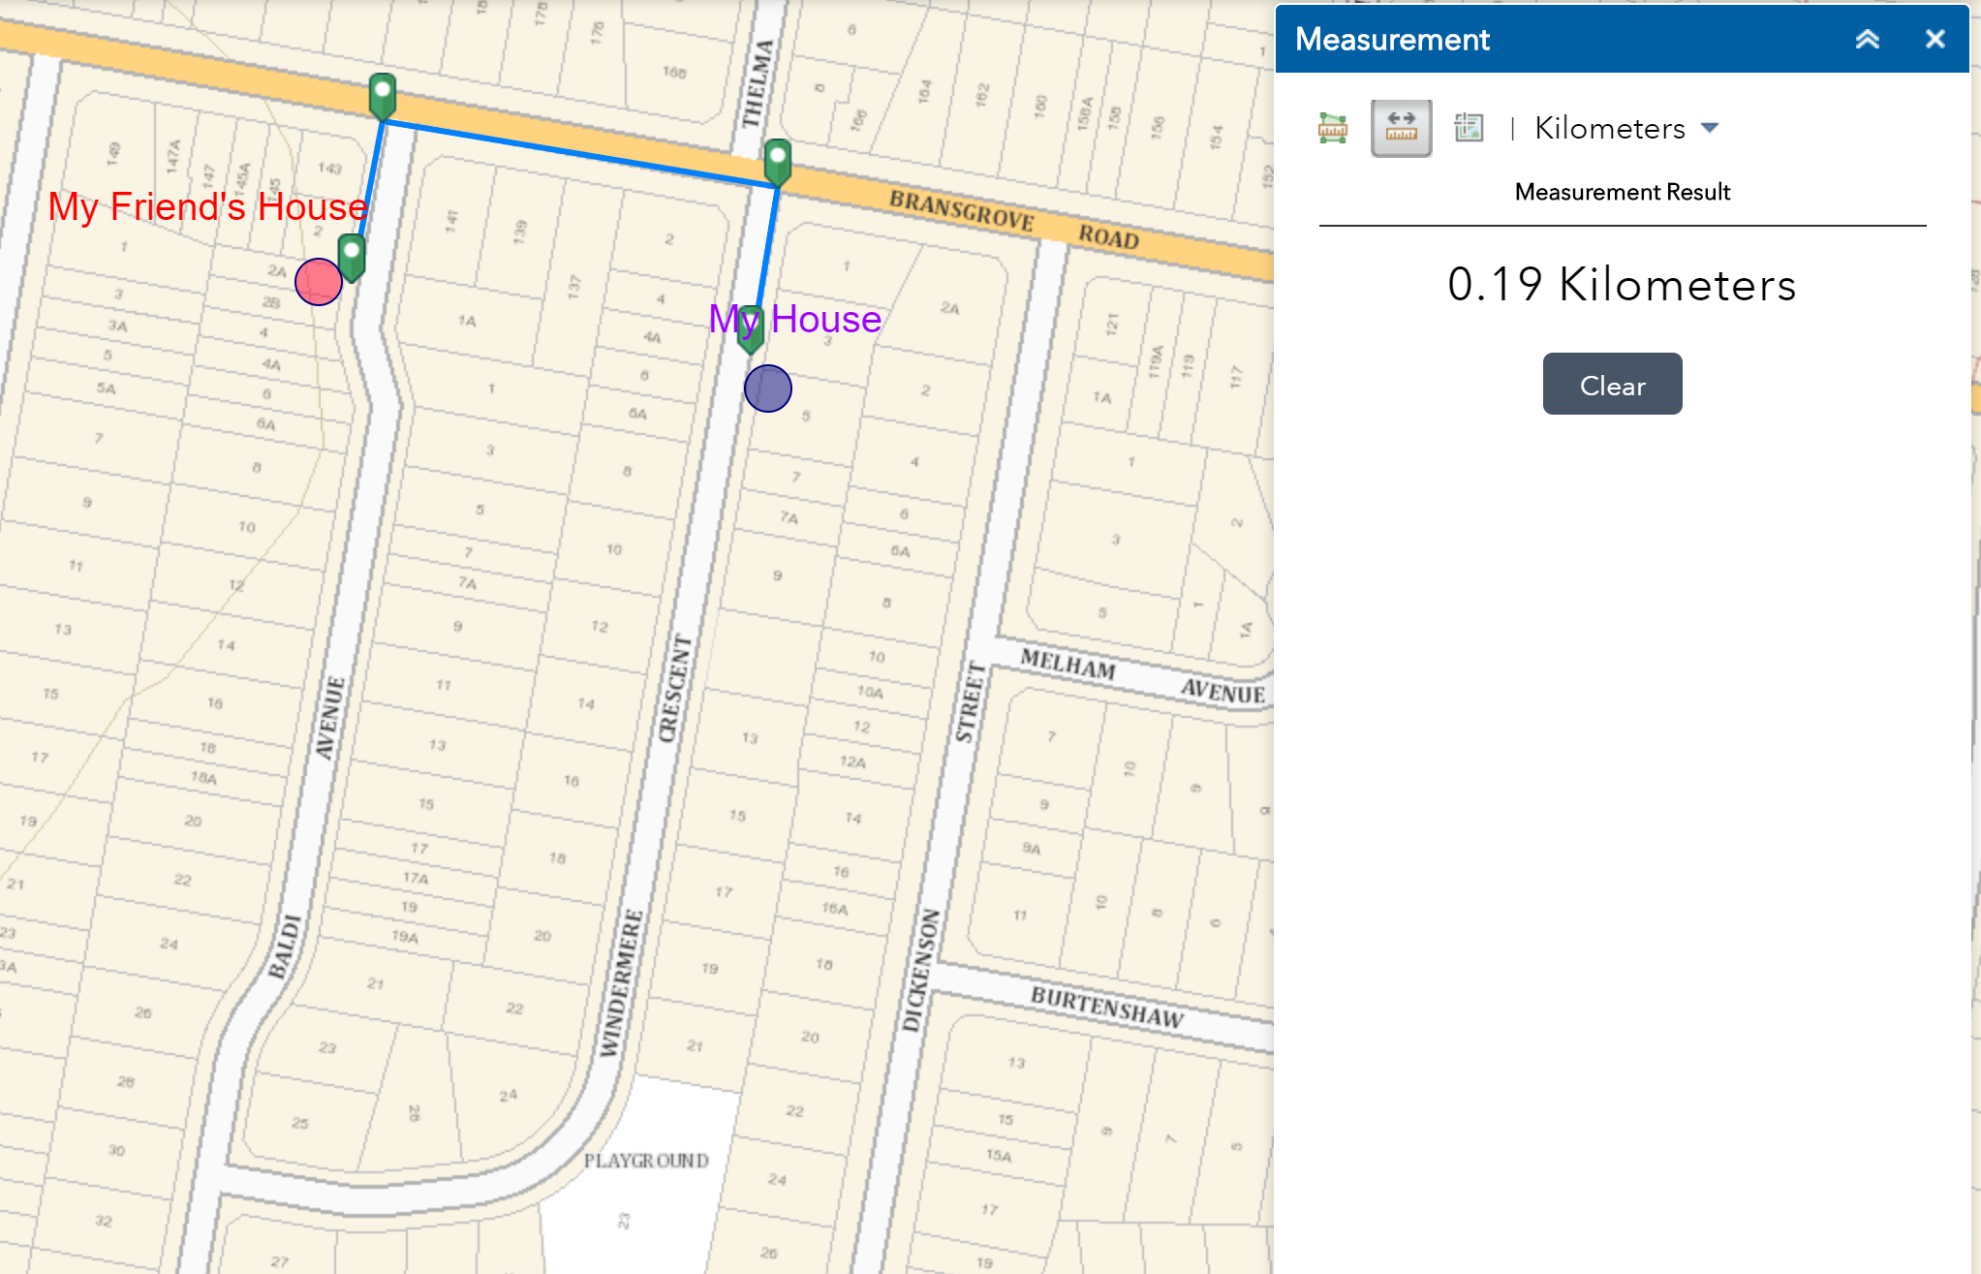
  - The second route is longer and is 0.54 km.
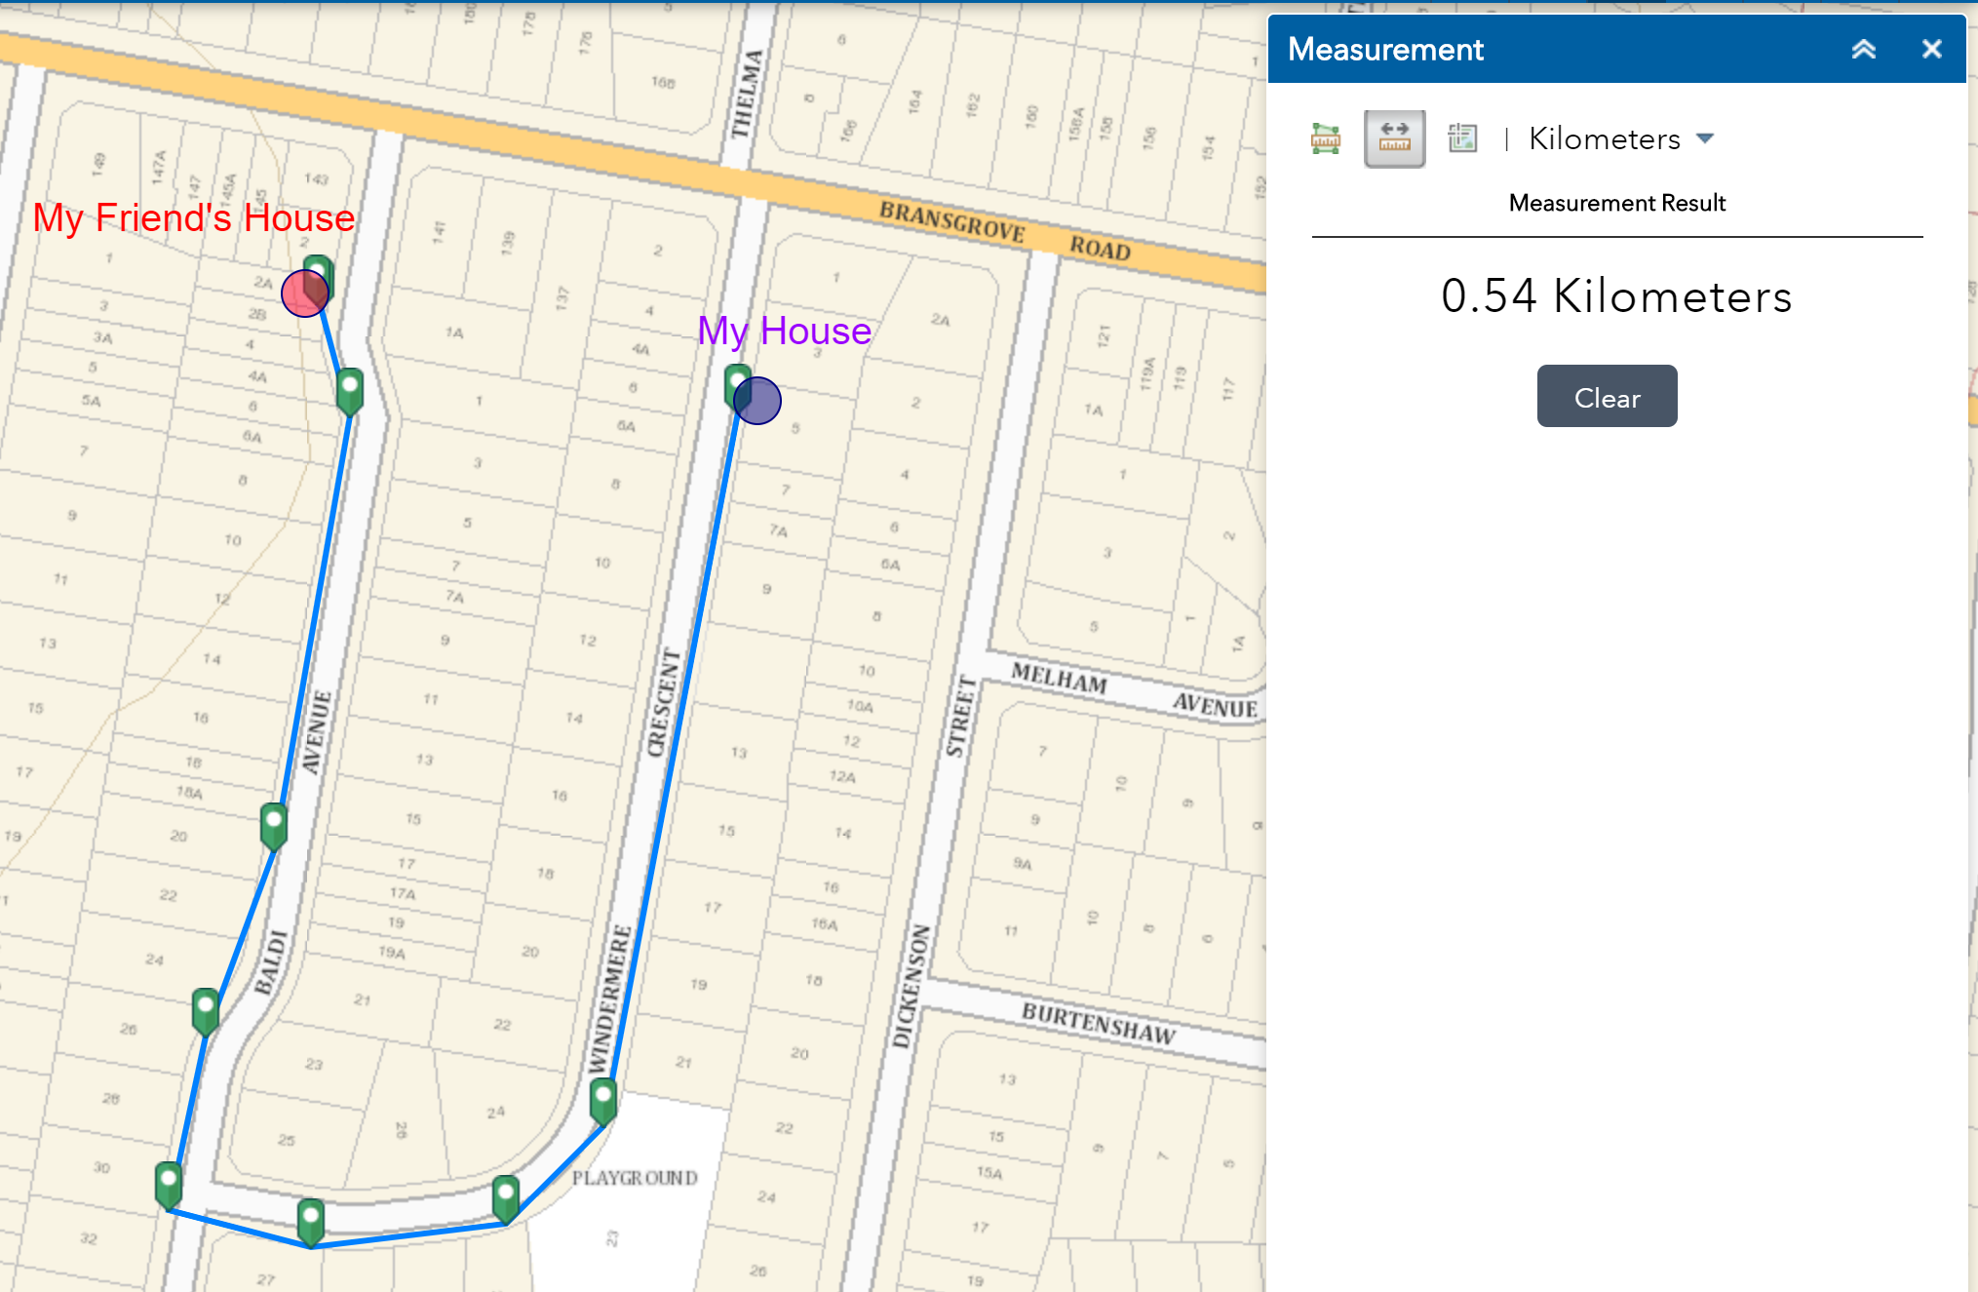
  - Can you see any reason you might take the long way?

- List the reasons why you might take a longer route rather than looking for the shortest way.

