Creating a social network
This activity allows students to create a social network by looking at social media connections between friends or classmates.

Method
- Select up to 9 people to construct a social network with. Each dot (vertex) in the diagram below will represent one person. Write the names of these people in the space beside each vertex. You can put your own name at the centre if you would like to.
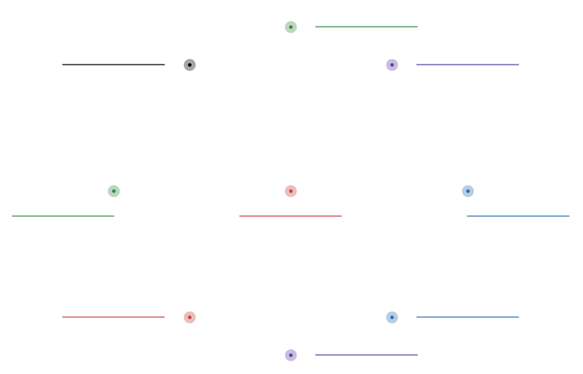

- Interview each person in your diagram. Ask them who from this group they are friends with on Facebook. Draw lines(edges) connecting the people in the diagram if they are friends on Facebook.
If you instead discuss a different social media site, such as Instagram or Twitter, where people “follow” one another, use arrows to show who everyone follows. An example is below.
The network diagram example above shows students who follow one another on the social media site Instagram.
- Alicia follows Elizabeth because there is an arrow pointing from Alicia to Elizabeth.
- Elizabeth follows Alicia because the same arrow points back to Alicia.
- Olivia follows Evelyn, and Evelyn follows Olivia.
- Emily follows Elliott, but Elliott does not follow Emily, because the arrow does not point back towards Emily.

Questions
- Who has the most connections in this group?
- Is that the same person who has the most connections overall?

