Booking your seat
This activity allows students to read seating plans at the movies and on a flight.

Activity 1: Going to the movies

Consider the movie cinema seating plan below. The red seat is called E14.
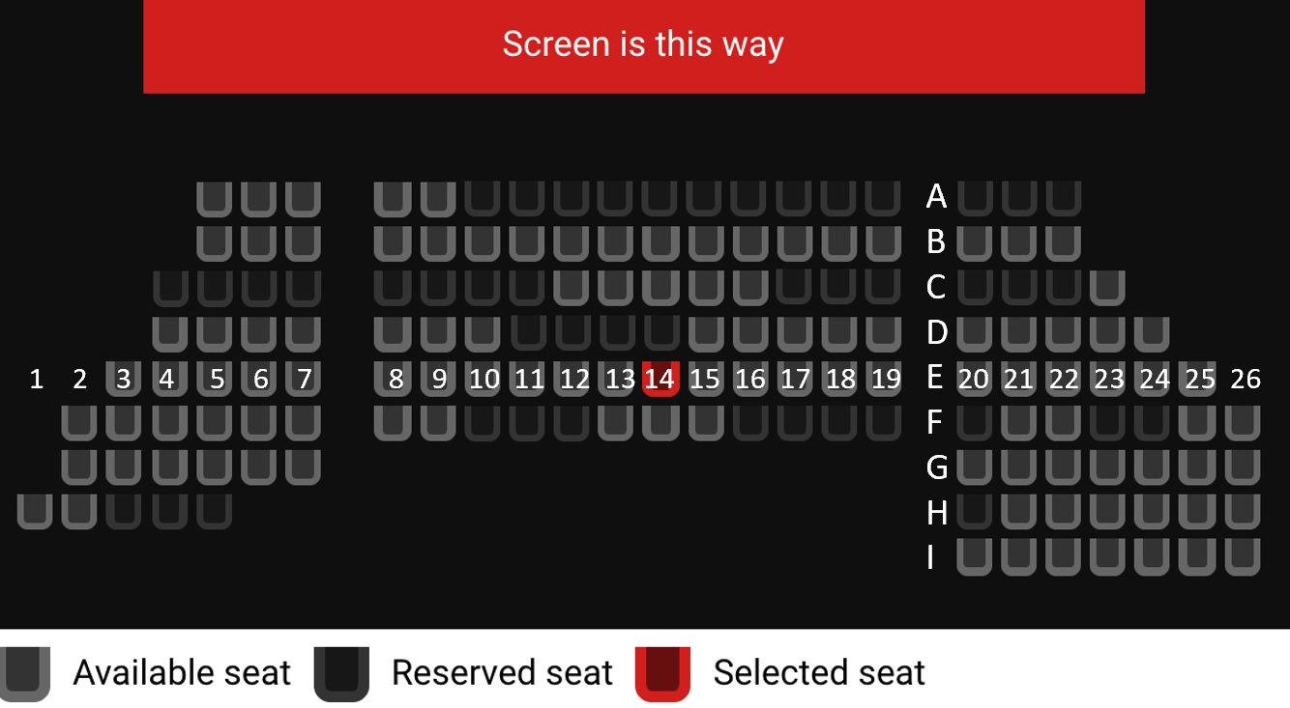

Problems
- What is the name of the seat at the front row on the far left?

- You want to sit in an aisle seat. Name an aisle seat that is available.

You have come to the movies with your friend Paul.
- Because Paul is very tall, you like to sit towards the back so that there is no one behind you. Name two seats you can book.

- You want to sit together, and against the wall. What row can’t you sit in?

You have come to the movies with four friends, Emily, Olivia, Paul and James.
- If you want to sit in a row with all four of them, where can you sit?

- You want to sit in a group, but you don’t want anyone else to sit beside your group. Where can you sit?

Activity 2: Booking a flight
Consider the diagram of the plane below. All shaded seats have been booked and are unavailable. You can only book the white seats.

Problems
- What row numbers and letters are missing from the diagram of the plane above? Can you think of any reason why?

You are going on holidays with your friend Rozina.
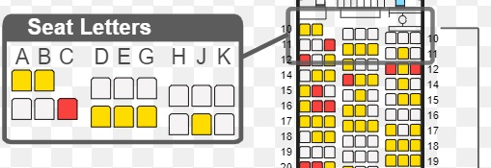
- In the section of the plane shown above, name two seats that you and Rozina can book to sit next to one another.

- You and Rozina both want to sit beside a window. Name two window seats that are available, one in front of the other.

- You have both decided you want to sit in an aisle seat so it is easy to get up and use the bathroom. Name two aisle seats that are across from one another.

- You want to sit somewhere with no seat in front of you. Name two seats that you and Rozina can book.

- You are now flying with your parents in a group of 3. Mum wants a window seat, and you want an aisle seat. Name three seats you can book to sit together.

