Arranging the furniture
This activity allows students to arrange the furniture in a floorplan of a house.
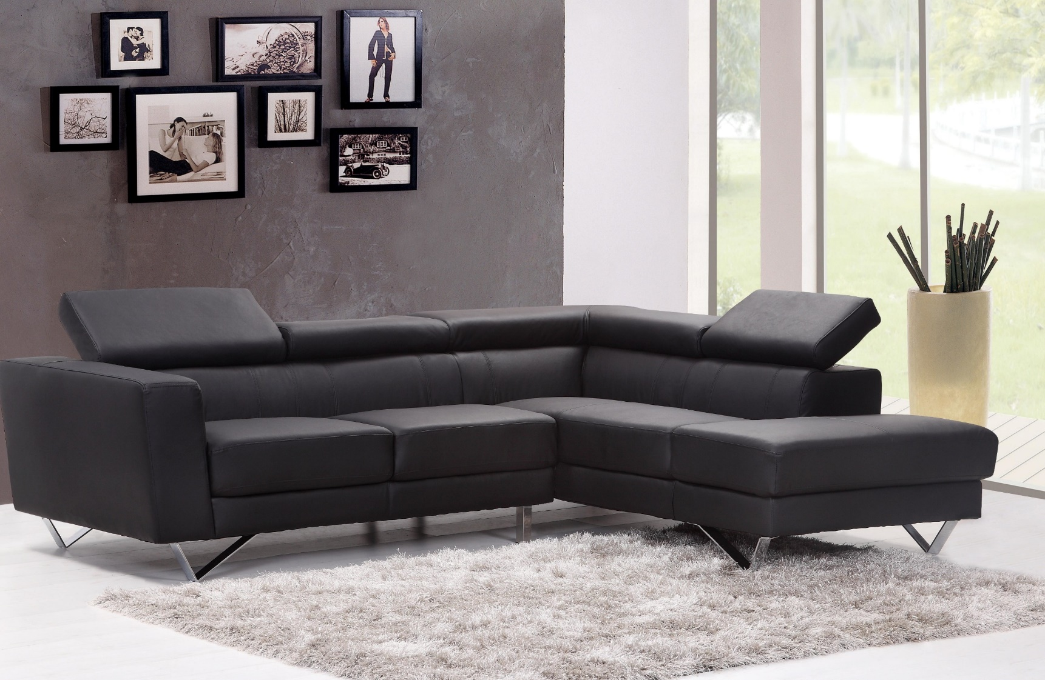

Method
The floorplan below shows a house that has the following rooms:
- Three bedrooms
- One bathroom
- One kitchen
- One living room
- One external balcony
Label the diagram with the names of the rooms.

Symbols
Below are the symbols of many items of furniture. You can cut and paste these items into the diagram above to arrange your home.

Application
- What additional furniture might you like to add?
- Is there any room you are uncertain about?
- Which room is the main bedroom? Why do you choose this room?
- Students can research furniture to buy for their home, and consider options and prices.

