House numbers
Houses are numbered so that similar numbers are located near each other along the street. Traditionally, odd numbered houses are on one side of the road and even numbered houses are on the opposite side of the road like in the diagram below.
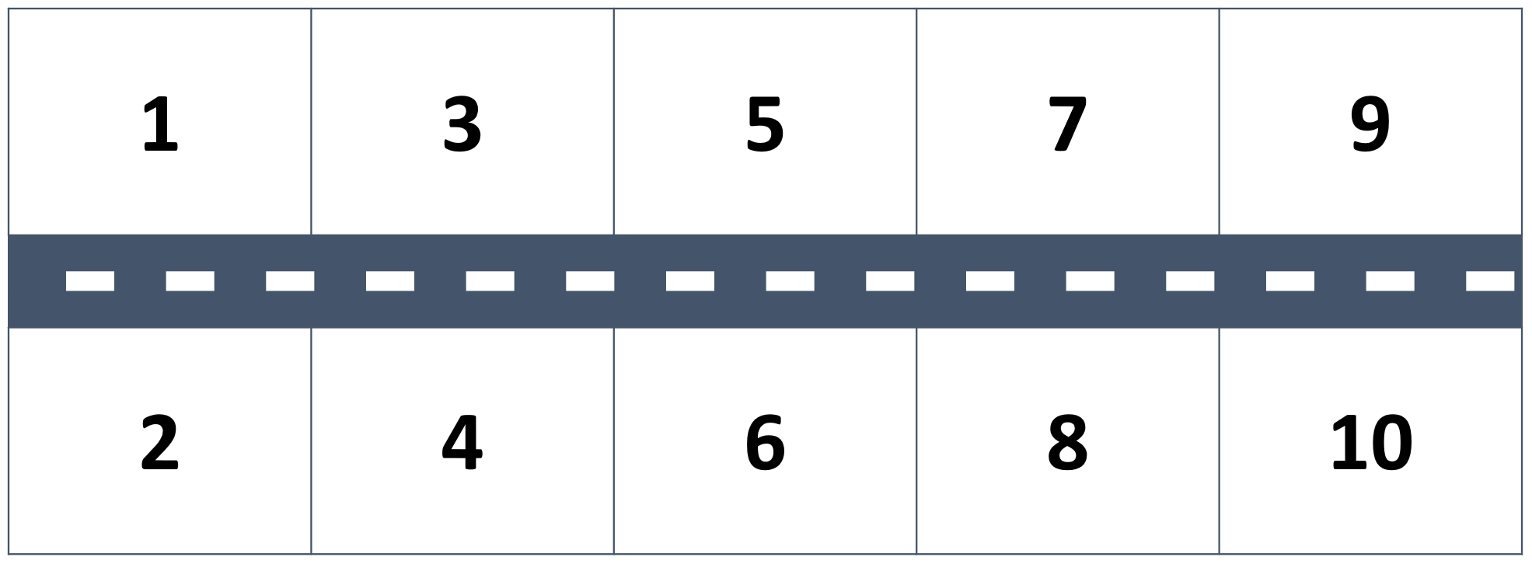
Given this pattern, what numbers should be in place of the question marks below?
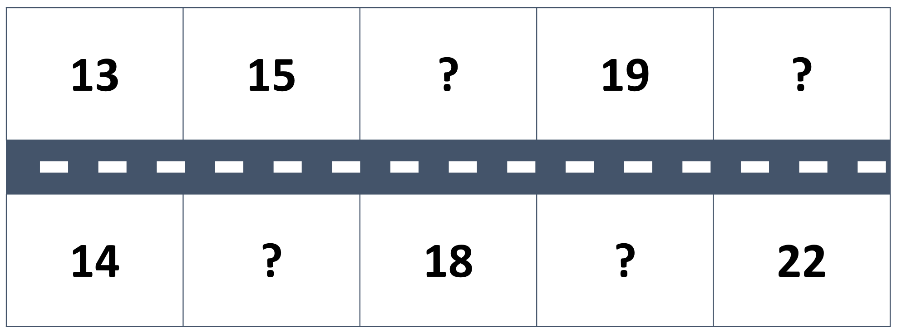
What is the number of your house? _____
What are the house numbers next door to your house? _____
What is the number of the house across the street from you? _____
Does your street follow the same number pattern? _____
If not, explain the number pattern used in your street.

