Fibonacci sequence activity
Leonardo of Pisa was a mathematician also known as ‘Fibonacci’. Fibonacci discovered one of the most famous number sequences in the world: the Fibonacci Sequence.
The rule to the pattern is that you add the 2 previous number together to get the next number in the sequence.
Let’s investigate…
The Fibonacci sequence starts with 0 and 1. We add 0 and 1 together to get the next number which is another 1. Fill out the blank squares below to uncover the rest of the sequence.
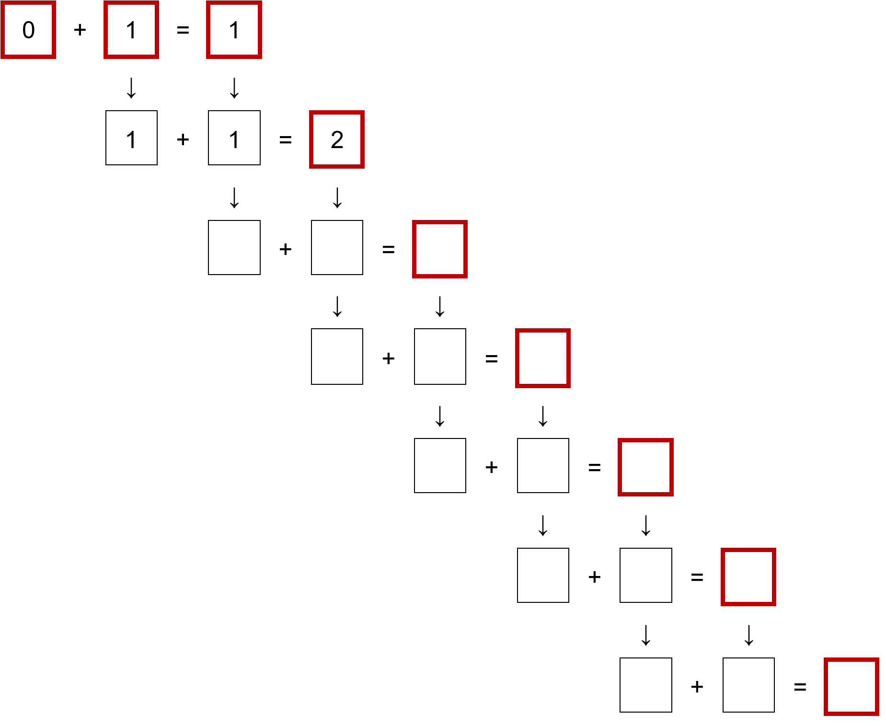
List the numbers in the red squares: 0, 1, 1, ______________________________
Now let’s create a Fibonacci spiral!

- On grid paper draw squares that have the same side lengths as the numbers in the Fibonacci sequence.
That is, draw a:
1 by 1 square
1 by 1 square
2 by 2 square
3 by 3 square
5 by 5 square etc.

- Cut out the squares and arrange them so that they are connected side-by-side as shown in the diagram below.
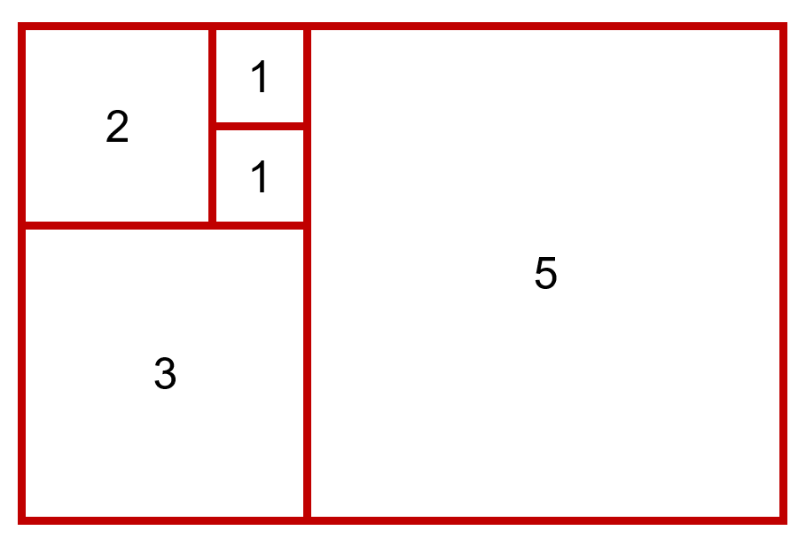

- Draw a curve going through the diagonals of each square forming a spiral. Start with the original 1 by 1 square.
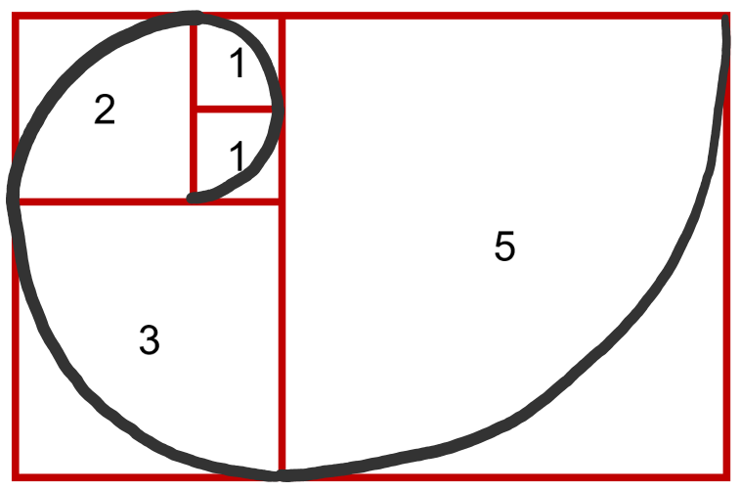
Source: Print-Graph-Paper.com

