Surface area vs Volume
In this activity you will investigate the volume of objects that have the same surface area.

Task 1 – the experiment
- Take an A4 piece of paper in landscape orientation and fold it to form a cylinder.
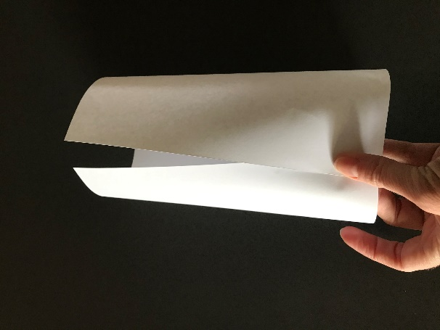
- Stick your cylinder together, being careful not to overlap the edges by too much.
- Stand your cylinder on a table and carefully fill it with rice or something similar.
- Measure how much rice it took to fill the cylinder.

- Take a second sheet of A4 paper in portrait orientation and fold it to form a tall, skinny cylinder.
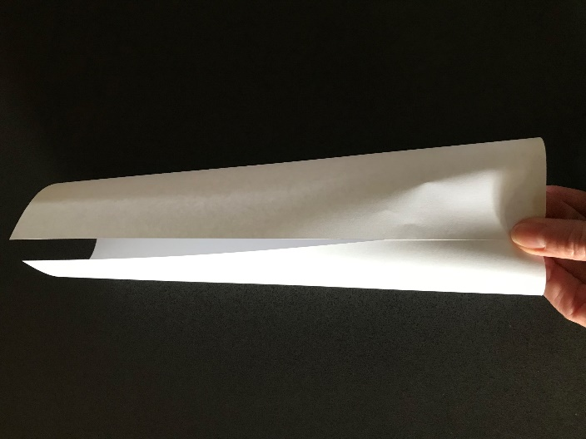
- Again, stick your cylinder together, being careful not to overlap the edges by too much.
- Stand your cylinder on a table and carefully fill it with rice, as before.
- How much rice did it take to fill this cylinder?

Task 2 – analysing the experiment
These two cylinders have the same surface area because they are made from the same sized piece of paper.
- What did you notice about their volumes?
- Repeat the experiment with a different sized piece of paper (maybe cut your A4 sheet in half).
- What did you notice this time?

