Investigating tiling patterns

Task 1 - collecting
You are to collect photos of as many tiling/paving patterns as possible. You may choose to take photos yourself, or to find pictures in magazines, newspapers or the internet.

Task 2 – investigating shapes
For each of your patterns, identify the number and name of the different shapes used in the pattern.
You may choose to record your results in a table similar to the one below.

Pattern | Number of shapes | Name of shapes
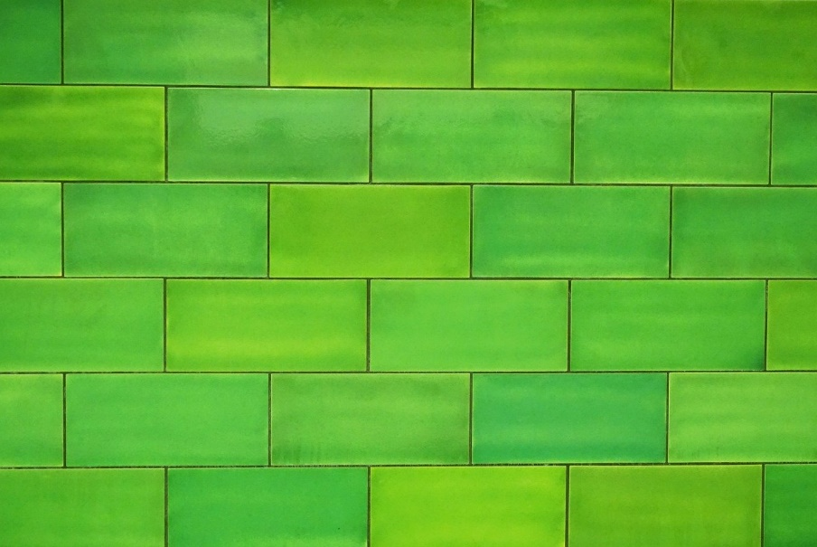 | 1 | Rectangle

Task 3 – naming patterns
Many common tiling patterns have been given specific names. Add a column to your table above and using the internet, try to find a name for each of your patterns.
The Bunnings website will get you started: https://www.bunnings.com.au/diy-advice/home-improvement/tiles/10-tile-patterns-you-need-to-know

