Area estimation
During this activity, will use areas and ratios to compare the sizes of states around Australia using estimated and exact areas.

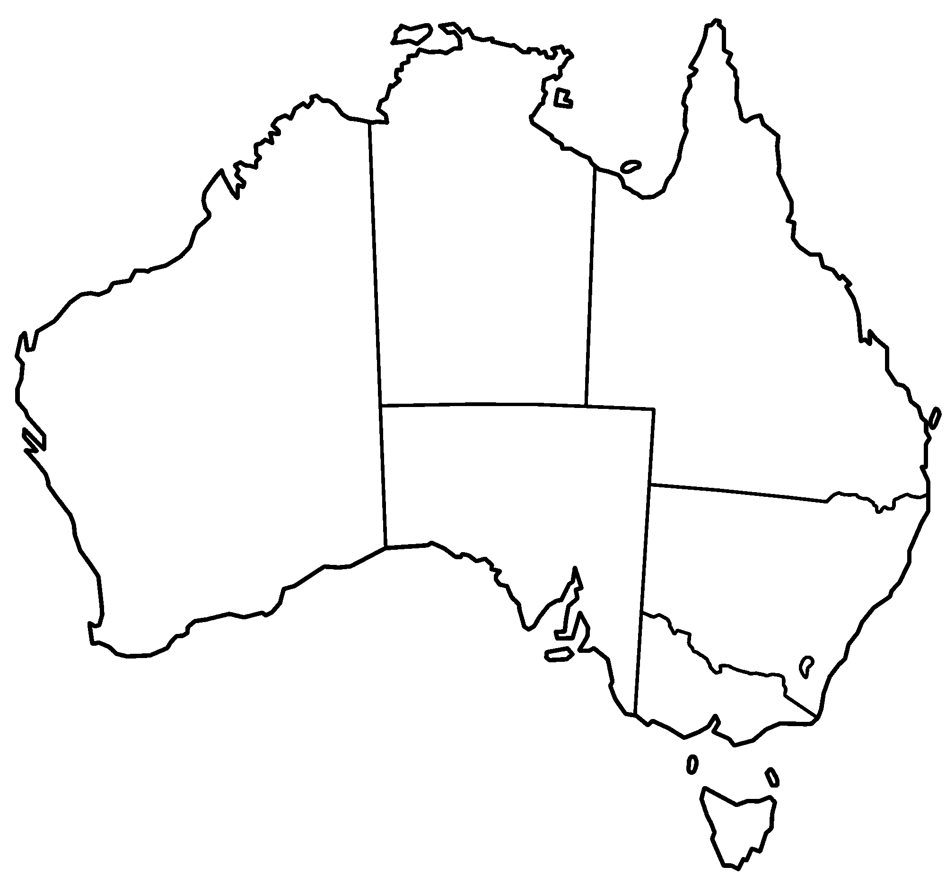

Part A
- If Victoria is a size of 1, estimate the area of each state in terms of the area of Victoria:
  - NSW
  - Tasmania
  - Western Australia

- If Victoria is a size of 1, estimate the area of each again by cutting out the copies of Victoria and overlaying:
  - NSW
  - Tasmania
  - Western Australia

You may like to use the cut-outs below for question 2

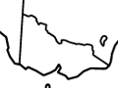

- Use a grid to try to improve your estimate.
- Find the true areas of compared to Victoria: Refer to the Governments table.

Extension
If Australia is an area of 1, find the area of its states and territories.

