Pi scavenger hunt
- Collect your items
- Label each part of your work
- Decide on a creative way to present your findings.

3 | geometric solids which have circular cross-sections. You must submit pictures labelled with the names of the solids.
.
1 | Australian suburb with a post code containing the first 4 digits of Pi – beginning with the 3 i.e. name the suburb and state
4 | capital letters of the alphabet – in block style – with rotational symmetry i.e. list the 4 letters
1 | name of the person who holds the world record for memorising the most digits of pi
5 | formulas which include π. Give the formulas in symbols and explain what each formula represents
9 | labels or advertisements for products which use circles in their name or logo. Create a document with the labels or pictures from advertisements in newspapers, magazines, or from the internet.
2 | Australian place/cities/suburbs/towns with names that have references to something circular – place/cities/suburbs/towns (name each place/city/suburb/town and state)
6 | Aboriginal artworks including circles. Include the image, title and artist.
5 | sports or games which use a circle or a sphere in their play. Include pictures of the circles or spheres from the games, labelled with names of the games.
3 | famous people with birthdays on March 14. Give name and year of birth.
5 | movie titles with references to something circular. List the movie titles.
8 | kinds of lollies that comes in circular pieces. You must submit pictures of the packages or lollies from advertisements or internet.
9 | song titles with references to something circular. List the song titles – bonus points for including a pi song.
7 | recipes for different kinds of pie. Include the recipes.

Investigation: What is pi?
You will need: a piece of string, a ruler.
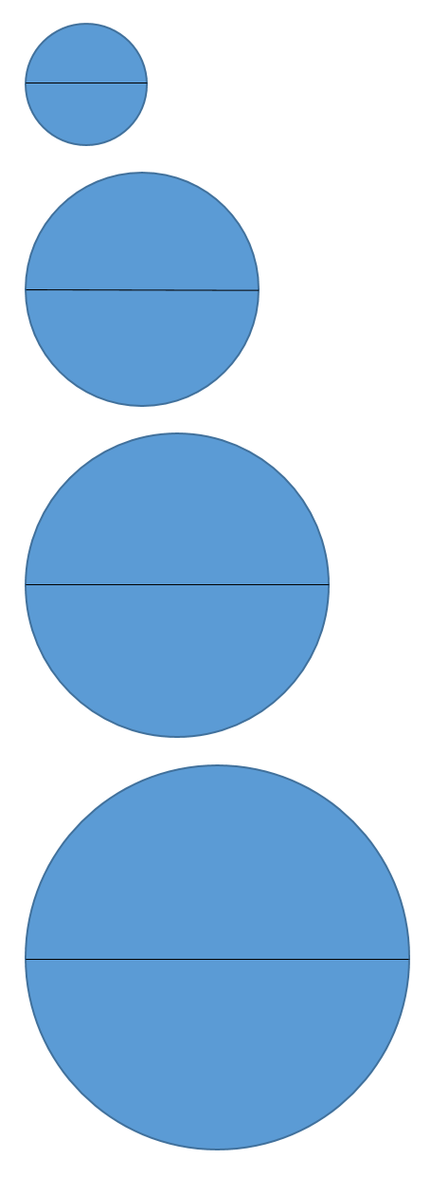

Instructions
- Use your piece of string to measure around the outside of each circle.
- Lengthen out the piece of string alongside a ruler and record the measurement. This is called the circumference of the circle
- Use the ruler to measure the line through that cuts each circle in half and record the measurement. This is called the diameter.

Circle | Circumference | Diameter | Circumference $÷$ Diameter
1
2
3
4

- Check and compare you answers with a friend or family member. Are your answers the same? Are they similar? Are they very different? Make sure you come to an agreement by being as precise as possible and adjust your answers if you need.

- Once you agree, use a calculator to find the Circumference $÷$ Diameter and record the value. This is called the ratio of the circumference to the diameter.

- What do you notice? What do you wonder?

- Find some other circles around the house and investigate the circumference, diameter and ratio for each of those too. For example, around the edge of a plate or bowl.

Circle | Circumference | Diameter | Circumference $÷$ Diameter

- What do you notice? What do you wonder?

- Check in with your teacher about your findings.

Outcome
Calculates the perimeters of plane shapes and the circumferences of circles MA4-12MG

Content
Investigate the relationship between features of circles, such as the circumference, radius and diameter; use formulas to solve problems involving circumference (ACMMG197)
All outcomes referred to in this unit come from Mathematics K-10 Syllabus © NSW Education Standards Authority (NESA) for and on behalf of the Crown in right of the State of New South Wales, 2012

