Area estimation
During this activity, will use areas and ratios to compare the sizes of states around Australia using estimated and exact areas.

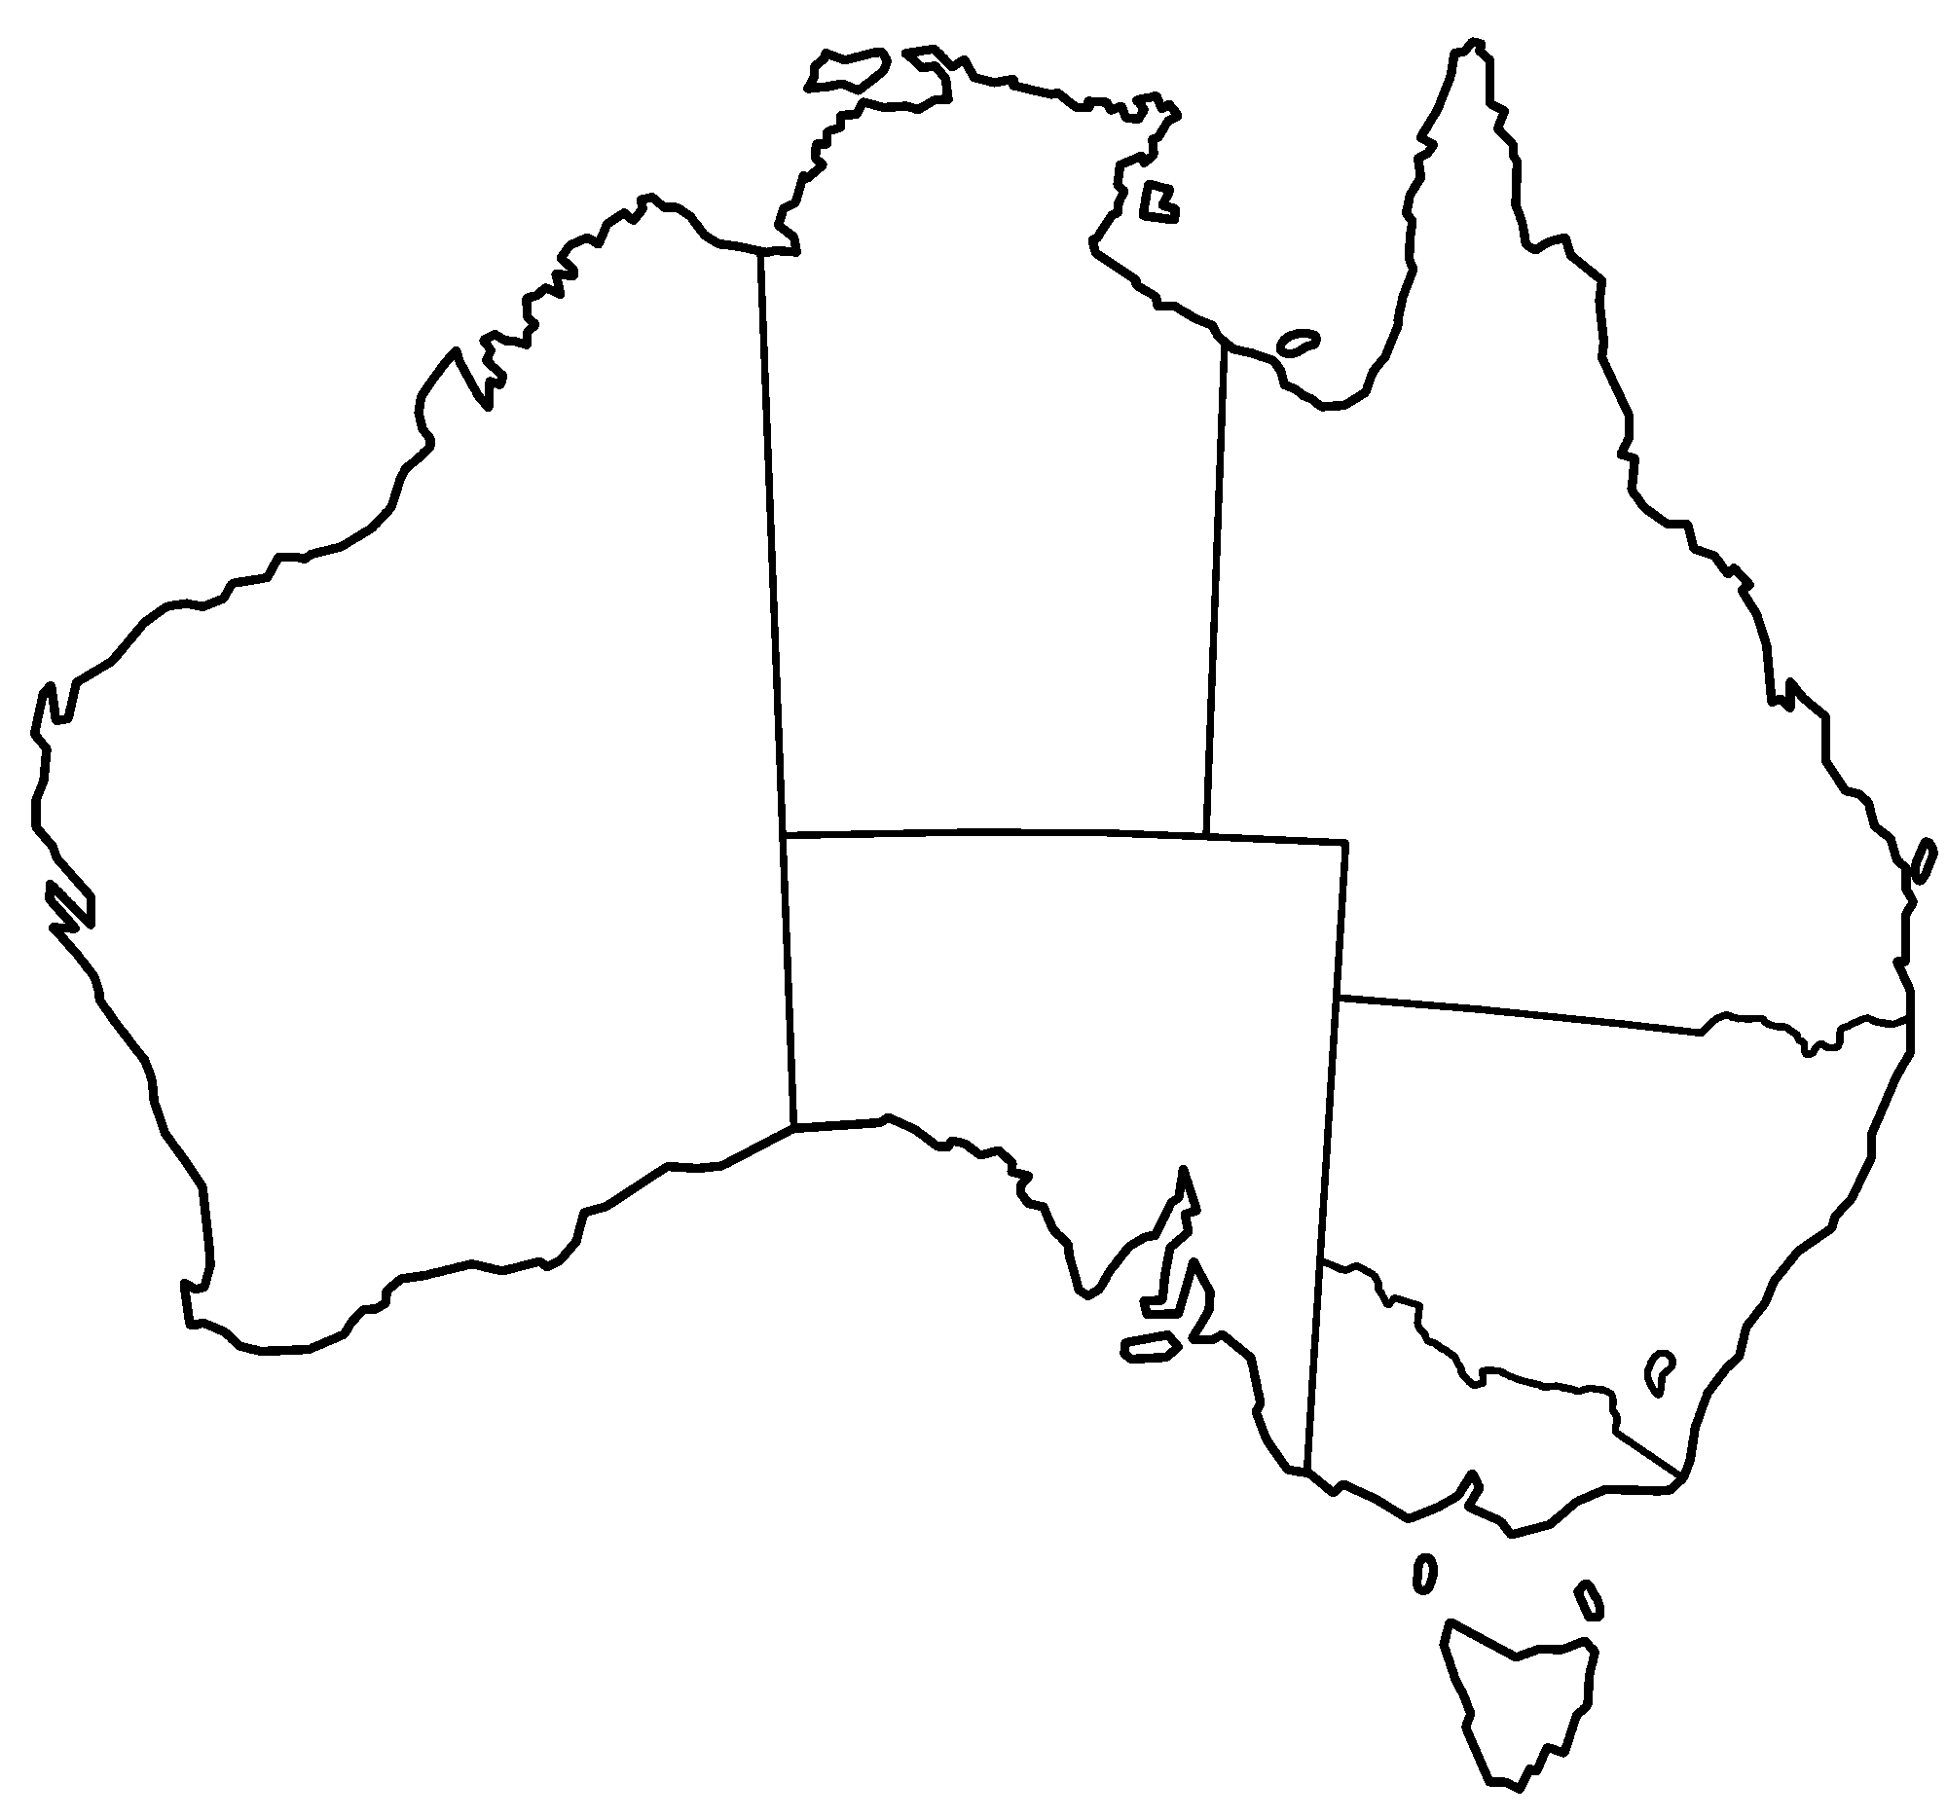

Task
- If Victoria is a size of 1, estimate the area of each state in terms of the area of Victoria:
  - NSW
  - Tasmania
  - Western Australia

- If Victoria is a size of 1, estimate the area of each again by cutting out the copies of Victoria and overlaying:
  - NSW
  - Tasmania
  - Western Australia

You may like to use the cut-outs below for question 2

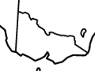

- Use a grid to try to improve your estimate.
- Find the true areas of compared to Victoria: Refer to the Governments table.

Extension
If Australia is an area of 1, find the area of its states and territories.

Outcome
Operates with ratios and rates, and explores their graphical representation MA4-7NA
All outcomes referred to in this unit come from Mathematics K-10 Syllabus © NSW Education Standards Authority (NESA) for and on behalf of the Crown in right of the State of New South Wales, 2012

