Using Google Trends to collect data
- Open Google Trends https://trends.google.com/trends/?geo=US
- Enter your search term eg “Itunes”
- Adjust the timeframe to “2004 – present”
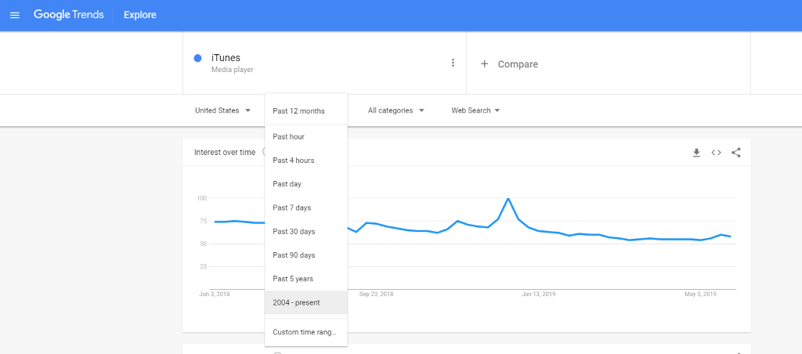
- Download the data to a .csv file by clicking on the icon
- Open the file in Microsoft Excel or similar spreadsheet program.
- Add a column C to represent the number of months after 1/2004 (in this case)
  - Type 0 next to your first number
  - In the cell below type ‘=1+’ and then click on the cell above (ie your 0 cell)
  - Fill down to the rest of your values.
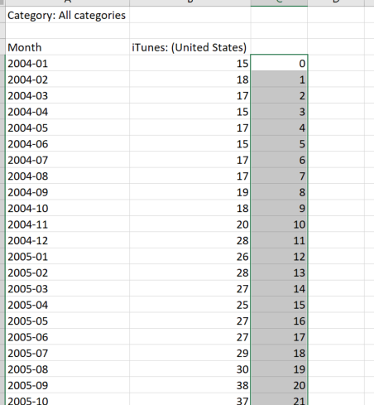
Page Break
- Add a column D for the cumulative number of time using the formula shown and then copying cell D5 down
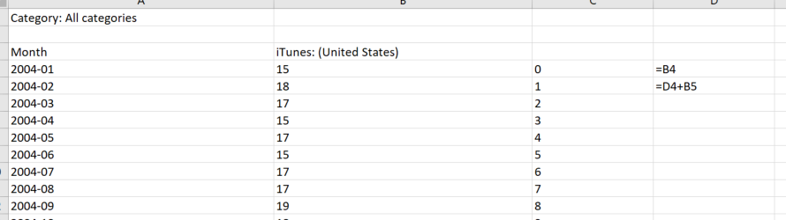

- Highlight the data in columns C and D and Insert a Scatter with Smooth Line graph.

