Mathematics and farming
MS-M3, MS-M4, MS-M5 – assessment task
All outcomes referred to in this unit come from Mathematics Standard Stage 6 Syllabus
© NSW Education Standards Authority (NESA) for and on behalf of the Crown in right of the State of New South Wales, 2017
Assessment type: Assignment
Stage: 6
Due Date:

Outcomes
A student:
- interprets the results of measurements and calculations and makes judgements about their reasonableness MS1-12-3
- analyses simple two-dimensional models to solve practical problems MS1-12-4
- chooses and uses appropriate technology effectively and recognises appropriate times for such use MS1-12-9
- uses mathematical argument and reasoning to evaluate conclusions, communicating a position clearly to others MS1-12-10

Learning across the curriculum
- Cross-curriculum priorities
  - Aboriginal and Torres Strait Islander histories and cultures
  - Asia and Australia’s engagement with Asia
  - Sustainability
- General capabilities
  - Critical and creative thinking
  - Ethical understanding
  - Information and communication technology capability
  - Intercultural understanding
  - Literacy
  - Numeracy
  - Personal and social capability
- Other areas of learning
  - Civics and citizenship
  - Difference and diversity
  - Work and enterprise

Task
In an effort to promote environment awareness and sustainability education, the state government has awarded a block of land to each school in the state. The land that has been allocated to your school is suitable for farming and your school decides to grow crops and raise chickens. The student body has an active role in planning and designing the farm.
The dimensions of the farm is 50m by 35m. Below is an aerial photograph of the farm that has been allocated to your school, enclosed by a white border.
Tools required: pen, pencil, ruler, eraser, set square, a stencil for drawing circles, A3 paper, computer, writing paper.
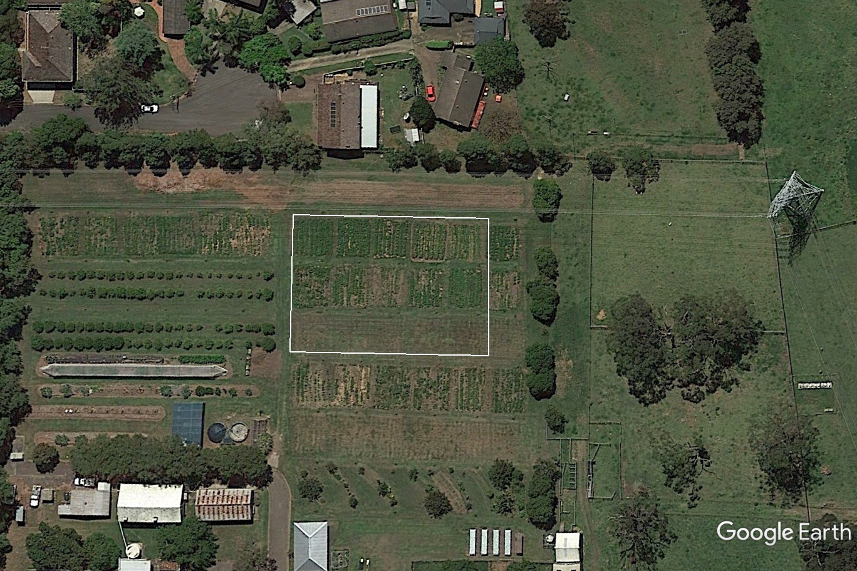
Figure 1: Aerial photograph of the farm

Section 1 – Scale Drawing (20 marks)
The aim of this section is for you to design a development plan for the block of land. You will need to take into account a variety of constraints provided to design a scale drawing of your land.
Features in the block of land
You have to develop your given block of land. It should include:
- Five square garden beds of size 10m by 10m to cultivate crops. There should be a walking path between the garden beds.
- A garden shed of size 5m by 8m.
- A cylindrical water tank with a diameter of 2 m.
- A chicken coop surrounded by area for chickens to roam. The coop will have dimensions of 3m by 2 m and the chicken run (surrounding area) will be triangular in shape. To save costs on fencing, the chicken run will be fenced off with a 20m long fence along one of the corners of the farm.
- One other feature of your choosing, such as a kennel. Write the name of this feature.
- On an A3 sheet of paper, draw a 1:125 colourful scale drawing of your block of land. It should contain all the features listed above. Remember to label the real world dimensions on your diagram. (8 marks)
- Include a key with your scale drawing to identify the features. You may wish to use colour to achieve this. (1 mark)
- Include the scale on your diagram. (1 mark)
- Another student, Minji, has designed the farm as shown in ‘Figure 2’ (you cannot copy this for question 1). Determine the scale of Minji’s diagram. (2 marks)
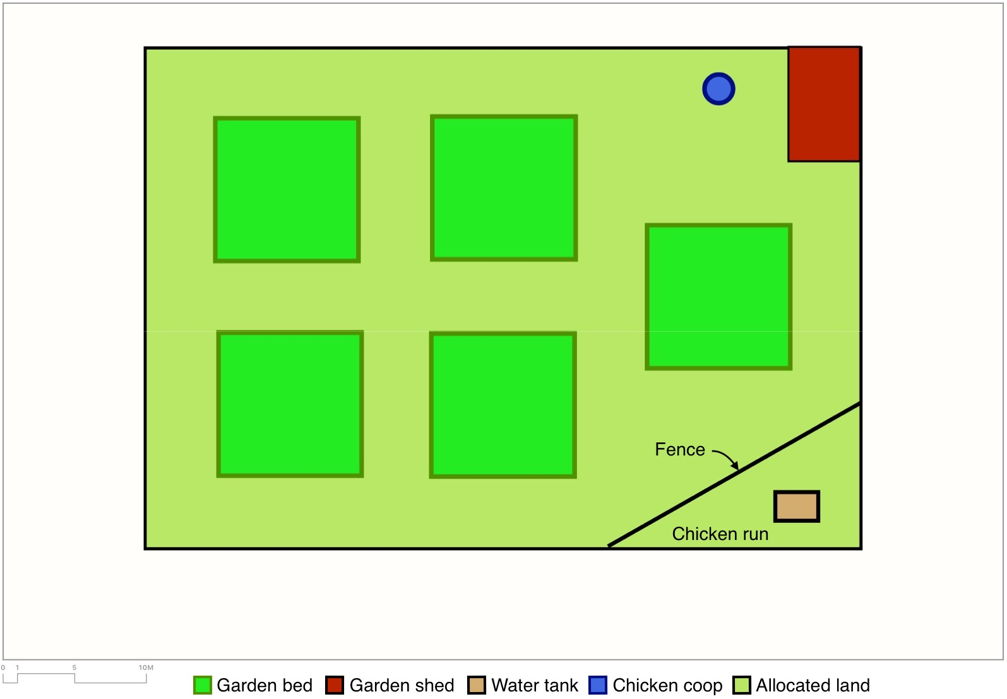
Figure 2: Minji’s scale drawing of the farm

- Complete the table below using measurements from the two scale drawings. The second and third column require you to calculate the area using the formulae provided. (8 marks)
Measurements | Minji’s scale drawing | Your scale drawing | Simplified ratio of Minji’s drawing to your drawing
Width of farm (in mm)
Area of garden beds (in mm²)
$$Area=l×b$$
Area of triangular enclosure (in mm²)
$$Area=\frac{1}{2}×b×h$$

Section 2 – Right-angled Triangles (20 marks)
- Your farm has a chicken coop to house the chickens. The chickens need to climb up a ramp to enter the chicken coop. The coop is 125cm above the ground and the ramp is angled at 30 degrees to the horizontal so that the chickens do not slide down.
- Draw a right-angled triangle and label it to show the information above. This diagram does not need to be drawn to scale. (2 marks)
- Find the horizontal distance travelled by the chicken. This is the distance from the base of the coop to the end of the ramp. Give your answer in centimetres. (2 marks)
- The farm hand needs to create a ramp for the chickens to walk up to the coop. Find the length of the ramp using your answer to (b). Give your answer correct to the nearest 10 centimetres. (1 mark)
- Draw the ramp on your scale drawing from Section 1. This should be drawn to scale using your solution to 1(b). (1 mark)
- There is a 20m long fence along one corner of the farm that creates a triangular chicken run.
- What could be the lengths of the other two sides of the chicken run if it is a right-angled triangle? Use Pythagoras’ theorem to justify your answer. (2 marks)
- Draw a right-angled triangle for your solution to (a) and label its lengths. This diagram does not need to be drawn to scale. (1 mark)
- One of the angles in the chicken coop is 90 degrees. Using your answers in (a), find the other angles of the right-angled triangle. Give your answers correct to the nearest degree. (2 marks)
- This question requires you to download and use Google Earth on your BYOD device.
- Search for ‘NSW Rural Fire Service Heliport Yass’. This will be identified with a red balloon.
- Activate the ‘Ruler’ tool by clicking on the ruler button. Now you are able to find the distance (‘ground length’) and bearing (‘heading’) between places by clicking any two places.
- Select one farm to the west of the fire station and one farm to the east of the fire station. Then complete the following table by using the ruler tool. Submit a screenshot and label the farms used. (9 marks)
Locations | Distance (‘ground length’) | Bearing (‘heading’) | Equivalent compass bearing
Fire station to western farm
Western farm to eastern farm
Eastern farm to fire station

Section 3 – Rates (24 marks)
There are a variety of costs and calculations involved in setting up and running the farm.
- The students like the idea of raising chicks for their chicken coop. Chicks cost $3 each. They will need to be fed Chick-Starter for the first 8 weeks which costs $25 for a 20kg bag. They are fed Pullet-Grower from weeks 8 to 16, which costs $23 for a 20kg bag. After this time, they will cost nothing to feed as they will feed on grass and vegetable scraps collected from the school.
- Find the cost of 50g of Chick-Starter. Give the exact answer.
- How many bags of Chick-Starter will the students need to buy to feed the 15 chicks for the first 8 weeks if each chick eats 50g/day?
- Find the cost of 500g of Pullet-Grower. Give the exact answer.
- How many bags of Pullet-Grower will the students need to buy to feed the 15 chicks for the next 8 weeks if each chick eats 500g/week?
- Find the total cost of buying and feeding the 15 chicks for the first 16 weeks.
- The students decide to buy chickens that are ready to lay eggs instead of chicks so that they can start selling eggs sooner to cover their costs. The farm manager must decide between two suppliers from which to buy the chickens – Supplier A sells 5 chickens for $105 and supplier B sells chickens at a cost of $60 for 3.
- Which supplier’s cost is cheaper? Justify your answer.
- The farm manager says that it is not ideal to go to the cheapest supplier. What could be another factor that needs to be taken into consideration?
- The Free Range Farmers Association (FRFA) has set a stocking density of 750 chickens per hectare of land. How many chickens would the FRFA recommend for a 15-hectare farm?
- The students decide to purchase 15 chickens as they would like to keep within this limit in the space they have available. Find the cost of the 15 chickens if the farmer decides to purchase the chickens from the cheapest supplier.
- The farm manager must travel to a nearby rural area to buy chickens.
- The speed limit for part of the journey is 60km/h. Convert this speed to metres per second (m/s). Show your working and give your answer to 2 decimal places.
- At 60km/h, the truck’s fuel consumption is 11.2L/100km. How many litres of fuel will be required to complete the return journey if the distance from the school to the chicken seller is 32km? Show your working and give the exact answer.
- Find the total fuel cost for the entire journey if fuel costs $1.43/L.

- The graph below shows the trip made by the farm manager to buy the chickens and return back. (An online and adaptable version of this ‘Distance Time’ graph is available from Geogebra.)
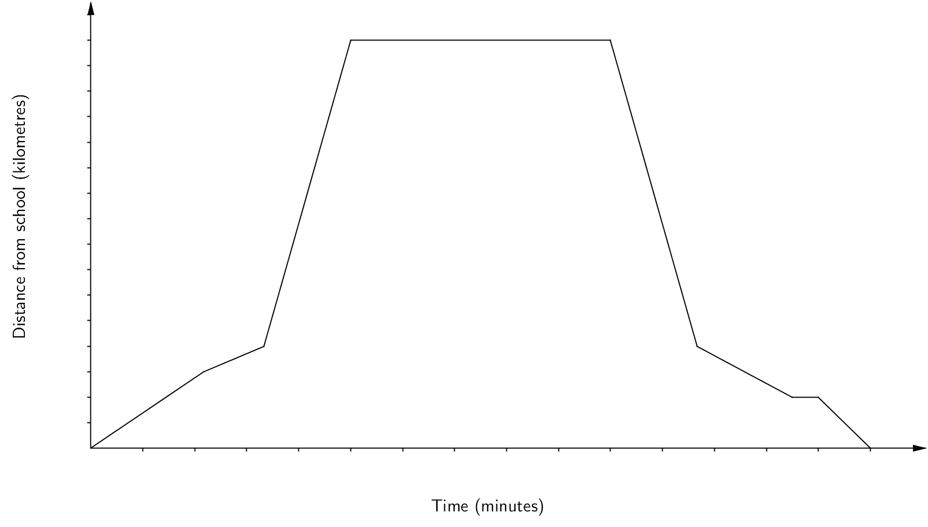
- The trip to purchase the chickens and return took 150 minutes and the supplier was located 80km away. Use this information to label the horizontal and vertical axis.
- How long was the farm manager at the supplier’s shop?
- Calculate the average speed when travelling to the supplier’s shop. Give your answer in km/h.
- The farm manager stopped during the return journey for a few minutes. Briefly state a reason for this.
- The farm manager had to travel on the highway for most of the journey. Approximately how long did he travel on the highway when returning with the chickens? Give your answer to the nearest minute.
- The farm’s water tank has a capacity of 8000L. It has sprung a leak. In order to fix the tank, a plumber has advised the school to drain the tank before he arrives to complete the job.
- The water tank is being drained of liquid at the rate of 500mL/s
    - Convert the rate to L/min.
    - At this rate, how long will it take for the water to empty from the tank? Give your answer to the nearest half hour.
- The plumber charges a call-out fee of $85 plus $110/h for his work. Calculate the cost for the tank repair if it takes him 4 hours to repair the tank.
- If the tank had not been drained before he arrived, calculate the extra cost for the repairs if the plumber must wait for the tank to empty. You may assume that the plumber will charge for a half hour.

Marking guideline and rubric
Teachers are advised to provide a copy of the rubric to students along with the task after deleting the sample answers.

Section 1 – Scale drawing (20 marks)
Question | Sample answer | Criteria | Marks
1 | N/A | N/A | 8
2 | Answers may vary | 1 mark – A key is provided to distinguish features  0 marks – A key is not provided to distinguish features | 1
3 | 1:125 | 1 mark – Scale for the diagram is written/indicated visually  0 marks – Scale for the diagram is not provided | 1
4 | N/A | 2 marks – Correct simplified ratio of scale drawing  1 mark – Progress towards answer  0 marks – No correct answer | 2
5 – width of farm | Minji = 118  Student = 1  Ratio = 1:125 | Correct width from both scale drawings (1 mark) and correct simplified ratio of width, CFPA allowed (1 mark) | 2
5 – area of garden beds | Minji $=22×22$  Student $=2750×2750$  Ratio = 1:125 | Correct area of garden beds (1 mark each) and correct ratio of area of garden beds, allowing CFPA (1 mark) | 3
5 – area of enclosure | Minji $=\frac{1}{2}×38×22$  Ratio = 1:125 | Correct area of triangular enclosure (1 mark each) and correct ratio of area of enclosure, allowing CFPA (1 mark) | 3
Total:

Marking criteria
Marks | Criteria
13-15 | - Extensive knowledge to convert scale factor from map to actual size and vice versa  - High level of competence in utilising space provided effectively and featuring key features and appropriate scale
10-12 | - Thorough knowledge to convert scale factor from map to actual size and vice versa  - Competent in utilising space provided effectively and featuring key features and appropriate scale
7-9 | - Sound knowledge to convert scale factor from map to actual size and vice versa  - Adequate perception in utilising space provided effectively and featuring key features and appropriate scale
4-6 | - Basic knowledge to convert scale factor from map to actual size and vice versa  - Basic perception in utilising space provided effectively and featuring key features and appropriate scale
1-3 | - Limited knowledge to convert scale factor from map to actual size and vice versa  - Limited perception in utilising space provided effectively and featuring key features and appropriate scale
Feedback:

Section 2 – Right-angled Triangles (20 marks)
Question | Sample answer | Criteria | Marks
1a) | 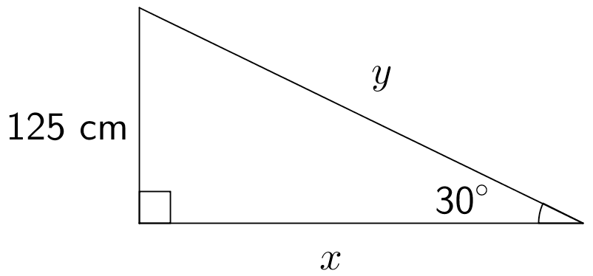 | 2 marks – Correct diagram labelling 125cm and 30 degrees  1 mark – Correct diagram labelling 125cm or 30 degrees  0 marks – Incorrect diagram or no labels | 2
1b) | $$\tan{30°}=\frac{125}{x}$$  $$x=\frac{125}{\tan{30°}}$$  $$x=216.5063509⋯cm$$  $x≈217cm$ (to nearest cm) | 2 marks – Correct answer, CFPA allowed  1 mark – A correct trigonometric ratio for the right-angled triangle, CFPA allowed  0 marks – Incorrect answer, CFPA allowed | 2
1c) | $$\cos{30°=\frac{217}{y}}$$  $$y=\frac{217}{\cos{30°}}$$  $$y=250.5700168⋯cm$$  $x≈250cm$ (to nearest cm)  or  $$y^{2}={125}^{2}+{217}^{2}$$  $$y^{2}=62714$$  $$y=\sqrt{62714}$$  $$y=250.4276343⋯cm$$  $y≈250cm$ (to nearst 10cm) | 1 mark – Correct answer using 1b), CFPA allowed  0 marks – Incorrect answer or did not use 1b), CFPA allowed | 1
1d) | $$Ramp length≈1.75cm±2mm$$ | 1 mark – Ramp drawn to scale, CFPA allowed from Section 1  0 marks – Incorrect answer, CFPA allowed from Section 1 | 1
2a) | One possible solution:  The other two lengths are 13.23m and 15m.  Proof:  $${13.23}^{2}+{15}^{2}={20}^{2}$$  $$175.0329+225=400$$  $$400.0329≈400$$  $∴$ The thee lengths form a right-angled triangle as required. | 2 marks – Correct side lengths, justified using Pythagoras’ theorem, in metres  1 mark – Correct side lengths without justification or correct Pythagoras’ theorem solution or correct solution that is not in metres  0 marks – Incorrect answer | 2
2b) | One possible solution based on 2a):  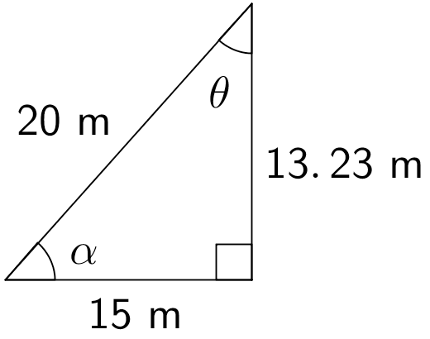 | 1 mark – Correct diagram, CFPA allowed  0 marks – Incorrect diagram, CFPA allowed | 1
2c) | One possible solution based on 2a) and 2b):  $$\sin{θ}=\frac{15}{20}$$  $$θ=\sin^{-1}\left(\frac{15}{20}\right)$$  $$θ=48.59037789⋯°$$  $θ≈49°$ (to nearest degree)  $$α=180°-\left(90°+49°\right)$$  $$α=41°$$ | 2 marks – Two correct angles, CFPA allowed  1 mark – One correct angle or progress towards answer, CFPA allowed  0 marks – Incorrect answer, CFPA allowed | 2
3 | Use the screenshot and Google Earth while marking this question. Answers will vary.  Note – Only mark the last column if the screenshot is not supplied. | 9 marks – All nine values are correct  8 marks – Eight values are correct  7 marks – Seven values are correct  6 marks – Six values are correct  5 marks – Five values are correct  4 marks – Four values are correct  3 marks – Three values are correct  2 marks – Two values are correct  1 mark – One value is correct or screenshot supplied  0 marks – Incorrect answer | 9
Total:

Section 3 – Rates (24 marks)
Question | Sample answer | Criteria | Marks
1a) | $0.625 or 6.25c | 1 mark – Correct answer | 1
1b) | 3 bags, as chicks will eat 42kg of Chick-Starter | 1 mark – Correct answer | 1
1c) | $0.575 or 57.5c | 1 mark – Correct answer | 1
1d) | 3 bags, as chicks will eat 60kg of Pullet-Grower | 1 mark – Correct answer | 1
1e) | $$15×\$3+3×\$25+3×\$23=\$189$$ | 1 mark – Correct answer | 1
2a) | Supplier B  Justification:  • Supplier A = $21/chicken  • Supplier B = $20/chicken | 1 mark for correct answer, and 1 mark for providing a reason | 2
2b) | Supplier B is further away, costing more time and fuel. | 1 mark – Reason | 1
2c) | $$750×15=11250$$ | 1 mark – Correct answer | 1
2d) | $$15×\$20=\$300$$ | 1 mark – Correct answer | 1
3a) | $${60km}/h=60000m∕3600s$$  $$=16.666⋯m∕s$$  $$≈16.67m∕s$$ | 1 mark for correct answer, and 1 mark for showing working out | 2
3b) | $$32×2×\frac{11.2}{100}=7.168L$$ | 1 mark – Correct answer | 1
3c) | $$7.168×\$1.43=\$10.25$$ | 1 mark – Correct answer | 1
4a) | Horizontal axis – one division equals 10 min  Vertical axis – one division equals 5km | 1 mark for correct labelling of horizontal axis and 1 mark for correct labelling of vertical axis | 2
4b) | 50min | 1 mark – Correct answer | 1
4c) | 80km/50min = 16km/10min = 96km/h | 1 mark – Correct answer | 1
4d) | He may have stopped to use the bathroom or buy lunch/fuel. | 1 mark – One valid reason | 1
4e) | He drove for approximately 17 min. (Allow $±1$ min variation) | 1 mark – Correct answer | 1
5a) i) | $${500mL}/s=0.5L∕s$$  $$=0.5×{60L}/{min}$$  $$30L∕min$$ | 1 mark – Correct answer | 1
5a) ii) | $$\frac{8000}{30}=266.666⋯min$$  $$=4.444⋯hrs$$  $$=4.5hrs$$ | 1 mark – Correct answer | 1
5b) | $$\$85+\$110×4=\$525$$ | 1 mark – Correct answer | 1
5c) | $$\$110×4.5=\$495$$ | 1 mark – Correct answer | 1
Total:

