Solving problems involving networks

Using a map or network diagram

Road trip – problem 1
Students refer to the network diagram of Goulburn to Tamworth.
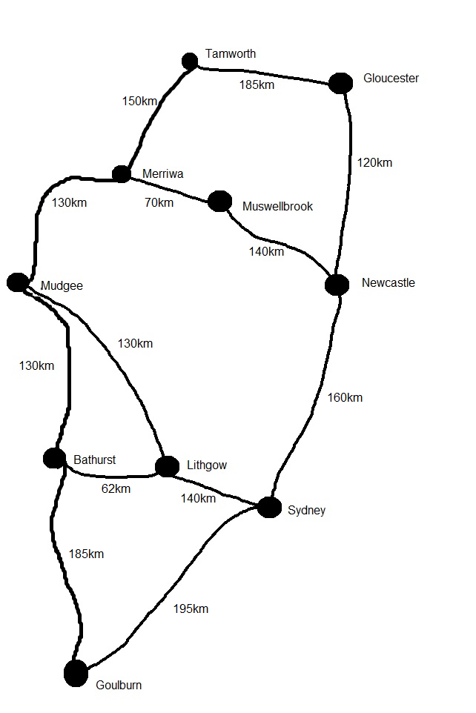
- Draw arrows on the network to represent direction if each route is to take you closer towards Tamworth.
- List the vertices of this network.
- What do the numbers on the weighted edges represent?
- What is the greatest distance between any two nodes?
- Which two towns are 70 km apart?
- Given that each path taken must bring you closer to Tamworth, list the number of routes from Goulburn to Tamworth.
- Calculate the distance for each route from Goulburn to Tamworth.
- Does the longest route from Goulburn to Tamworth go through Sydney or Bathurst?
- Which route represents the shortest path?
- Is it possible to visit every town or city exactly once when travelling from Goulburn to Tamworth?
- Is it possible to use every road exactly once when travelling from Goulburn to Tamworth?
- Is it quicker to take the coastal road via Sydney/Newcastle, or inland via Bathurst?
- Which route would you prefer to use and why?
- Extension – Students choose two locations of their own and draw a network diagram showing different routes between each. Weighted edges can be travel times using speed distance formula.

Solution
- Draw arrows on the network to represent direction if each route is to take you closer towards Tamworth.
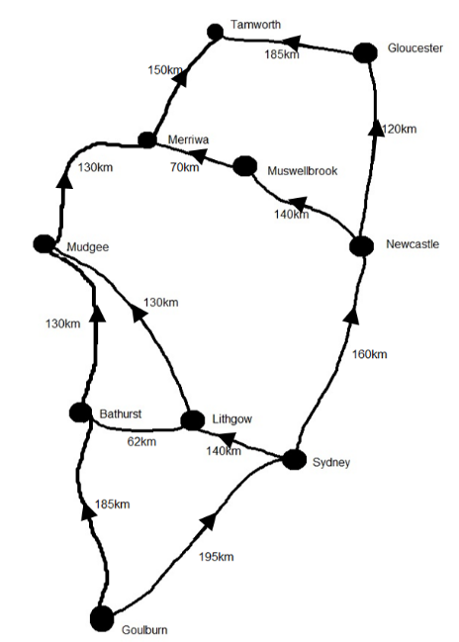
Note: No arrow has been included between Bathurst and Lithgow as this route will not take you further or closer to Tamworth.
- List the vertices of this network.
Goulburn, Sydney, Lithgow, Bathurst, Mudgee, Newcastle, Muswellbrook, Merriwa, Gloucester and Tamworth.
- What do the numbers on the weighted edges represent?
The distance in kilometres between two towns/cities.
- What is the greatest distance between any two nodes?
195 km, the distance between Goulburn and Sydney.
- Which two towns are 70 km apart?
Merriwa and Muswellbrook.
- Given that each path taken must bring you closer to Tamworth, list the number of routes from Goulburn to Tamworth.
4 routes.
Route 1: Goulburn-Bathurst-Mudgee-Merriwa-Tamworth
Route 2: Goulburn-Sydney-Lithgow-Mudgee-Merriwa-Tamworth
Route 3: Goulburn-Sydney-Newcastle-Muswellbrook-Merriwa-Tamworth
Route 4: Goulburn-Sydney-Newcastle-Gloucester-Tamworth
- Calculate the distance for each route from Goulburn to Tamworth.
  - Route 1: Goulburn-Bathurst-Mudgee-Merriwa-Tamworth
$$Distance=185+130+130+150=595 km$$
  - Route 2: Goulburn-Sydney-Lithgow-Mudgee-Merriwa-Tamworth
$$Distance=195+140+130+130+150=745 km$$
  - Route 3: Goulburn-Sydney-Newcastle-Muswellbrook-Merriwa-Tamworth
$$Distance=195+160+140+70+150=715 km$$
  - Route 4: Goulburn-Sydney-Newcastle-Gloucester-Tamworth
$$Distance=195+160+120+185=660 km$$
- Does the longest route from Goulburn to Tamworth go through Sydney or Bathurst?
Sydney
- Which route represents the shortest path?
  - Route 1: Goulburn-Bathurst-Mudgee-Merriwa-Tamworth
- Is it possible to visit every town or city exactly once when travelling from Goulburn to Tamworth?
It is possible. Route: Goulburn-Sydney-Lithgow-Bathurst-Mudgee-Merriwa-Muswellbrook-Newcastle-Gloucester-Tamworth
- Is it possible to use every road exactly once when travelling from Goulburn to Tamworth?
It is not possible.
- Is it quicker to take the coastal road via Sydney/Newcastle, or inland via Bathurst?
Which is quicker will depend on traffic conditions and speed limits on the road. This could be investigated by students by drawing a new weighted network where the travel time is given on the edges. Students could use the internet to obtain travel times for each segment. The following was obtained using google maps in October 2019.
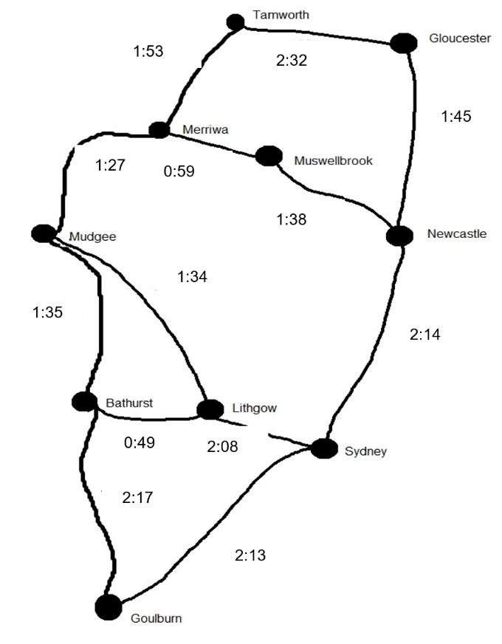
  - Route 1: Goulburn-Bathurst-Mudgee-Merriwa-Tamworth
$$Time=2:17+1:35+1:27+1:53=7 hours and 12 minutes$$
  - Route 4: Goulburn-Sydney-Newcastle-Gloucester-Tamworth
$$Time=2:13+2:14+1:45+2:32=8 hours and 44 minutes$$
- Which route would you prefer to use and why?
Answers may vary. For example a students may wish to take the coast road to go to the beach where as others may wish to avoid travelling through Sydney.
- Extension – Students choose two locations of their own and draw a network diagram showing different routes between each. Weighted edges can be travel times using speed distance formula.
No solution is provided.

On the farm – problem 1
A farm has one generator to power four sheds, a barn, an office and two houses. The undirected diagram below shows the distance between each node in metres. Cabling costs $25 per metre.
- How much would it cost the farmer to cable directly to the two houses from the generator?
- What is the minimum cost for cabling the two houses from the generator?
- Is the 12m cable between the houses necessary? Why/why not?
- What is the minimum cost of cabling just the four sheds to the generator?
- The farmer could save money by removing some cables. Which cables do you think should be removed if every building must have power?
- Calculate the minimum cost for the farmer to cable his entire network.
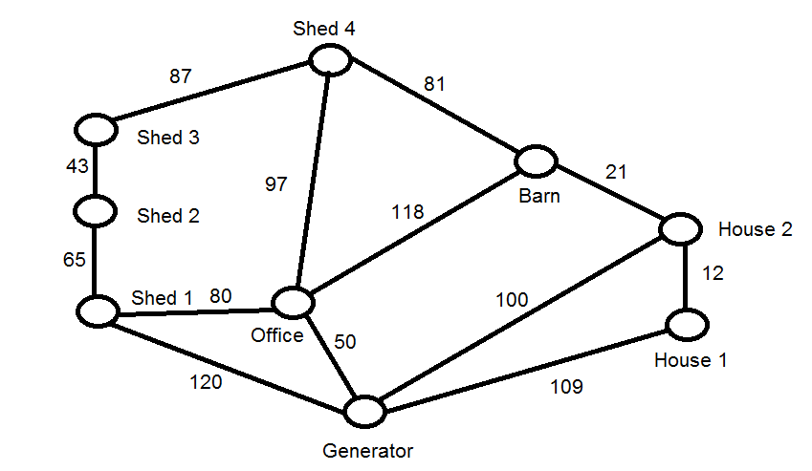

Solution
- How much would it cost the farmer to cable directly to the two houses from the generator?
$$Cable required=100+109=209 m$$
$$Cost=\$25 ×209=\$5225$$
- What is the minimum cost for cabling the two houses from the generator?
Join the Generator to House 2 to House 1.
$$Cable required=100+12=112 m$$
$$Cost=\$25 ×100+\$25 ×12=\$2800$$
- Is the 12m cable between the houses necessary? Why/why not?
It is not necessary, but it is the cheapest way to connect the two houses. Alternatively, the houses could both be joined directly from the generator.
- What is the minimum cost of cabling just the four sheds to the generator?
Join the generator to shed 1 to shed 2 to shed 3 to shed 4.
$$Cable required=120+65+43+87=315 m$$
$$Cost=\$25 ×315=\$7875$$
- The farmer could save money by removing some cables. Which cables do you think should be removed if every building must have power?
Construct the minimum spanning tree.
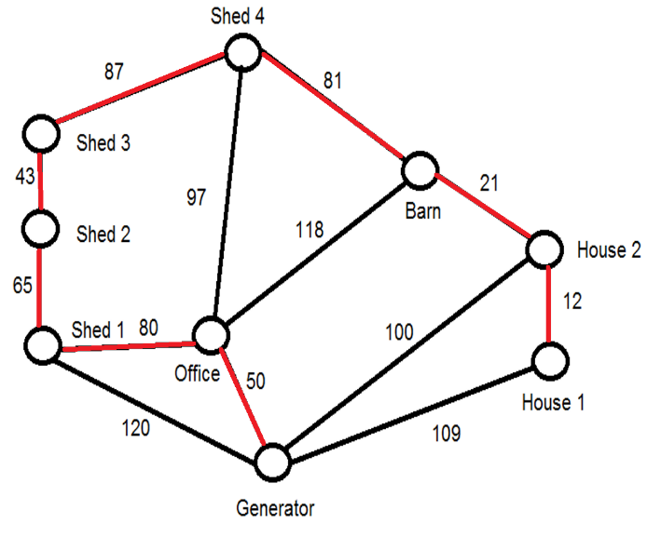
The cables not in the minimum spanning tree should be removed. i.e. The cables between the Generator and House 1, the Generator and Shed 1, the Generator and House 2, the Office and Barn and the Office and Shed 4 should be removed.
- Calculate the minimum cost for the farmer to cable his entire network.
$$Cable required=50+80+65+43+87+81+21+12=315 m$$
$$Cost=\$25 ×50=\$10975$$

One the farm – problem 2
Locate a property on Google Earth or SIX maps that contains different buildings. Use the calculator function in the given application to create a weighted network diagram, using distance. Calculate the shortest path from the main building to a shed.

Solution
No solution provided. Answers will vary depending on the students.

Road trip – problem 2
Refer to the inland route of the map from Goulburn to Tamworth from road trip – problem 1.
- Complete the table below:
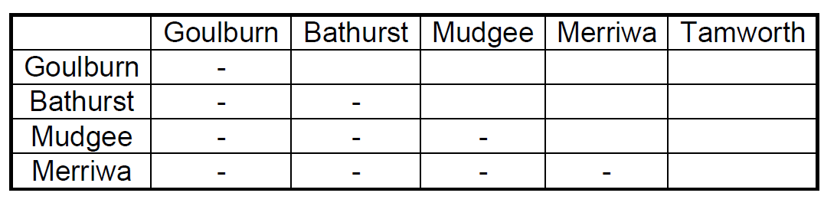

Solution
- Complete the table below:
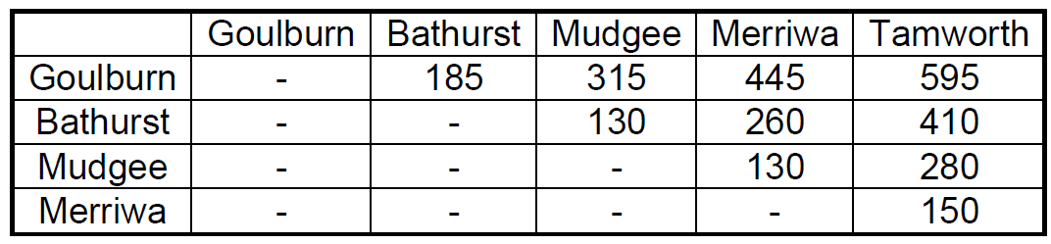

Road trip – problem 3
You live in Bathurst, NSW and you are planning a road trip to visit friends in Tumut, Wagga Wagga, Hay and Lake Cargelligo. However, with the price of petrol is around $1.40/L and your car uses 13L per 100km. You want to calculate the order to visit the cities to make the round-trip the shortest and save money on petrol.
- Copy the map and find the distance between each of these two points.
- Find the distance between each point from the given table
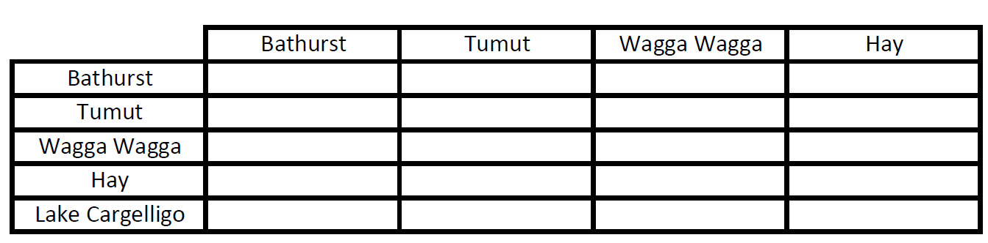

Solution
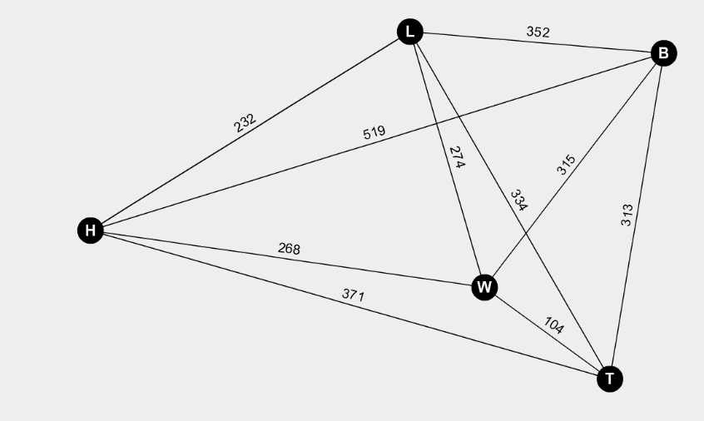
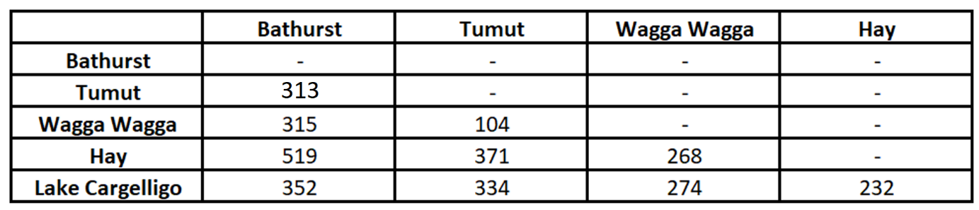
Shortest round trip: Bathurst-Tumut-Wagga-Wagga-Hay-Lake Cargelligo-Bathurst
$$Distance=313+104+268+232+352=1269 km$$

School computer network – problem 1
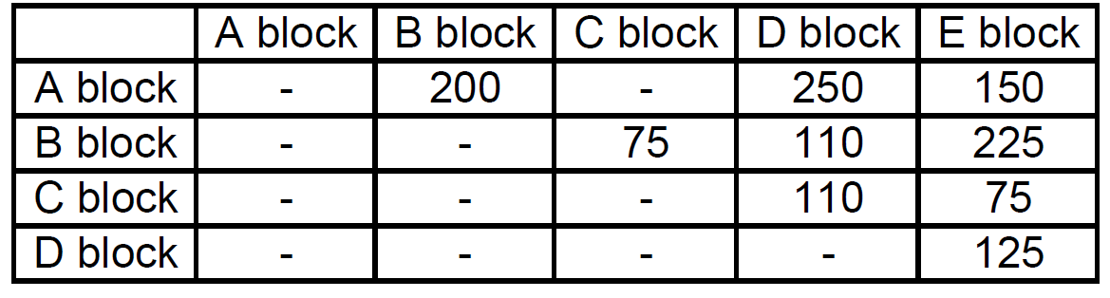
The cost in dollars of connecting various blocks in a school with network cables is given in the table above. A blank space indicates no direct connection. Draw a weighted network diagram to represent this situation.

Solution
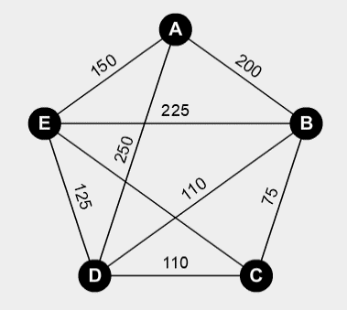

School computer network – problem 2
- Select five locations from around the school to construct a simple network diagram.
- Students use a stopwatch to time in seconds the distance between each vertex (students may need help with rounding), recording the information in a table.
- Add weighted edges to the network diagram.
- Compare the table and network diagram. Discuss the advantages and disadvantages of each.

Solution
Solutions will vary from student to student.

