Year 12 Mathematics Standard 1
MS-N1 Networks and paths | Unit duration
Students develop their appreciation of the applicability of networks throughout their life, for example, social networks, and their ability to use associated techniques to optimise practical problems. Students learn through practical tasks. | 3-4 weeks

Subtopic focus | Outcomes
The principal focus of this subtopic is to identify and use network terminology and to solve problems involving networks.  Students develop their awareness of the applicability of networks throughout their lives, for example, social media networks, and their ability to use associated techniques to optimise practical problems. | A student:  - applies network techniques to solve network problems MS1-12-8  - chooses and uses appropriate technology effectively and recognises appropriate times for such use MS1-12-9  - uses mathematical argument and reasoning to evaluate conclusions, communicating a position clearly to others MS1-12-10  Related Life Skills outcomes: MALS6-11, MALS6-12, MALS6-13, MALS6-14

Prerequisite knowledge | Assessment strategies
Students will benefit from the language and terminology of the Measurement and Geometry strand. | - Teachers may wish to use this formative assessment tool to create a Google or Microsoft Form to assess student understanding during the unit, networks-formative-assessment-tool.DOCX

All outcomes referred to in this unit come from Mathematics Standard Stage 6 Syllabus
© NSW Education Standards Authority (NESA) for and on behalf of the Crown in right of the State of New South Wales, 2017

Term | Definition
Cycle | A cycle is a walk where the initial and final vertices are the same, but no other vertices are repeated.
Degree | The degree (or order) of a vertex is the number of edges connected to it. An even vertex has an even number of edges connected to it and an odd vertex has an odd number.
Directed network | A directed network is a network whose edges have arrows and travel is only possible in the direction of the arrows.
Edge | In a network diagram, an edge refers to a line which joins vertices to each other. Also called an arc.
Kruskal’s algorithm | Kruskal's algorithm finds a minimum spanning tree for a connected weighted network.
Minimum spanning tree | A minimum spanning tree is a spanning tree of minimum length in a connected, undirected network. It connects all the vertices together with the minimum total weighting for the edges.
Network | A network is a group or system of interconnecting objects which can be represented as a diagram of connected lines (called edges) and points (called vertices). For example a rail network.
Network diagram | A network diagram is a representation of a group of objects called vertices that are connected together by lines called edges. Also known as a network graph or network map.
Paths | A path in a network diagram is a walk in which all of the edges and all the vertices are different. A path that starts and finishes at different vertices is said to be open, while a path that starts and finishes at the same vertex is said to be closed. There may be multiple paths between the same two vertices.
Prim’s algorithm | Prim's algorithm finds a minimum spanning tree for a connected weighted network.
Shortest path | A shortest path in a network diagram is a path between two vertices in a network where the sum of the weights of its edges are minimised.
Spanning Tree | A spanning tree of an undirected network diagram is a tree which includes all the vertices of the original network connected together, but not necessarily all the edges of the original network diagram. A network can have many different spanning trees.
Tree | A tree is an undirected network in which any two vertices are connected by exactly one path.
Vertex | A vertex is a point in a network diagram at which lines of pathways (called edges) intersect or branch. Also called a node.
Walk | A walk is a sequence of vertices connected by edges such that the end vertex of one edge is the start vertex of the next.
Weighted edge | A weighted edge is an edge of a network diagram that has a number assigned to it which implies some numerical value such as cost, distance or time.

Lesson sequence | Content | Suggested teaching strategies and resources | Date and initial | Comments, feedback, additional resources used
Considerations |  | Technology note  The following technology can be used throughout this unit to assist students in drawing networks:  - Graph creator  - Team Gantt  - Lucid chart  - Geogebra can also be used to create a network diagram with weightings as captions.  Terminology note  Teachers may wish to highlight some of the additional terms or concepts used to describe networks in other resources, but these are not included in the syllabus.  Some of these include:  - The study of networks is from the branch of mathematics called, “Graph theory”  - Network diagrams can also be called maps or graphs  - Vertices can also be called nodes  - The only specific algorithms that are explicitly mentioned in the syllabus are Prim’s and Kruskal’s for finding the minimum spanning tree  - It is not necessary to explore any terminology that is not explicitly stated in the syllabus e.g. Hamiltonian paths, traversable networks
Introducing networks  (1-2 lessons) | Note: While these activities do not link explicitly to a N1.1 dot point, they are an engaging way to introduce the concept of a network to students. | Introducing networks – The Königsberg bridge  - Students could watch How the Königsberg bridge problem changed mathematics and teacher to pause at 1:00. Students collaboratively work on the Konigsberg bridge investigation.  - The resource explores representing the Königsberg bridge problem as a network and determining whether it can be solved, introducing edges, vertices and degrees. It includes prompts for investigating the definition of and conditions for a traversable network. Teacher to determine if and when to watch the remainder of the clip.  Resource: Königsberg-bridge-problem.DOCX  Further introductory activities  - Students could design a network to represent different routes from home to school, starting with 3 vertices and increasing up to 10. The network could be modelled using pop sticks and foam cups. Students could add weights to the network with travel time estimates. Students to calculate time taken to travel to school for 3 different paths from their network diagram.  - Students could attempt to solve Hamilton’s puzzle. Is there is path along the edges of a regular dodecahedron which visits every vertex exactly once and returns to the start?  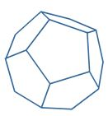  - Students could play the planarity game to reinforce drawing graphs with vertices and edges  - Students could also complete the Vax activity that looks at the spread of disease by representing human contact as networks.  - Students could also investigate the travelling salesperson problem where they have to visit each town once and return to their starting position.
Constructing networks  (2 lessons) | N1.1: Networks  - identify and use network terminology: vertices, edges, paths, the degree of a vertex, directed networks and weighted edges | Defining the key terms  - Students need to develop an understanding of the essential terms and ideas involved in this unit such as vertices, edges, paths, degree of a vertex, directed networks and weighted edges. Teachers are encouraged to adapt the resource by removing the diagrams and have students construct their own using the descriptions.  - Resource: networks-glossary.DOCX  Construction of networks  - Students could read the article Meet the Sydney train enthusiasts on the fast track for the all stations record to reinforce the idea of travelling along each edge in a network. Students could label the graph of the Sydney rail network using the key terms vertex, edge, paths and degree of vertex.  - Students may also consider the Qantas domestic routes as a network diagram.  - Students could also complete the simply graphs activity, where they look at a number of networks and use network terminology to decide what they have in common  - Students need to be able to complete basic activities such as “Draw a graph with $x$ vertices and $y$ edges”. Teachers need to lead students to an understanding that a network needs enough edges to be connected. Resource: Trees – activities in minimumum-spanning-trees.DOCX  - Extension: Students to watch Inside the beach house connecting the world's internet and investigate why global internet networks continue to operate even when a significant link has been severed. Teacher to lead students into an understanding of “redundancies” and backup systems in the event of failure.  Related resources:  - Ships did not cut internet cables – news article, Egypt (ABC),  - The internet’s undersea world – a map showing the location of communication cables under the ocean  Supplementary materials  - Graph theory notes (AMSI Maths Modules)  - Talking Walks, Delivering Mail: An introduction to graph theory including teacher and student notes  NESA exemplar questions  - Model the following house plan as a network, showing doors (doorways) as edges and the rooms as vertices.  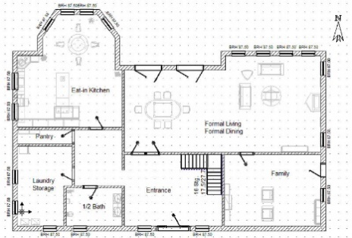  - Draw a network diagram to illustrate the following table:  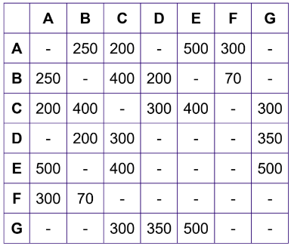  Resource: ms-n1-nesa-exemplar-solutions.DOCX
Apply network theory to real life contexts (3 lessons) | - solve problems involving network diagrams AAM  - recognise circumstances in which networks could be used, eg the cost of connecting various locations on a university campus with computer cables  - given a map, draw a network to represent the map, eg travel times for the stages of a planned journey | Solving problems involving network diagrams  - Students need to be able to translate between a real-world problem and network diagram with vertices and weighted and/or directed edges.  - Students need to be able to read and interpret a table.  - Students could create a network diagram that represents a situation that they are familiar with. For example: cost of cabling between buildings, distances between towns, times between train stations, power lines leaving a power station, water leaving a water treatment plant, gas leaving a gas station or planes leaving an airport.  - Students could create a map of their local area using Six Maps; identifying less than ten places of interest and the distances between them. They then translate this information into a graph and discuss situations in which it would be beneficial to use this type of representation.  - Students could plan the shortest route for the Olympic torch tour using a distance chart/table to create a network diagram.  - Are all people on Earth really connected through just six steps? Students watch the video Science of six degrees of separation to see the science behind this theory  - Students could watch the video on Networks, mathematics and rival factions to see the theory of social networks and how they allow us to mathematically model and analyse the relationships between governments, organisations and even the rival factions warring on Game of Thrones.  - Students could consider the article Accounting for Computer Scientists which uses networks to explain accounts and transactions.  - Students could solve problems using maps or network diagrams  Resource: Using a map or network diagram, solving-problems-involving-networks.DOCX
Drawing a network diagram from a table  (1 lesson) | - solve problems involving network diagrams AAM  - draw a network diagram to represent information given in a table | Drawing a network diagram from a table  - Students could solve problems using tables to draw networks  Resource: Australian driving distances, solving-problems-involving-networks.DOCX
Find the minimum spanning tree for a network (2 lessons) | N1.2 Shortest paths  - determine the minimum spanning tree of a given network with weighted edges AAM  - determine the minimum spanning tree by using Kruskal’s or Prim’s algorithms or by inspection  - determine the definition of a tree and a minimum spanning tree for a given network | Investigating minimum connections between vertices  - Driving question – What is the cheapest (minimum) way to link vertices? Links could be roads or telegraph cables or global computer networks or train tracks. Vertices could be cities, houses or businesses, for example.  - Students to complete the muddy city problem to introduce the idea of creating a minimum spanning tree to connect all vertices.  - Allow students to develop their own ideas/algorithms for a variety of network diagrams.  Resources: muddy-city-problem.DOCX; minimum-spanning-trees.DOCX  Using algorithms  - What is an algorithm? Students could pair up. One closes their eyes and the other provides a set of instructions in order to move their partner across the room, one step at a time. This activity provides an opportunity for students to experience the concept of an algorithm and can lead into a discussion about them.  - Teacher to demonstrate Kruskal’s and Prim’s algorithms to solve minimum spanning tree problems. Connect these to any strategies students have previously discovered from their earlier investigations. Students practise using these algorithms.  - Resource: Prim’s and Kruskal’s geogebra applet, prims-and-kruskals-algorithms.DOCX, Kruskal’s algorithm in 2 minutes (to 1:24), Prim’s algorithm in 2 minutes (to 1:54)  NESA exemplar questions  - For the following network:  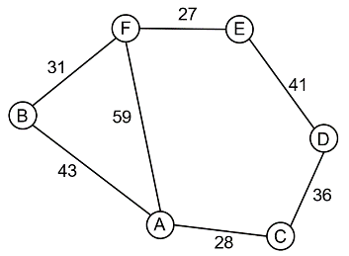  - Find all possible spanning trees  - Which of the spanning trees has the minimum weight?  - Use Prim’s algorithm, starting with vertex A, to find the minimum spanning tree.  - Show that Kruskal’s algorithm produces the same minimum spanning tree as Prim’s algorithm.  - Consider the following network:  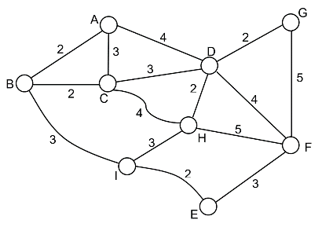  - Find the minimum spanning tree.  - Find the length of the shortest path from A to E in the network.  - The following table shows the travelling times in minutes between towns which are connected directly to each other. Note: The dash in a box indicates that towns are not directly to each other:  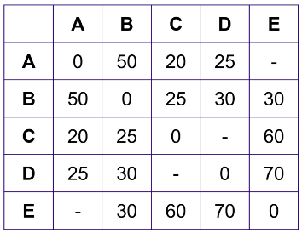  - Draw a network diagram showing the information on this table  - Find the shortest travelling time between A and E  Resource: ms-n1-nesa-exemplar-solutions.DOCX
Find the shortest path from one vertex to another. (Note: Leads onto critical path analysis in MS-N3)  (2 lessons) | - find a shortest path from one place to another in a network with no more than 10 vertices AAM  - identify the shortest path on a network diagram  - recognise a circumstance in which a shortest path is not necessarily the best path or contained in any minimum spanning tree | Finding the shortest path  - Teacher discusses with students what constitutes the shortest path? Is ‘shortest’ the best word? Could it also be replaced with cheapest? Or lightest? Is the shortest path always the quickest?  - More formally, the shortest path refers to the shortest distance between two vertices. It does not necessarily imply that all vertices are visited. It does not always refer to the shortest distance in length, it could also refer to the cheapest route/path or quickest route.  - Students to investigate the cheapest way to travel between two cities considering various forms of transport e.g. Sydney to Dubbo via car, plane, public transport, Uber, etc. Each weighted edge represents the cost of a link. Each node/vertex represents a different town/station/airport.  - Students to find the fastest way to get to the ten closest sporting fields/parks/places of interest to their home. Students to consider if any of these paths are unrealistic or less desirable at different times of the day or year e.g. muddy when it rains  - To find the shortest path between A and B in a network:  - Step 1 – For all vertices one step away from A, write down the smallest number. If two vertices are equidistant from A, then follow both pathways.  - Step 2 – For all vertices two steps away from A, write down the smallest number and continue on that pathway.  - Step 3 – Repeat until B is reached and then add up the numbers.  Example  - In the 2x2cm grid, find the number of shortest paths that exist.  - Find the shortest path from the hall to the basketball court in the network diagram below:  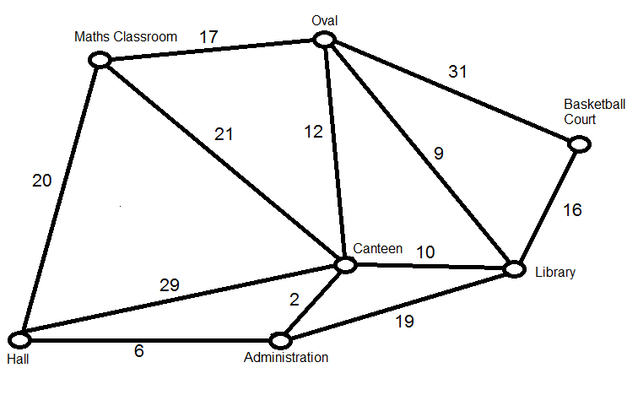  - Discuss circumstances for the school network example where the shortest path is not necessarily the best path. For example, the oval in wet weather could be too wet, some of the pathways could not be undercover and wouldn’t be suitable in rain, and so forth.  - Students could consider Dijkstra’s algorithm as a strategy for determining the shortest path, though this terminology is not used in the syllabus.  Resource: Shortest path geogebra applet, shortest-path.DOCX

Reflection and evaluation
Please include feedback about the engagement of the students and the difficulty of the content included in this section. You may also refer to the sequencing of the lessons and the placement of the topic within the scope and sequence. All information and communications technology (ICT), literacy, numeracy and group activities should be recorded in the ‘Comments, feedback, additional resources used’ section.

