The muddy city problem
Once upon a time there was a city that had no roads. Getting around the city was particularly difficult after rainstorms because the ground became very muddy—cars got stuck in the mud and people got their boots dirty. The mayor of the city decided that some of the streets must be paved, but didn’t want to spend more money than necessary because the city also wanted to build a swimming pool.
The mayor therefore specified two conditions:
- Enough streets must be paved so that it is possible for everyone to travel from their house to anyone else’s house only along paved roads, and
- The paving should cost as little as possible.
Here is the layout of the city. The number of paving stones between each house represents the cost of paving that route. Find the best route that connects all the houses, but uses as few paving stones as possible.
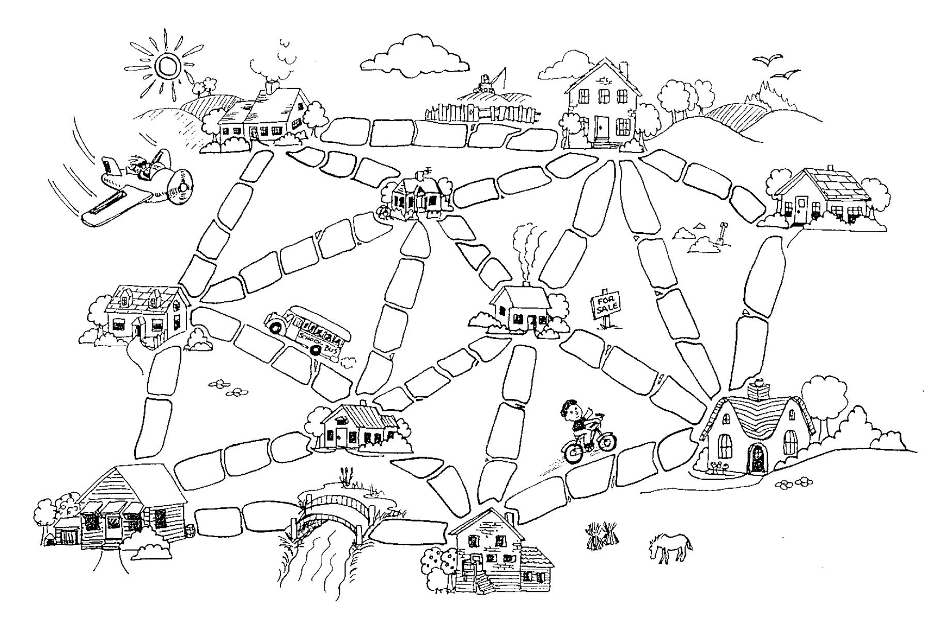
Source: CS Unplugged

Sample solution: The minimum number of paving stones required is 23. This is obtained from the minimum spanning tree. Note: There are other equivalent minimum spanning trees.
Network diagram:
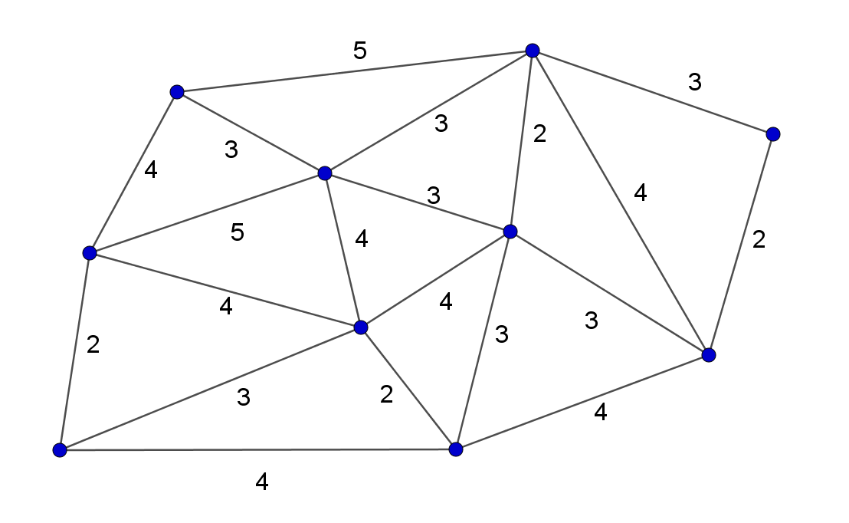
Minimum spanning tree:
