How-to guide: Desmos lines of best fit by eye

Part 1: Making a scatterplot
- Enter your data into Desmos.
Method 1: Press plus, then table and then manually enter data.
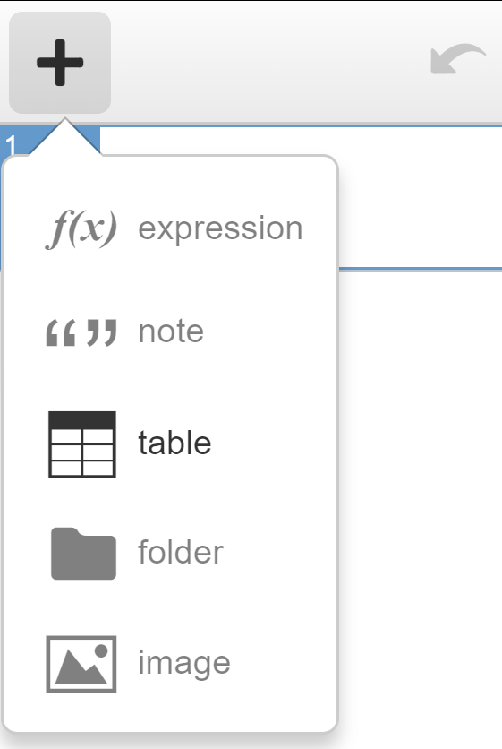
Method 2: If the data exist in a table such as in a MS Word document or MS Excel spreadsheet, copy the data and paste it into Desmos
- Click into a blank rectangle next to a number
- Press Ctrl V to paste.
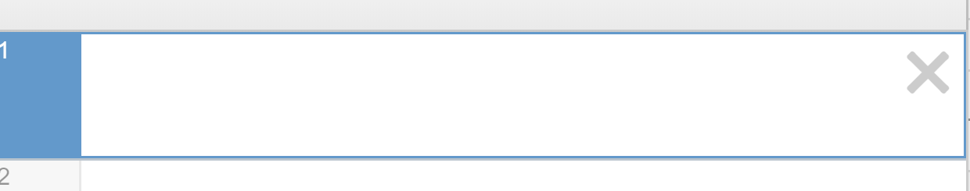
- The headers of the table can be renamed by clicking into the appropriate location.
- A scatterplot will automatically appear.
- Settings can be adjusted using the settings menu by clicking the spanner on the right hand side of the Cartesian plane.

Part 2: Fitting a line of best fit by eye using Desmos.
- Add a line. Type y=mx+c into a blank row. Select all to add sliders for m and c.
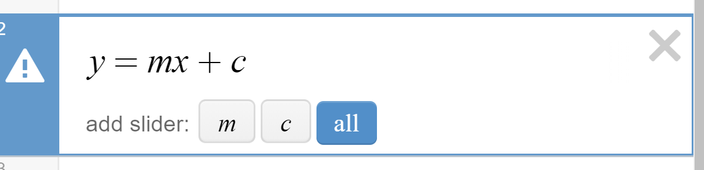
- Use the sliders for m and c to adjust the gradient and y intercept of the line until you believe it represents a line of best fit.

