MS-S4 Bivariate Data Analysis

Describing the strength of an association

Purpose
This resource can be used for two purposes:
- To examine and then identify the strength and direction of an association.
- To relate the strength and direction to a correlation coefficient.

Method
- Class discussion around whether each association is positive or negative, and then the strength of each association.
- View the correlation coefficients and see how they relate to the strength of an association.

Scatterplots
- Which is a positive association and which is a negative association?

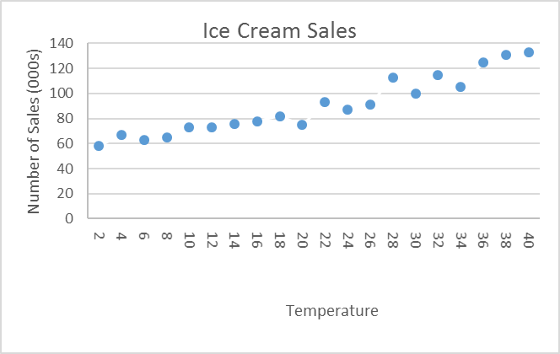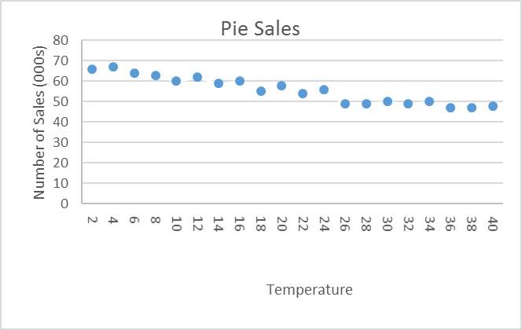
- The following have a positive association. Is it weak, moderate, strong, or perfect in strength?

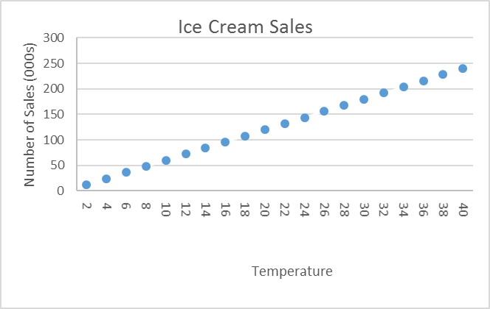
r = 1
r = 0.96
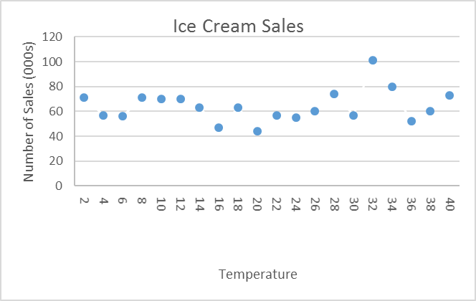
r = 0.17
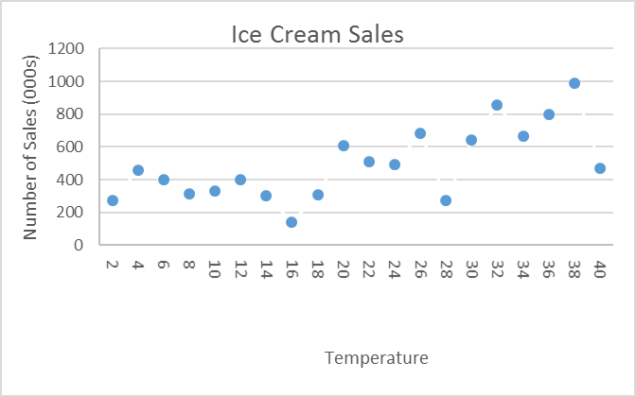
r = 0.69

- The following have a negative association. Is it weak, moderate, strong, or perfect in strength?

r = -0.96
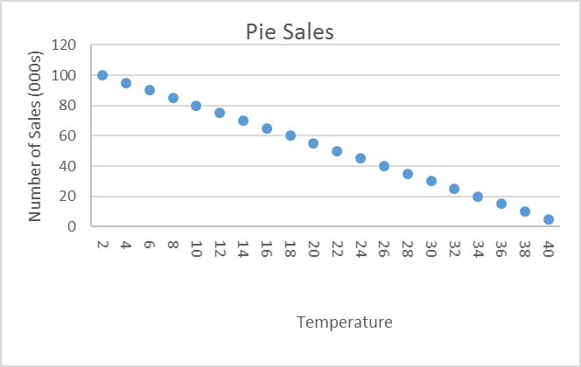
r = -1
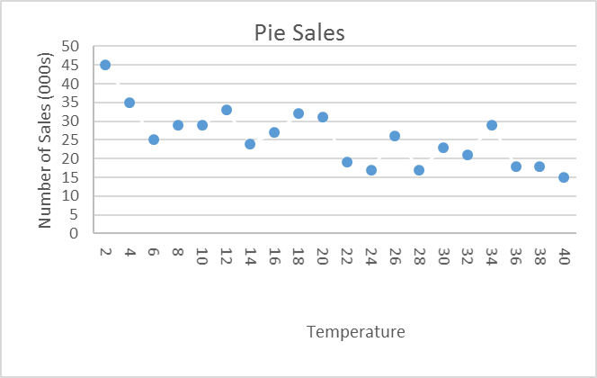
r = -0.74
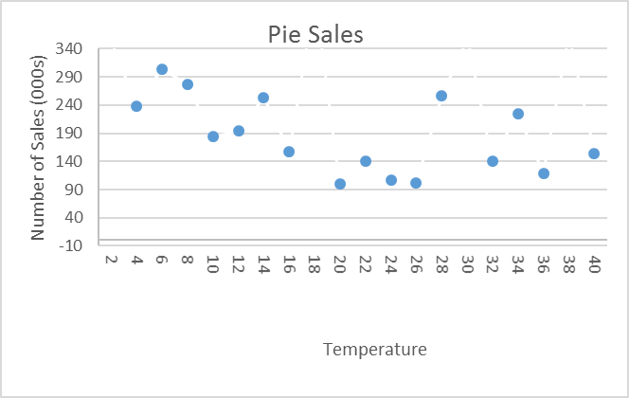
r = -0.23

