Collating data using MS Excel

Collating data
This is a how to guide on collating or tabulating data using pivot tables in MS Excel.
The guide refers to the MS Excel file sample-collating-data.XLSX

Make a blank pivot table
Select the data you wish to collate or tabulate. Left click A2, press and hold ctrl and shift then press the down arrow followed by the right arrow.
Insert a pivot table. Click insert, PivotTable, then ok.
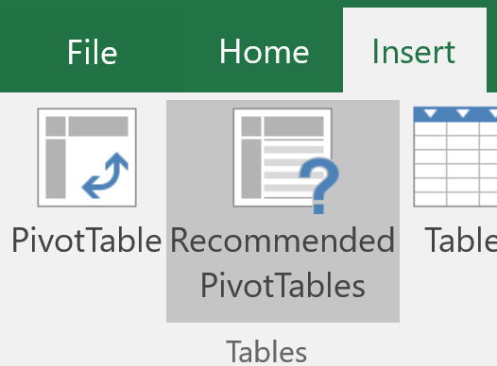
This will insert the pivot table into a new worksheet.
Now you can refer to the appropriate method for your data i.e. categorical data, ungrouped data and grouped data.

Categorical data:
Select the desired data using the PivotTable Fields.
For example, if you wanted to count the number of people that travel to school by by bus, rail, car etc. you would left click and drag the option Travel_to_school, into the
  - Rows area. This will make our row labels the method of transport.
  - Values area. This will add the frequency (count) of each method.
Note: If the Values section doesn’t default to count, select it by left clicking the down arrow in the field then selecting Value Field Settings

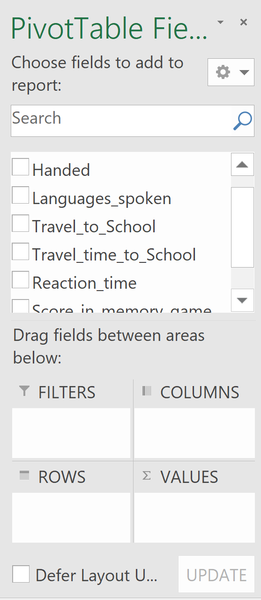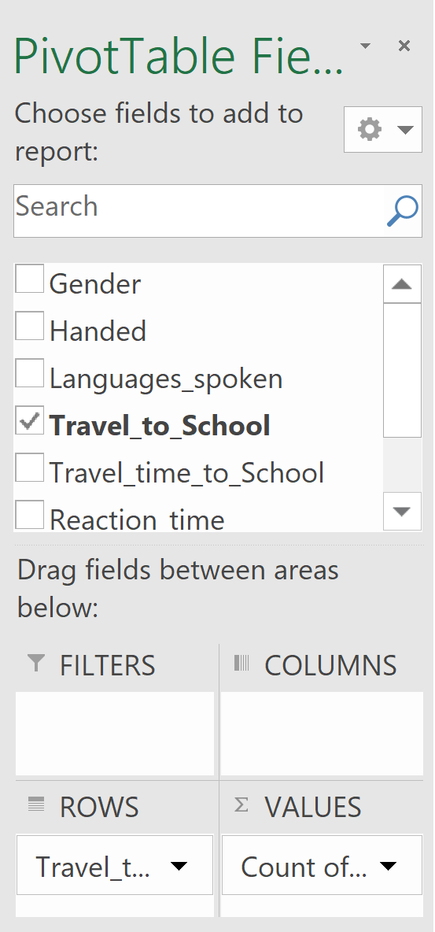
You should now have tabulated data:
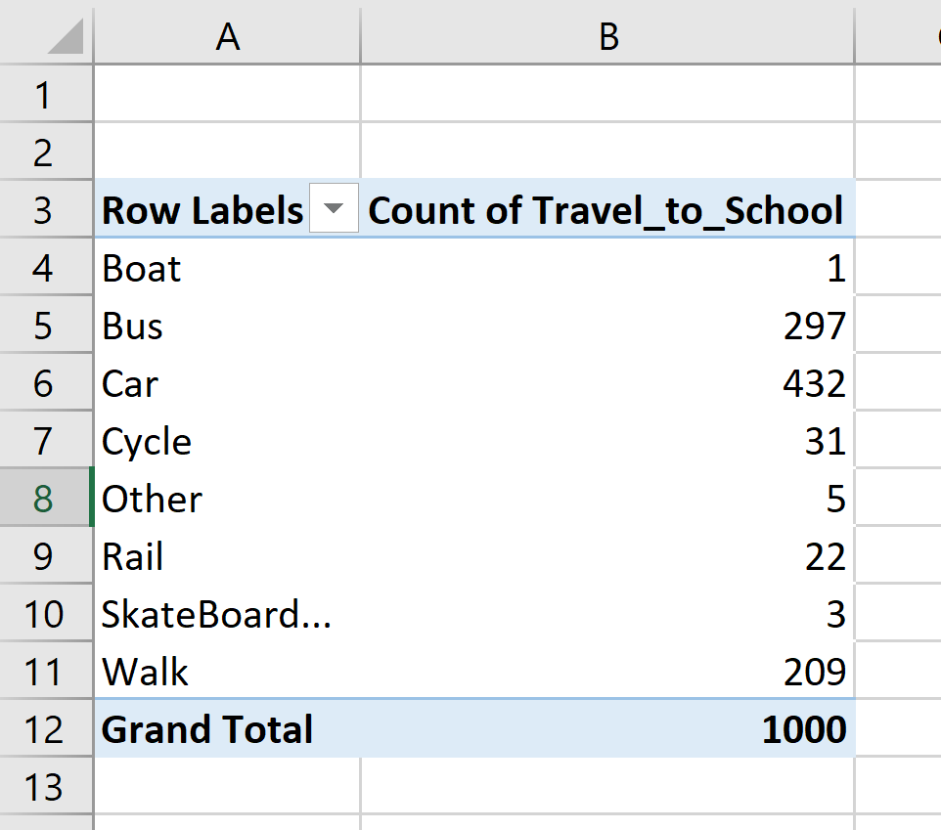

Ungrouped data:
Select the desired data using the PivotTable Fields.
For example, if you wanted to count the number of people that speak 1, 2, 3 etc languages, you would left click and drag the option Languages_spoken into
  - Rows area. This will make our row labels the number of languages spoken.
  - Values area. This will add the frequency (count).
Note: If the Values section doesn’t default to count, select it by left clicking the down arrow in the field then selecting Value Field Settings
You should now have tabulated data:
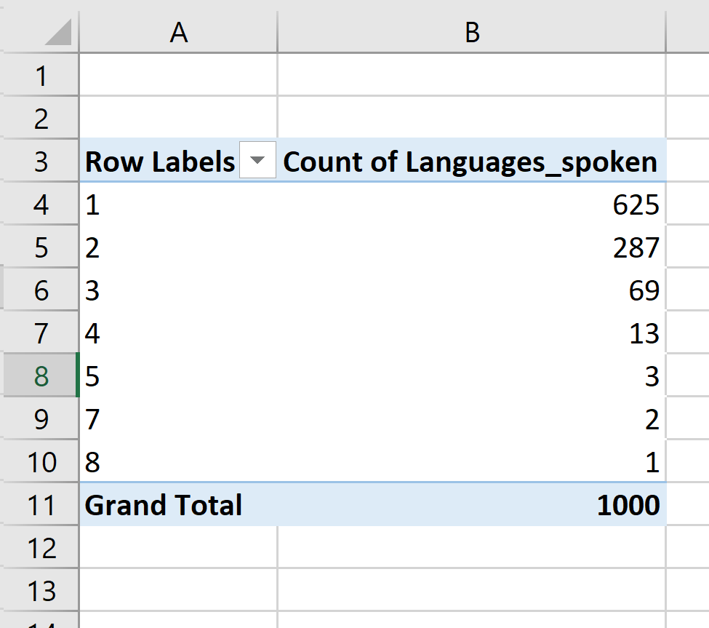

Grouped data:
Select the desired data using the PivotTable Fields.
For example, if you wanted to look at the proportion of people who travel for 0 to <10 minutes, 10 to <20 minutes… to get to school you would left click and drag the option Travel_time_to_School into
  - Rows area. This will make our row labels the Travel_time_to_School.
  - Values area. This will add the frequency (count).
Note: If the Values section doesn’t default to count, select it by left clicking the down arrow in the field then selecting Value Field Settings
You will notice that the data is not grouped. To group the data left click into the row label column, select Analyze then Group Field.
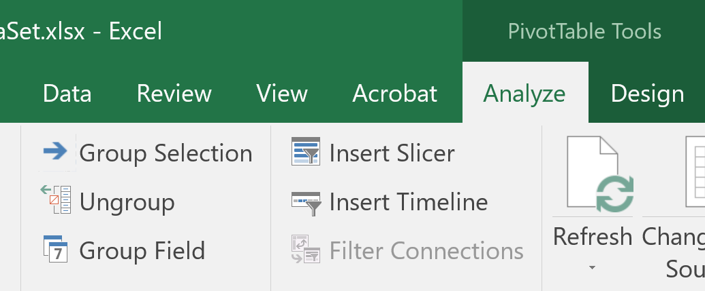
Select the desired group sizes, then ok,
You should now have tabulated data:
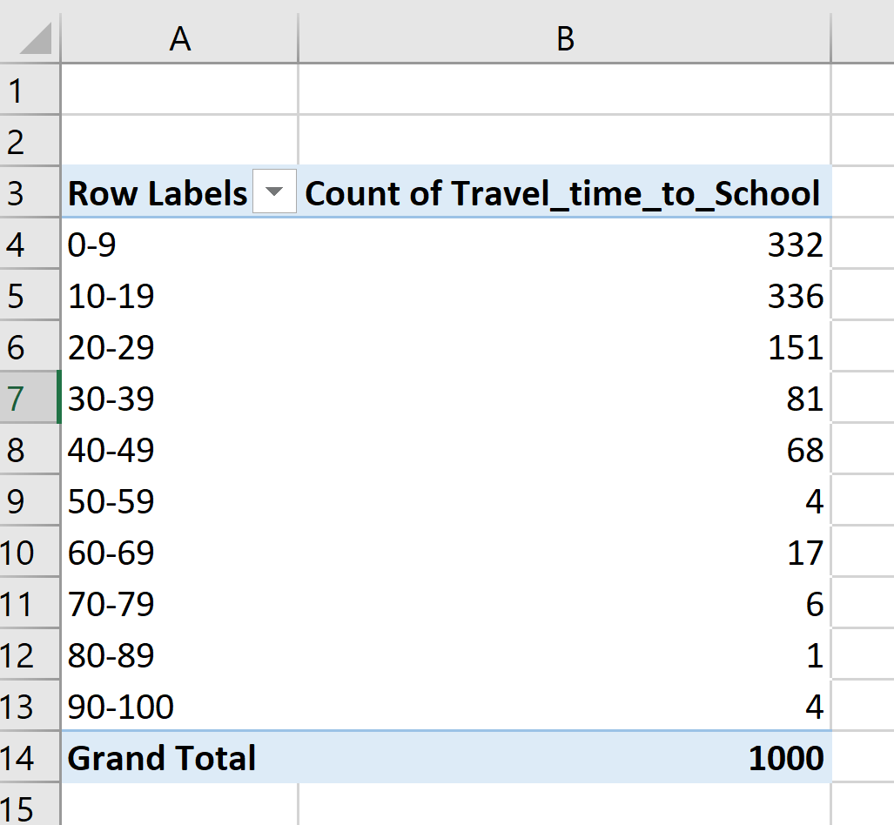

Grouped data:
Some graphs cannot be made directly from a Pivot Table.
Copy the table (ctrl c) and then paste values (right click then 123). You can now manipulate this data.

