Simplifying surds hexagon jigsaw
Cut out each of the triangles. Shuffle the pieces and match the sides of the triangles using equivalent expressions.
Note: this resource was created using Tarsia software. You can download the free software using the following link: http://www.mmlsoft.com/index.php/products/tarsia
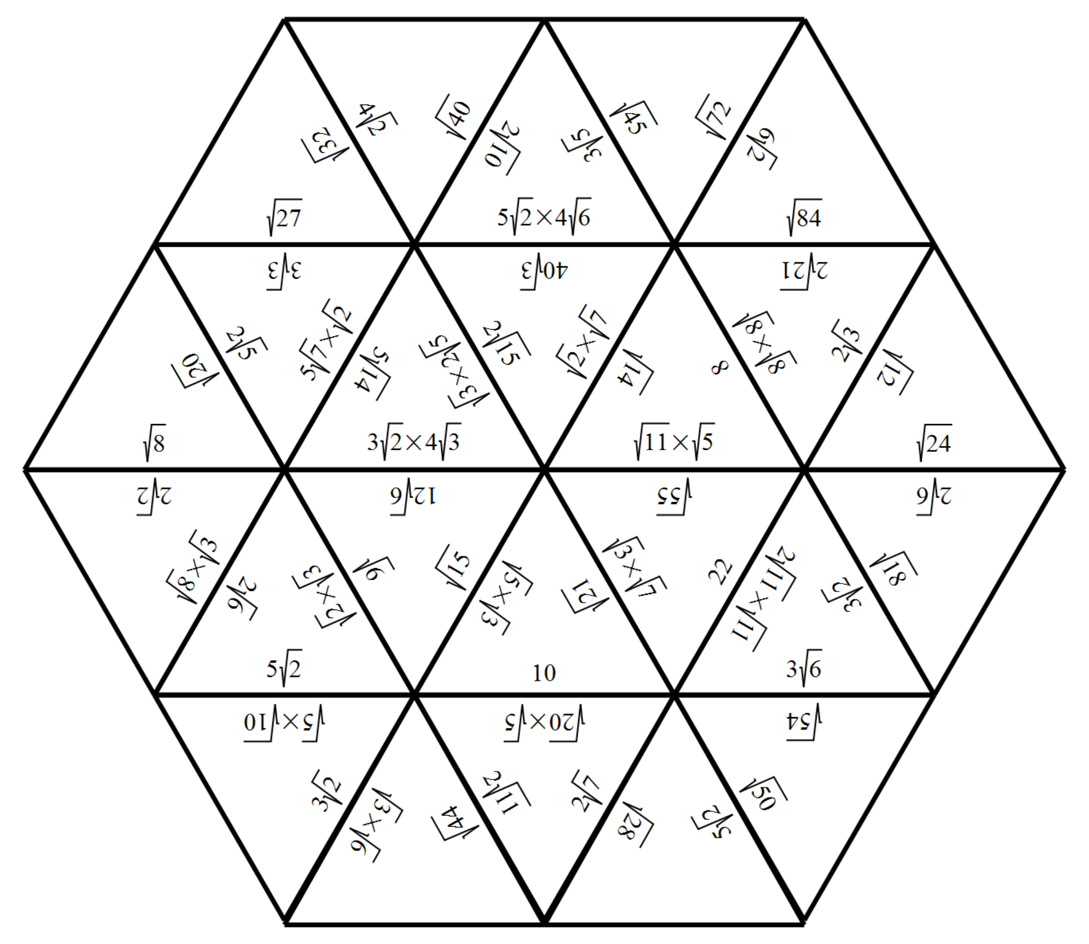

Outcome
Performs operations with surds and indices. MA5.3-6NA

