Trigonometry – goal free problems

Your task
Determine as much information as you can about every side and angle from each of the diagrams below.
- 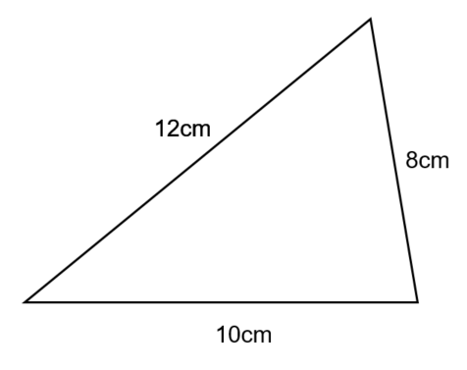

- 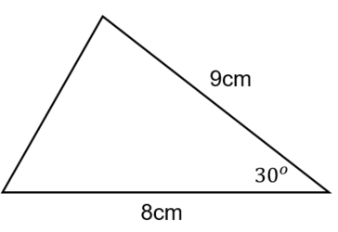

- 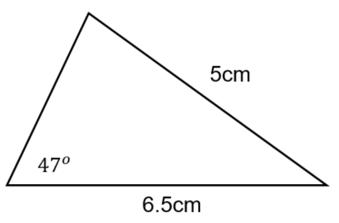

- 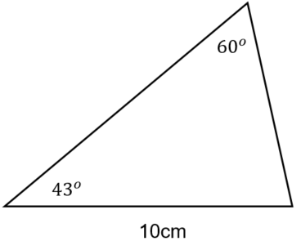
- 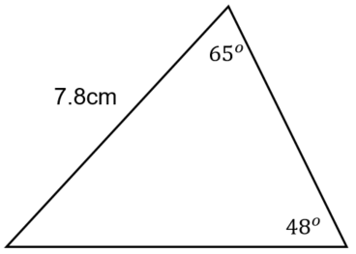

- 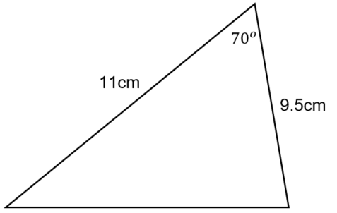

- 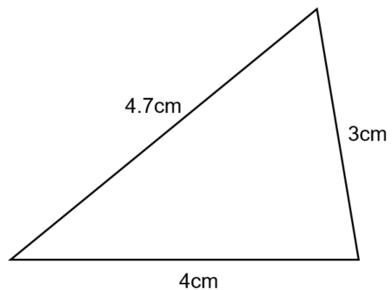

- 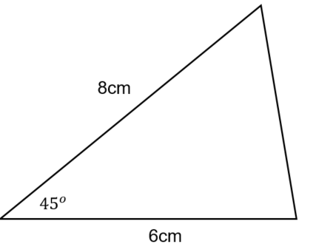

Outcomes
- generalises mathematical ideas and techniques to analyse and solve problems efficiently MA5.3-2WM
- uses deductive reasoning in presenting arguments and formal proofs MA5.3-3WM
- applies Pythagoras’ theorem, trigonometric relationships, the sine rule, the cosine rule and the area rule to solve problems, including problems involving three dimensions MA5.3-15MG

