Non-linear graphs

The parabola

Optional internet activities

Will it hit the hoop?
Go to http://student.desmos.com
- Enter the class code <teacher insert class code> and hit the join button.
- Hit “Continue without signing in”.
- Please enter your first name.
- Work through the activities.

Polygraph: Parabolas Part 2
- Enter the class code <teacher insert class code>
- And hit the join button
- Continue without signing in again
- Complete the definitions below.

Definitions
Complete the sentences using the following terms: axis of symmetry, concave up, concave down, vertex, x-intercept, y-intercept, intercept, maximum, minimum and turning point

- The _________________________ or _______________________ of a parabola is the highest or lowest point.

- A ________________________ parabola looks like a smile.

- A ________________________ parabola looks like a frown.

- The point where the parabola crosses the axes is called an _______________________.

- The point where the parabola crosses the y-axis is called the ______________________

- The point(s) where the parabola crosses the x-axis is called the ______________________

- The ____________________________________ cuts the parabola in half.

Positive coefficients of $x^{2}$
- Complete the tables of values and plot points on the opposite page. Use a different colour pen for each graph and clearly label your graph. If you have access to graphing software, you could complete these activities by entering the equations and looking at the graphs.
  - $y=x^{2}$

x | $$-3$$ | $$-2$$ | $$-1$$ | 0 | 1 | 2 | 3
y

  - $y=2x^{2}$

x | $$-3$$ | $$-2$$ | $$-1$$ | 0 | 1 | 2 | 3
y

  - $y=3x^{2}$

x | $$-2$$ | $$-1$$ | 0 | 1 | 2
y

  - $y=4x^{2}$

x | $$-2$$ | $$-1$$ | $$-0.5$$ | 0 | 0.5 | 1 | 2
y

  - $y=\frac{1}{2}x^{2}$

x | $$-6$$ | $$-4$$ | $$-2$$ | 0 | 2 | 4 | 6
y

  - $y=\frac{1}{4}x^{2}$

x | $$-6$$ | $$-4$$ | $$-2$$ | 0 | 2 | 4 | 6
y

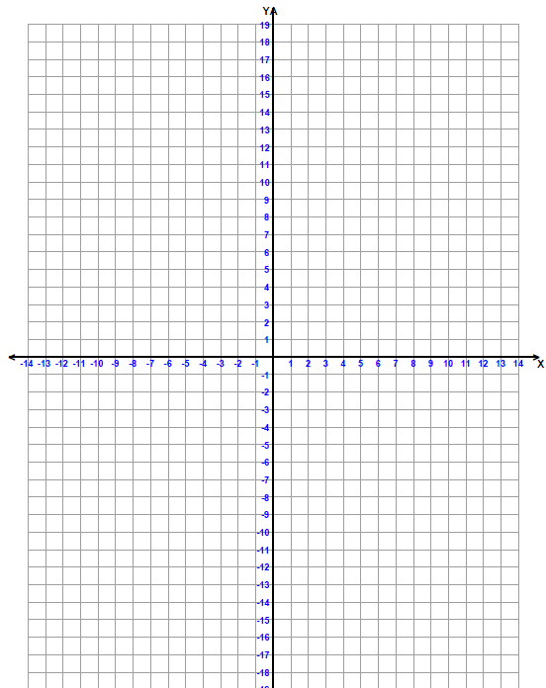

- For the graphs you drew:

  - Which curve appears most wide and flat? ____________________

  - Which curve appears the most narrow and steep? ____________________

  - What is their common vertex ? ____________________

  - Are the curves pointing up or down? ____________________

- Write a sentence that explains how the graphs change as the co-efficient of $x^{2}$ changes.

__________________________________________________________________________

__________________________________________________________________________

Negative coefficients of $x^{2}$
- Complete the tables of values and plot points on the opposite page. Use a different colour pen for each graph and clearly label your graph.

  - $y=-x^{2}$

x | $$-3$$ | $$-2$$ | $$-1$$ | 0 | 1 | 2 | 3
y

  - $y=-2x^{2}$

x | $$-3$$ | $$-2$$ | $$-1$$ | 0 | 1 | 2 | 3
y

  - $y=-3x^{2}$

x | $$-2$$ | $$-1$$ | 0 | 1 | 2
y

  - $y=-4x^{2}$

x | $$-2$$ | $$-1$$ | $$-0.5$$ | 0 | 0.5 | 1 | 2
y

- For the graphs you drew:

  - Which curve appears most wide and flat? ____________________

  - Which curve appears the most narrow and steep? ____________________

  - What is their common vertex ? ____________________

  - Are the curves pointing up or down? ____________________

- Write a sentence explaining how the graph changes when the coefficient is a negative number.

________________________________________________________________________

_________________________________________________________________________

Adding a constant term

- Complete the tables of values and plot points on the opposite page. Use a different colour pen for each graph and clearly label your graph.
  - $y=x^{2}$

x | $$-3$$ | $$-2$$ | $$-1$$ | 0 | 1 | 2 | 3
y

  - $y=x^{2}+1$

x | $$-3$$ | $$-2$$ | $$-1$$ | 0 | 1 | 2 | 3
y

  - $y=x^{2}+3$

x | $$-3$$ | $$-2$$ | $$-1$$ | 0 | 1 | 2 | 3
y

  - $y=x^{2}+5$

x | $$-3$$ | $$-2$$ | $$-1$$ | 0 | 1 | 2 | 3
y

  - $y=x^{2}-2$

x | $$-3$$ | $$-2$$ | $$-1$$ | 0 | 1 | 2 | 3
y

  - $y=x^{2}-3$

x | $$-3$$ | $$-2$$ | $$-1$$ | 0 | 1 | 2 | 3
y

- Write a description to explain what the graphs have in common.

__________________________________________________________________________

__________________________________________________________________________

- How are the graphs different?

__________________________________________________________________________

__________________________________________________________________________

- Write a sentence to describe the effect of the constant term on the shape and position of the parabola.

_________________________________________________________________________

__________________________________________________________________________

Definition
Use Google or a dictionary to find a mathematical definition for:

Translation
_____________________________________________________________________________

Optional internet activities

Polygraph: Parabolas
- Go to http://student.desmos.com
- Enter the class code <teacher insert class code> and hit the join button.
- Hit “Continue without signing in”.
- Please enter your first name.
- Use your new terminology to play this game with your friends.

Mixed questions
1) Write the missing features for each graph.
a) | 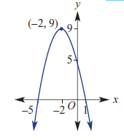 | (i) | The parabola has a ________________ turning point.
 |  | (ii) | The co-ordinates of the vertex are __________.
 |  | (iii) | The y-intercept is $y=__________$
 |  | (iv) | The x-intercepts are $x=_________$ and $x=_________$
 |  | (v) | The axis of symmetry has equation _____________
b) | 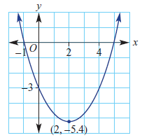 | (i) | The parabola has a ________________ turning point.
 |  | (ii) | The co-ordinates of the vertex are __________.
 |  | (iii) | The y-intercept is $y=__________$
 |  | (iv) | The x-intercepts are $x=_________$ and $x=_________$
 |  | (v) | The axis of symmetry has equation _____________

c) | 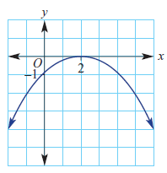 | (i) | The parabola has a ________________ turning point.
 |  | (ii) | The co-ordinates of the vertex are __________.
 |  | (iii) | The y-intercept is $y=__________$
 |  | (iv) | The x-intercepts are $x=_________$ and $x=_________$
 |  | (v) | The axis of symmetry has equation _____________
d) | 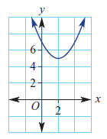 | (i) | The parabola has a ________________ turning point.
 |  | (ii) | The co-ordinates of the vertex are __________.
 |  | (iii) | The y-intercept is $y=__________$
 |  | (iv) | The x-intercepts are $x=_________$ and $x=_________$
 |  | (v) | The axis of symmetry has equation _____________

e) | 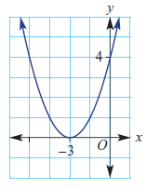 | (i) | The parabola has a ________________ turning point.
 |  | (ii) | The co-ordinates of the vertex are __________.
 |  | (iii) | The y-intercept is $y=__________$
 |  | (iv) | The x-intercepts are $x=_________$ and $x=_________$
 |  | (v) | The axis of symmetry has equation _____________

f) | 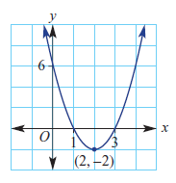 | (i) | The parabola has a ________________ turning point.
 |  | (ii) | The co-ordinates of the vertex are __________.
 |  | (iii) | The y-intercept is $y=__________$
 |  | (iv) | The x-intercepts are $x=_________$ and $x=_________$
 |  | (v) | The axis of symmetry has equation _____________

g) | 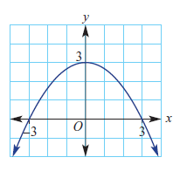 | (i) | The parabola has a ________________ turning point.
 |  | (ii) | The co-ordinates of the vertex are __________.
 |  | (iii) | The y-intercept is $y=__________$
 |  | (iv) | The x-intercepts are $x=_________$ and $x=_________$
 |  | (v) | The axis of symmetry has equation _____________

The cubic function

Sketching cubics
- Complete the tables of values and plot points on the opposite page. Use a different colour pen for each graph and clearly label your graph.
  - $y=x^{3}$

x | $$-2$$ | $$-1$$ | 0 | 1 | 2
y

  - $y=-x^{3}$

x | $$-2$$ | $$-1$$ | 0 | 1 | 2
y

  - $y=2x^{3}$

x | $$-2$$ | $$-1$$ | 0 | 1 | 2
y

  - $y=x^{3}+3$

x | $$-2$$ | $$-1$$ | 0 | 1 | 2
y

  - $y=x^{3}-1$

x | $$-2$$ | $$-1$$ | 0 | 1 | 2
y

Optional internet activities

Polygraph cubics
- Go to http://student.desmos.com
- Enter the class code <teacher to enter the class code> and hit the join button.
- Hit “Continue without signing in”.
- Please enter your first name.
- Complete the questions.

The exponential function

Polygraph: Exponentials
- Go to http://student.desmos.com
- Enter the class code <teacher to insert class code> and hit the join button.
- Hit “Continue without signing in”.
- Please enter your first name.
- Complete the questions.

Evaluating exponential expressions

- Evaluate:
  - $2^{0}$ ______________
  - $2^{1}$ ______________
  - $2^{4}$ ______________
  - $3^{0}$ ______________
  - $3^{1}$ ______________
  - $3^{3}$ ______________
  - $4^{0}$ ______________
  - $4^{2}$ ______________
  - $5^{0}$ ______________
  - $5^{2}$ ______________

Sketching exponential functions
Complete the tables of values and plot points on the opposite page. Use a different colour pen for each graph and clearly label your graph.
a) $y=3^{x}$
x | $$-2$$ | $$-1$$ | 0 | 1 | 2
y

b) $y=2^{x}$
x | $$-2$$ | $$-1$$ | 0 | 1 | 2
y

c) $y=4^{x}$
x | $$-2$$ | $$-1$$ | 0 | 1 | 2
y

d) $y=-2$
x | $$-2$$ | $$-1$$ | 0 | 1 | 2
y

e) $y=-3^{x}$
x | $$-2$$ | $$-1$$ | 0 | 1 | 2
y

Extension
Now that you have explored the graphs of above. Apply similar principles to investigate the graphs mentioned below. Use desmos.com to draw graphs of the following:

Absolute Value
$$y=|x|$$
Try investigating expressions of the following form:
- Multiplying the absolute value by a number eg $y=2|x|$
- Adding a number to the absolute value expression eg $y=|x|+1$ and
- Adding a number within the absolute value expression eg $y=|x+1|$.

What effect do these have on the graph?

Circle
$$x^{2} + y^{2} = 1$$
Try investigating expressions of the following form:
- Try using different numbers to replace the 1
- Try putting numbers in a bracket with the x eg ${\left(x+1\right)}^{2}+y^{2} = 1$
- Similarly, try putting numbers in a bracket with the y.

What effect do these numbers have on your circle?

Trigonometry graphs
$$y=sinx$$
$$y=cosx$$
$$y=tanx$$
Try investigating expressions of the following form:
- Try putting numbers in front of the sin, cos or tan eg $y=2sinx$
- Try adding or subtracting numbers on the end, after the $sinx$, $cosx$ or $tanx$
eg $y=sinx + 1$

What effect do these have on the graph?

Outcomes
- MA5.2-1WM selects appropriate notations and conventions to communicate mathematical ideas and solutions
- MA5.2-3WM constructs arguments to prove and justify results
- MA5.2-10NA connects algebraic and graphical representations of simple non-linear relationships
- MA5.3-1WM uses and interprets formal definitions and generalisations when explaining solutions and/or conjectures
- MA5.3-3WM uses deductive reasoning in presenting arguments and formal proofs
- MA5.3-9NA sketches and interprets a variety of non-linear relationships

