Trigonometry – goal free problem

Your task

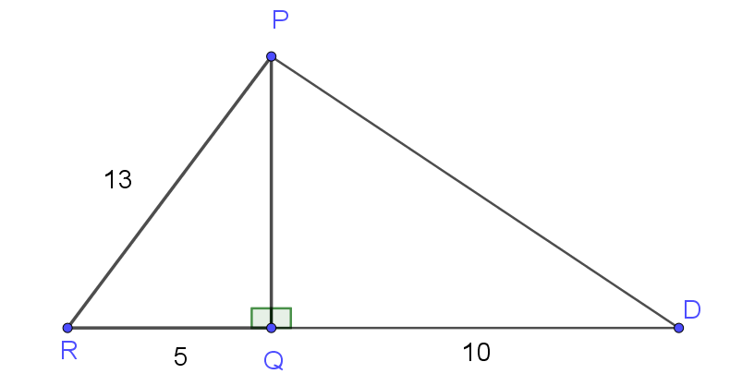
The diagram above shows two right angle triangles. Work out or calculate as much information as you can from the diagram.

Outcome
Applies trigonometry, given diagrams, to solve problems, including problems involving angles of elevation and depression MA5.1-10MG
All outcomes referred to in this unit come from Mathematics K-10 Syllabus © NSW Education Standards Authority (NESA) for and on behalf of the Crown in right of the State of New South Wales, 2012

