Mathematics Stage 5

Designing a greenhouse
This document references the Mathematics K-10 Syllabus© NSW Education Standards Authority (NESA) for and on behalf of the Crown in the right of the State of New South Wales, 2012

Assessment task
Area and Surface area; Volume; Trigonometry and Pythagoras’ Theorem; Properties of Geometrical Figures

Driving questions
Designing a greenhouse

Outcomes
- MA4-7NA operates with ratios and rates, and explores their graphical representation
- MA4-13MG uses formulas to calculate the areas of quadrilaterals and circles, and converts between units of area
- MA5.1-11MG describes and applies the properties of similar figures and scale drawings
- MA5.2-11MG calculates the surface areas of right prisms, cylinders and related composite solids
- MA5.2-12MG applies formulas to calculate the volumes of composite solids composed of right prisms and cylinders
- MA5.3-13MG applies formulas to find the surface areas of right pyramids, right cones, spheres and related composite solids
- MA5.3-14MG applies formulas to find the volumes of right pyramids, right cones, spheres and related composite solids
- MA5.3-15MG applies Pythagoras’ theorem, trigonometric relationships, the sine rule, the cosine rule and the area rule to solve problems, including problems involving three dimensions
- MA5.3-1WM uses and interprets formal definitions and generalisations when explaining solutions and/or conjectures
- MA5.3-2WM generalises mathematical ideas and techniques to analyse and solve problems efficiently
- MA5.3-3WM uses deductive reasoning in presenting arguments and formal proofs

Learning across the curriculum

Cross-curriculum priorities
- Sustainability

General capabilities
- Critical and creative thinking
- Ethical understanding
- Information and communication technology capability
- Intercultural understanding
- Literacy
- Numeracy
- Personal and social capability

Other areas of learning
- Civics and citizenship
- Difference and diversity
- Work and enterprise

Task
To avoid contact with the supermarket, your family has decided to build a greenhouse in your backyard to grow as much of your own food as possible.
A green house (also called a glasshouse) is a structure with walls and roof made chiefly of transparent material, such as glass, in which plants requiring regulated climatic conditions are grown. The interior of a greenhouse, exposed to sunlight, becomes significantly warmer than the external temperature, protecting its contents in cold weather.
Your task will be to design a greenhouse suitable for your family and backyard.

Part 1 - Your investigation
Before you start your own design you decide to investigate one of the most famous glass structures of all times, the Louvre Pyramid. The Louvre Pyramid is a large glass and metal pyramid designed by Chinese-American architect I. M. Pei. The large pyramid serves as the main entrance to the Louvre Museum. It was completed in 1989 and has become a landmark of the city of Paris.
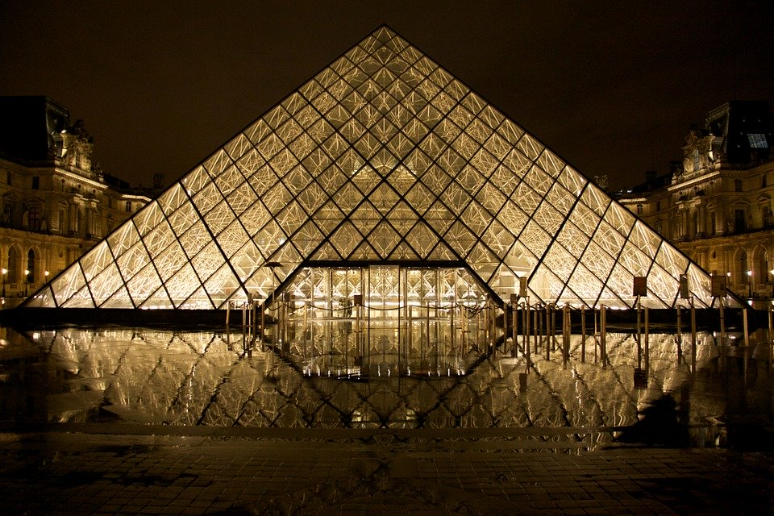
The pyramid is 21.6 m high (from apex to ground) with a 34m square base. There are 603 rhombus shapes and 70 triangular shapes.

- What are the dimensions (height and base) of each triangular face?
Hint: The height is not 21.6m!
- What is the area of each triangular face of the pyramid?
- Calculate the angle the triangular faces make with the ground.
- Find a method to determine the height and width of each rhombus. Explain your method.
- What is the area of each rhombus?
- What is the area of each small triangle?
- What are the dimensions of the door to the Louvre? What method did you use to work out your answer?
- What is the surface area of glass used in the Louvre pyramid?
- What is the volume of the Louvre?
- Use a suitable method to determine how many visitors would fit in the Louvre Pyramid. Justify your answer by explaining the method you used.

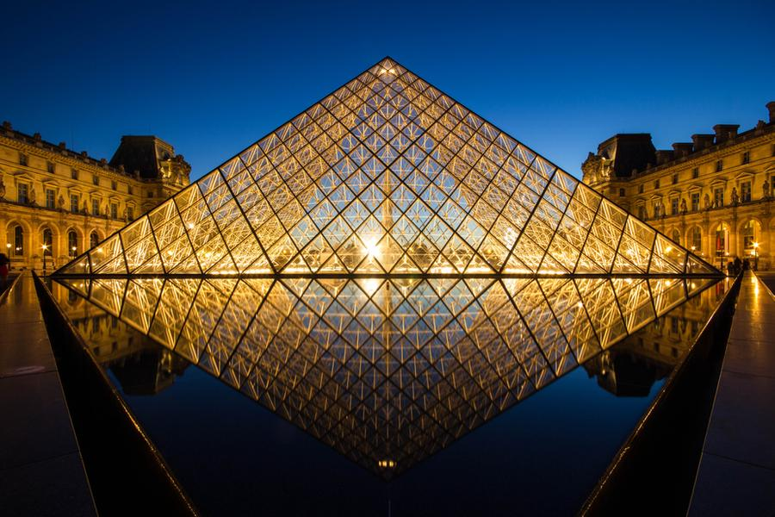

Part 2 - Designing your own Greenhouse
Using your knowledge of the size of the components used to build the Louvre, you are to design a greenhouse for your family. It does not need to look like a traditional greenhouse, be creative. It will need to fit in your backyard in a convenient location and be large enough to provide enough vegetables for your family. You may like to visit the website https://morningchores.com/vegetable-garden-size/ to help determine how much space you will require.
- Draw a 3D sketch of your design. You may like to use software such as Google Sketchup, or you could draw a neat diagram by hand.
- Draw a scaled diagram of each side and the roof of your design. Make sure you include the dimensions of all components. Again, this could be done in Google Sketchup, or neatly by hand.
- What is the overall surface area of glass you will need?
- Laminated safety glass costs about $320 per m². What will the glass cost for your glasshouse?
- What other cost considerations will you need to consider?
- What will the volume of your greenhouse be?
- Justify your design by talking about the size, volume and cost to build.

What to submit
Student should submit
- a poster, portfolio or presentation demonstrating Parts 1 and 2 above.
- photographs or image from Google Maps (or similar) showing the backyard location where the greenhouse will be built with annotations, such as measurements taken.
- 3D and 2D drawings of greenhouse design
- all calculations and reasoning fully communicated

Success Criteria
Criteria | Working towards developing | Developing | Developed | Well developed | Highly developed
Part 1 - Your investigation  Question 1  - MA5.3-15MG | Students identifies the right angled triangle needed to find the height and base of the triangular face | Student calculates the height of the triangular face using an incorrect measurement. | Student correctly calculates the height of the triangular face
Part 1 - Your investigation  Question 2, 5, 6  - MA4-13MG | Student correctly calculates the area of the triangle faces and small triangles. Possibly from incorrect measurements | Student correctly calculates the area of the triangle faces, rhombuses and small triangles
Part 1 - Your investigation  Question 3  - MA5.3-15MG | Student identifies the right angled triangle necessary to find the angle of the face with the ground. | Student calculates the angle the triangular face makes with the ground
Part 1 - Your investigation  Question 4, 7  - MA5.3-2WM |  | Student estimates the dimensions of the rhombus and door to the Louvre using a valid method | Student explains in detail a suitable method to determine the dimensions of the rhombus and door.
Part 1 - Your investigation  Question 8, 9  - MA5.2-11MG  - MA5.3-13MG  - MA5.2-12MG  - MA5.3-14MG | Student attempts to calculate the surface area and volume of the pyramid | Student correctly calculates the surface area and volume of the pyramid
Part 1 - Your investigation  Question 10  - MA5.3-1WM  - MA5.3-2WM  - MA5.3-3WM |  |  | Student provides a reasonable estimate of the number of visitors who would fit inside the Pyramid. | Student explains in detail an appropriate method to determine the number of visitors that would fit inside the Pyramid | Student justifies the number of visitors that would fit inside the Louvre, by outlining in detail an appropriate method with all necessary considerations.
Part 2 – Designing your own Greenhouse  Question 1, 2  - MA5.1-11MG | Student attempts to draw a sketch of their greenhouse showing views from different vantage points | Student attempts to draw a scaled diagram but not all sides are shown or some measurements are inaccurate. | Students draws a detailed 3D sketch of their design and accurate scale diagrams of each side of their greenhouse.
Part 2 – Designing your own Greenhouse  Question 3, 4, 6  - MA4-7NA  - MA5.2-12MG  - MA5.3-13MG  - MA5.3-14MG | Student attempts to calculate surface area, volume and cost of their greenhouse. | Student correctly calculates the surface area, volume and cost to build the greenhouse.
Part 2 – Designing your own Greenhouse  Question 5, 7  - MA5.3-1WM  - MA5.3-2WM  - MA5.3-3WM |  | Student attempts a simple design for a greenhouse with dimensions that would fit into an average backyard.  Not all calculations are accurate or not all reasoning is communicated. | Student creates a simple design for a greenhouse with dimensions that would fit into an average backyard.  Student communicates with full reasoning. | Student attempts a sophisticated design for a greenhouse.  A sophisticated design incorporates composite solids but meets the intended purpose.  Not all calculations are accurate or not all reasoning is communicated. | Student creates a sophisticated design for a greenhouse.  A sophisticated design incorporates composite solids but meets the intended purpose.  Student communicates with full reasoning.

Note – Any non-attempt in a section will be deemed zero. Marks can only be attributed to attempted responses.

Notes to teacher:
If students do not have access to technology, the teacher could provide students with a table of common vegetables and their required space from the website given.

Links to Science and TAS
This assessment would be suitable as a cross KLA or STEM project. Extension activities could include:
- Students could build a model (to scale) of their glasshouse in TAS
- Students could study the greenhouse effect in science, including heat transfer.
- Students could record and graph measurements of plants grown in the greenhouse, compared to plants that grow in the normal environment (Agriculture)
- Students could graph and compare the temperatures inside the greenhouse with outside, over time.
- Students use statistics to analyse the data they have collected.

