Compass bearings – goal free problem

Your task
Determine as much information as you can from the diagram below.
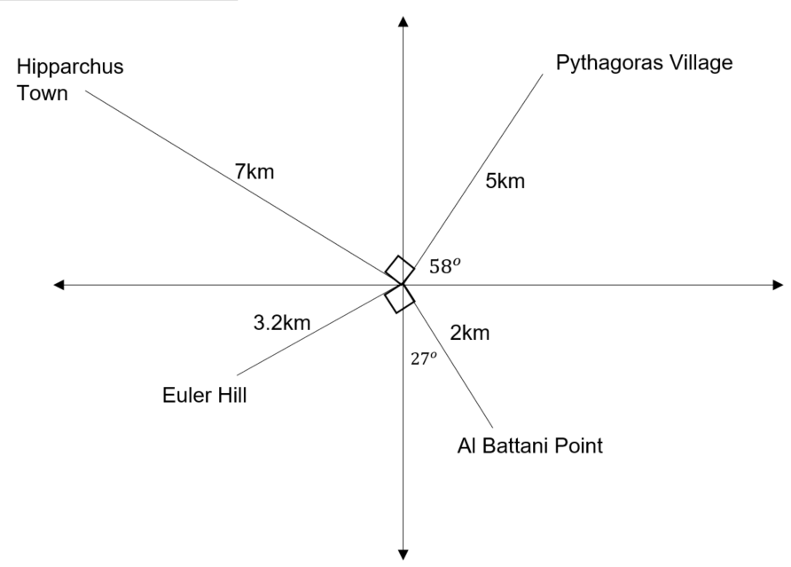

Enrichment
Research the mathematicians named above and find out as much as you can about their contributions to mathematics, particularly triangles and trigonometry.

Outcomes

5.2
- selects appropriate notations and conventions to communicate mathematical ideas and solutions MA5.2-1WM
- interprets mathematical or real-life situations, systematically applying appropriate strategies to solve problems MA5.2-2WM
- applies trigonometry to solve problems, including problems involving bearings MA5.2-13MG

5.3
- generalises mathematical ideas and techniques to analyse and solve problems efficiently MA5.3-2WM
- uses deductive reasoning in presenting arguments and formal proofs MA5.3-3WM
- applies Pythagoras’ theorem, trigonometric relationships, the sine rule, the cosine rule and the area rule to solve problems, including problems involving three dimensions MA5.3-15MG

