Blood stain analysis

Background
A droplet of blood has the shape of a sphere. If that droplet hits a surface at 90⁰, then the stain will be circular. Blood that strikes the surface at an angle will have a teardrop shape with the tail pointing in the direction of travel.
To calculate the angle of impact, measure the width and length of the stain in millimetres and use the formula $sinθ=\frac{width}{length}$ .

Scenario
Forensic scientists have discovered some blood stains at the scene of a crime where a victim was shot from the building 200m opposite the crime scene. They have taken measurements of the blood stains and recorded them in the table below.
- Calculate the impact angle of each blood stain using the formula above and fill in the third column of the table.
Width (mm) | Length (mm) | Impact angle | Height bullet fired from | Building Floor Level
3.6 | 10
1 | 6.1
3.8 | 12.3
2.1 | 9.8
3.25 | 11.8
Length
Width

- Determine the height the bullet was fired from.

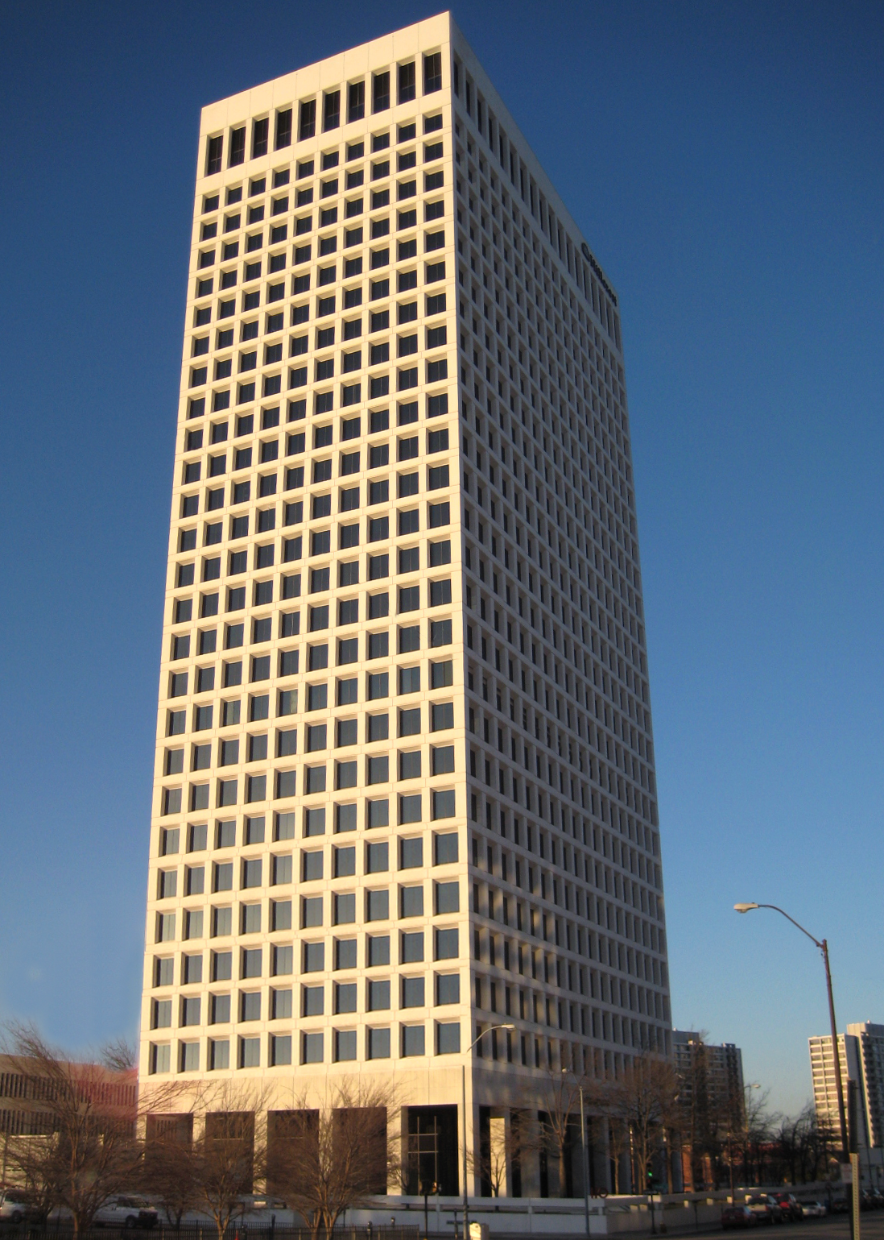
$$θ$$

- Assuming that each floor is roughly 4m high, which floor would the bullet have been fired from?

Outcomes
- MA5.1-1WM uses appropriate terminology, diagrams and symbols in mathematical contexts
- MA5.1-2WM selects and uses appropriate strategies to solve problems
- MA5.1-3WM provides reasoning to support conclusions that are appropriate to the context
- MA5.1-10MG applies trigonometry, given diagrams, to solve problems, including problems involving angles of elevation and depression

