Sample virtual program for Stage 5.1 Mathematics:
Guiding question
What are your students going to learn? (Objectives) | Students will learn how to construct and interpret linear graphs.
How are they going to learn it? (Resources and Strategies) | It is envisaged that all concepts will be introduced by the staff member via video conferencing and Microsoft Whiteboard; however, materials to supplement learning and independent learning activities have been provided for self-paced study.
Target date for completion | 4 lesson sequence
How are you going to know that they learned it? (Success criteria) | - Students calculate the gradient of a line  - Students describe the meaning of the gradient  - Students distinguish between positive and negative gradients  - Students find the midpoint of an interval using a diagram
Collecting evidence of student learning (Verification) | Activities provide formative assessment opportunities as student responses are collected. Students are provided with assessment as learning opportunities during interactive activities.
Feedback (Evaluation) | Staff can use video conferencing and Microsoft Whiteboard to lead student discussion and pose assessing and advancing questions. Staff can use these platforms to respond to student misconceptions identified through the formative assessment activities.
Communication | Staff can facilitate discussion and collaboration though video conferencing, like Skype, and collaborative platforms, like Microsoft Whiteboard and Teams.

Model 2 – Sharing resources for students to view/read and reflect on
It is envisaged that the following sequence of lessons would be facilitated by the peer discussion and conferencing, asynchronous discussion and mini-whiteboard activities from the Digital learning selector – Learning activities.

Constructing and interpreting linear graphs
Stage 5.1 Mathematics
During this sequence of lessons students will develop their understanding of gradient and calculate gradients in the real world with and without the use of technology.

Outcomes
A student:
- selects appropriate notations and conventions to communicate mathematical ideas and solutions MA5.2-1WM
- constructs arguments to prove and justify results MA5.2-3WM
- determines the midpoint, gradient and length of an interval, and graphs linear relationships MA5.1-6NA
- uses the gradient-intercept form to interpret and graph linear relationships MA5.2-9NA

Lesson sequence
1 | - Students investigate the language of linear graphs – slope, intercepts, positive, negative by playing the Desmos - Polygraph game. Students play in pairs to guess each other’s lines by asking questions about the characteristics of the line.  - Teacher should facilitate a discussion of the type of questions that students asked and the language they used to describe the lines. At this time, they should introduce the formal language used by mathematicians to describe features of linear graphs.  - Students then follow up by playing Polygraph 2 which allows them to practise using more formal language to describe lines. | Desmos – Polygraph  https://teacher.desmos.com/polygraph-lines  Desmos- Polygraph 2  https://teacher.desmos.com/activitybuilder/custom/5755ed8c0d942e9b07b65b98
2 | - Students to collect photos and details, from the internet of steep roads, hills, mountains etc in the real world.  - The staff member leads students to calculating the gradient by forming a right-angled triangle between two points on the linear graph. Introduce students to the idea of the run as the change in $x$ ordinates between the points, and the rise as the change in $y$ ordinates.  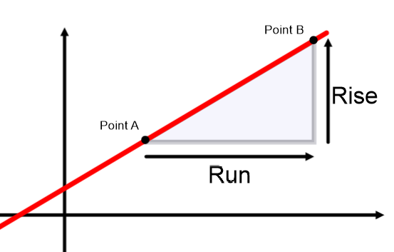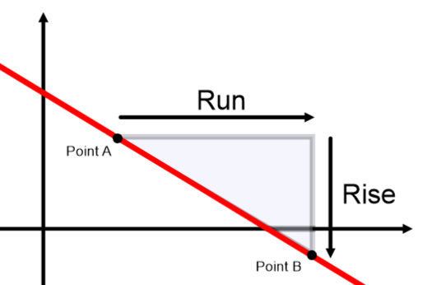  The staff member demonstrates the gradient calculation as $m=\frac{Rise}{Run}$.  The staff member should model examples of applying this calculation in a range of scenarios. The interactive explanation of gradient could be used to supplement students’ understanding.  - Students can interact with the Geogebra app to gain fluency. Students should drag the points to form lines with different gradients, then attempt to calculate the rise and run before applying them to calculate the gradient. Students can click on the triangle check-box to check their calculations for the rise and run; and the gradient check-box to check their gradient calculation.  - Students can use the questions on the Transum site to gain fluency in calculating the gradient of a line. | Video of how to calculate gradient by Rex Boggs, Mathematics Teacher at Rockhampton Grammar School  https://youtu.be/_9FrKcGNY4U  Students interact with the Geogebra app to gain fluency with calculating gradients  https://www.geogebra.org/m/YJAJcq2M  Transum – calculating gradient  https://www.transum.org/software/GraphMatch/Gradient.asp
3 | - Students can use Microsoft excel to calculate the gradient of ski lifts. The activity includes a PDF giving the length of the ski lift and its vertical height. Students will need to use Pythagoras’ Theorem to calculate the horizontal distance for the lift. They can then use $m=\frac{Rise}{Run}$ in a formula to find the gradient of the run.  - Students should then spend time ordering the runs from the steepest to the flattest.  - Students could research to see what criteria exists for ‘black’ runs etc | Gradient of ski lifts  https://schoolsequella.det.nsw.edu.au/file/554c2513-6c64-47e7-a2f2-77f6c324b724/1/8880.zip/8880_pop1.htm
4 | Baldwin Street in Dunedin, NZ holds the Guinness Book of Records title as the steepest street in the world. However, the claim is controversial due to the confusion surrounding how the gradient was recorded. Canton Street in Pittsburgh, USA would like to claim that they have the steepest street in the world.  - Students can calculate the gradient of the streets above and compare to the steepest street in their area using Google Earth. The altitude of the mouse point is given in the bottom right hand corner and there is a ruler tool to measure the length of the street. | Google Earth altitude  https://support.google.com/earth/answer/7420934?co=GENIE.Platform%3DDesktop&hl=en  Google Earth (works best in Chrome)  https://www.google.com/earth/
Extension | Students can investigate the gradient of parallel and perpendicular lines using the Desmos activity. | Desmos - Slopes of Parallel and Perpendicular lines  https://teacher.desmos.com/activitybuilder/custom/560bf52723f5c00206277850#preview/589d9b3d-9cb4-41b6-bd54-902be58cbfdd

