The last digit

Background
Working with exponents or powers makes numbers grow in huge leaps.

Powers or exponents require you to multiply numbers by themselves.
This means 3² = 3 x 3 = 9 (not 3 x 2)

5⁶ = 5 x 5 x 5 x 5 x 5 x 5 = 15 625

Most calculators have an exponent button that will perform these calculations for you.

It may look something like or

To use these buttons to calculate 5⁶, first type in 5, then press your exponent button, and then type in 6.

The Problem
5¹⁰⁰⁰ is a huge number.

In fact, the answer has close to 700 digits.

Do you think it is possible to determine the last digit of 5¹⁰⁰⁰ or 2¹⁰⁰⁰ or other numbers?

Task 1
Let’s look for a pattern in the power of 2’s.
  - Use your calculator to complete this table:

Power | Answer | Last Digit
2¹
2²
2³
2⁴
2⁵
2⁶
2⁷
2⁸
2⁹
2¹⁰

  - What patterns do you notice?
  - Use your pattern to predict what the last digit of 2¹⁰⁰⁰ will be. Explain your reasoning.

Task 2
Use a similar method to task 1 to find the last digit of each number listed in the table below.
As the numbers get larger, your calculator may have trouble displaying the whole number. If you have access to a computer, you may like to create your own spreadsheet (or use the one provided) to calculate the answers.
Number | Pattern | Last digit
1¹⁰⁰⁰
3¹⁰⁰⁰
4¹⁰⁰⁰
5¹⁰⁰⁰
6¹⁰⁰⁰
7¹⁰⁰⁰
8¹⁰⁰⁰
9¹⁰⁰⁰
10¹⁰⁰⁰
11¹⁰⁰⁰
12¹⁰⁰⁰
13¹⁰⁰⁰
14¹⁰⁰⁰
15¹⁰⁰⁰
16¹⁰⁰⁰
17¹⁰⁰⁰
18¹⁰⁰⁰
19¹⁰⁰⁰
20¹⁰⁰⁰
79¹⁰⁰⁰
273¹⁰⁰⁰

Task 3
  - Looking at the results in your table, what do you notice? What do you wonder?
  - Can you predict the last digit for any number?

Using the spreadsheet
To use the spreadsheet the-last-digit.XLSX, change the base number in cell B1 and the numbers in the table will change automatically.

Why does the pattern disappear and I end up with lots of zeroes?
As we said before, when you are working with exponents, numbers get really big really quickly. Sometimes the numbers get too big for even a spreadsheet to work out properly. When this happens, they lose some of their accuracy and the spreadsheet focuses on the millions and trillions places in the number rather than the ones, tens and even hundreds places.
The spreadsheet will be able to calculate enough numbers for you to see a pattern before this happens though.

Setting up a spreadsheet
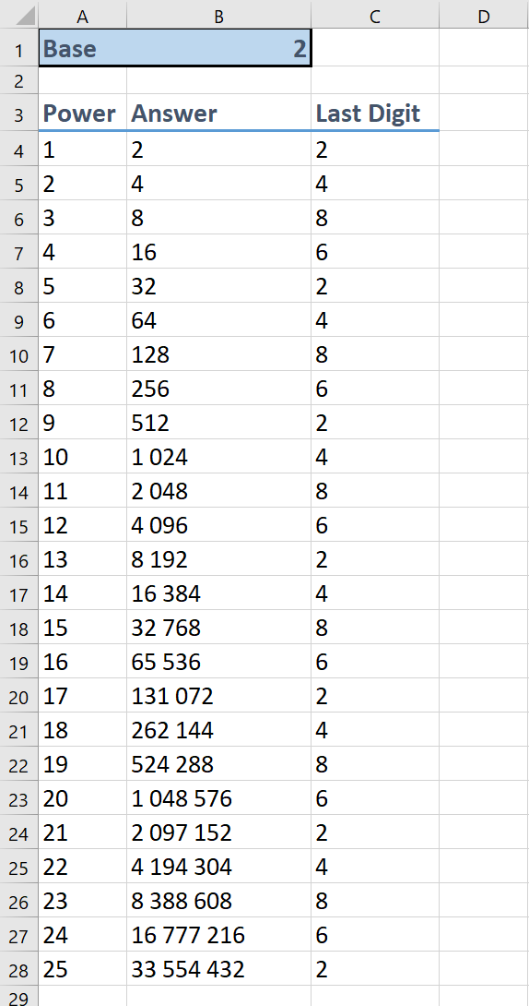

- Type the appropriate headings into cells A1, A3, B3 and C3
- Enter the number 1 into cell A4
- In cell A5, type in =A4 + 1 and press Enter. This adds one onto the number in A4
- Make sure you are still on cell A5, and then click and drag on the little box in the bottom right hand corner of the cell. You want to drag down to row 28.
- In cell B4 type in = $B$1^A4 and press enter. This will calculate 2¹. The ^ symbol is used for exponents (powers).
- Make sure you are still in cell B4 and use the above method to copy this formula down to row 28
- In cell C4 type in =right(B4, 1) and copy down as before. This finds 1 digit from the right (end) of the number in B4
- If column B starts to display ####### instead of your answer, click on the line in between the column B and C headings and drag to make the column wider.

Outcomes
- MA4-1WM communicates and connects mathematical ideas using appropriate terminology, diagrams and symbols
- MA4-2WM applies appropriate mathematical techniques to solve problems
- MA4-3WM recognises and explains mathematical relationships using reasoning
- MA4-9NA operates with positive-integer and zero indices of numerical bases

