Solving equations (pronumerals on both sides) square jigsaw
Cut out each of the squares. Shuffle the pieces and match the sides of the square by solving the equations.
Note: this resource was created using Tarsia software. You can download the free software using the following link: mmlsoft.com/index.php/products/tarsia
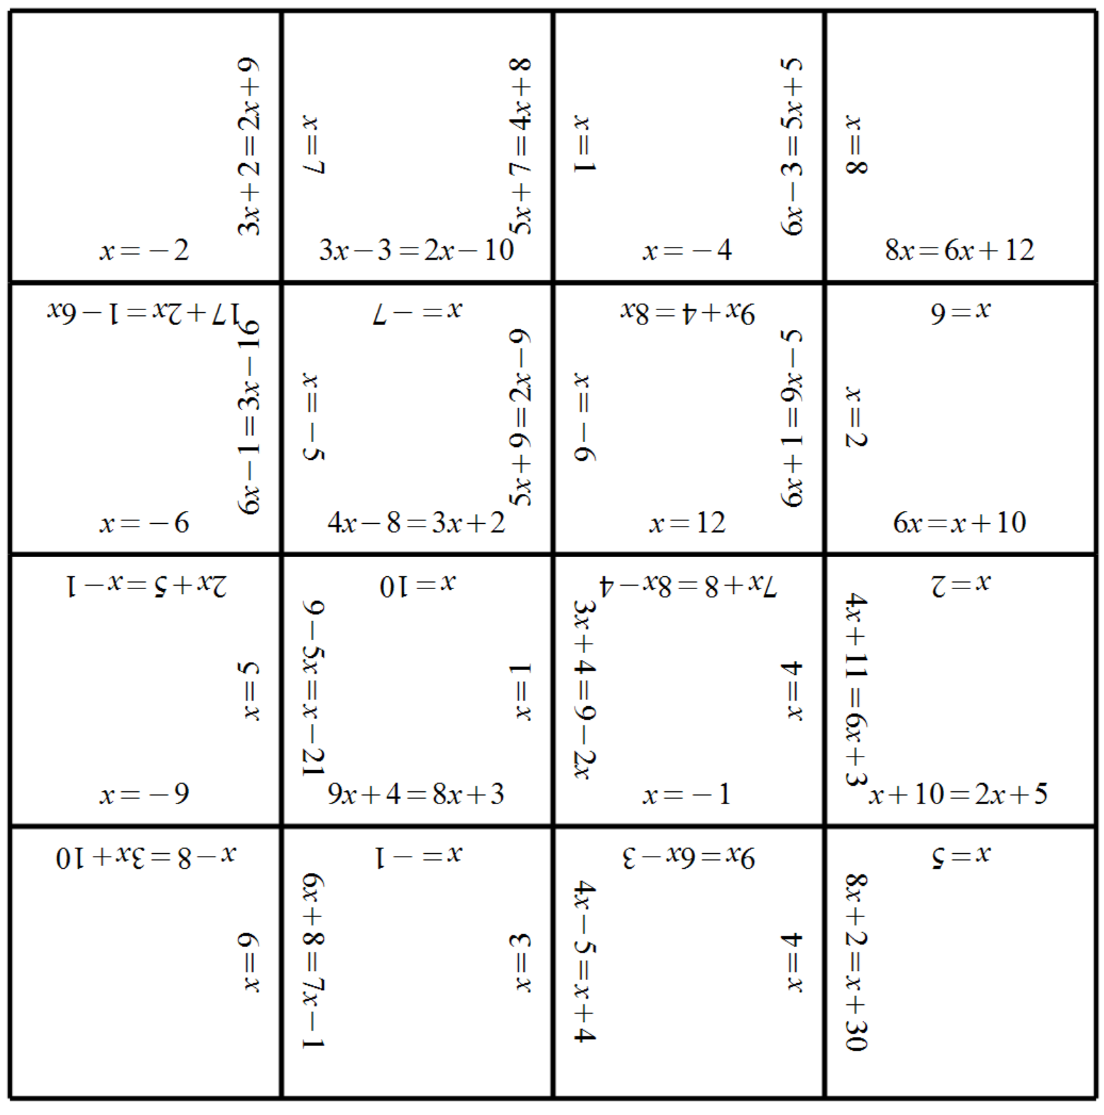

Outcome
Uses algebraic techniques to solve simple linear and quadratic equations. MA4-10NA

