Week 2: Profit and Loss (Offline learning)
Students will not need to have access to any digital devices in order to complete the following activities. Students will be required to keep a record of their learning and are encouraged to check in with their teacher at the end of the week via telephone or other means. Students may need a parent/carer to help facilitate some of the activities.

Lesson 1: Explicit learning
Students are to read through the ‘Profit and Loss’ section on pages 3, 4 and 5 with a parent/carer. Students are to then complete the ‘Profit and Loss worksheet’ on page 6.

Lesson 2: Enrichment task
Students are to complete the attached enrichment task entitled ‘Lamington Drive’. All instructions are included within the document. Students are required to provide evidence of the completion of the task to their classroom teacher. This could be done by dropping off a hard copy to their school or discussing the completed task with their teacher over the phone.
NOTE: In the enrichment task there is an option for students to use spreadsheet software. If students do not have access to this form of technology the task can still be completed with the aid of a calculator.

Lesson 3: Activity based consolidation
Students are to complete as many of the activities listed in the table below. Copies of each of the activities are attached.
- Storage hunters
- Profit and loss game
- Profit and loss word search
- Problem map
- Profit and loss acrostic poem

Outcomes
A student:
- Communicates and connects mathematical ideas using appropriate terminology, diagrams and symbols MA4-1WM
- Applies appropriate mathematical techniques to solve problems MA4-2WM
- Recognises and explains mathematical relationships using reasoning MA4-3WM
- Solves financial problems involving purchasing goods MA4-6NA

Related Life Skills outcomes: MALS-12NA, MALS-13NA, MALS-14NA, MALS-15NA, MALS-16NA

Content
Solve problems involving profit and loss, with and without the use of digital technologies (ACMNA189)
- calculate the selling price, given the percentage profit/loss on the cost price
- express profit/loss as a percentage of the cost price
- calculate the cost price, given the selling price and percentage profit/loss

Profit and Loss
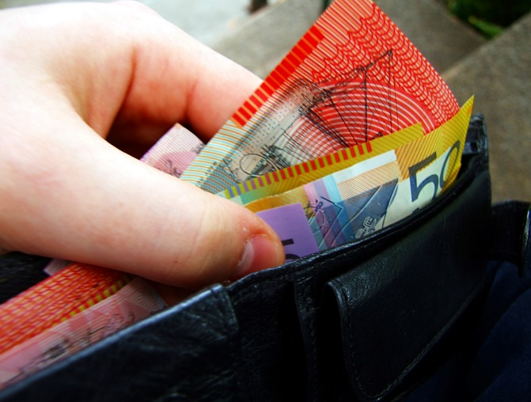
When you sell an item for more than it cost you then you will receive a profit. For example if you bought a chair for $20 and sold it for $30 then you have made a profit.
When you sell an item for less than it cost you then you have made a loss. For example if you bought a table for $50 and sold it for $30 then you have made a loss.
To calculate the amount of profit or loss made, you need to look at the difference between the cost price and the selling price.

Item | Cost price | Sales price | Profit or Loss | Amount
Chair | $$\$20$$ | $$\$30$$ | Profit | $$\$30-\$20=\$10$$
Table | $$\$50$$ | $$\$30$$ | Loss | $$\$50-\$30=\$20$$
Businesses find it useful to be able to express profit/loss as a percentage of the cost price.
Remember to calculate a percentage first form a fraction and then multiply that fraction by 100.
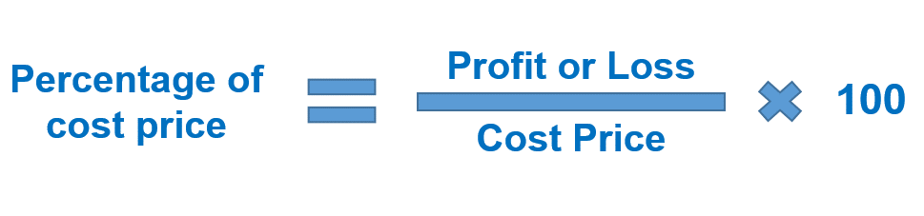
Item | Cost price | Selling price | Profit or Loss | Amount | Percentage of cost price
Chair | $$\$20$$ | $$\$30$$ | Profit | $$\$30-\$20=\$10$$ | $\frac{\$10}{\$20}×100=50\%$ profit
Table | $$\$50$$ | $$\$30$$ | Loss | $$\$50-\$30=\$20$$ | $\frac{\$20}{\$50}×100=40\%$ loss

Calculating the selling price
Businesses need to make a profit in order to survive. To do this they need to carefully calculate how much they are willing to sell their products for.

Example 1
A business buys candles from a warehouse for $\$5$ each. What selling price would they need to set if they want to receive a $30\%$ profit?
Step 1: Calculate the profit. In this case it is $30\%$ of the cost price.
$$30\% of \$5=30÷100×\$5$$
$$30\% of \$5=\$1.50$$
Step 2: Calculate the selling price by adding the profit to the cost price.
$$Selling price=profit+cost price$$
$$Selling price=\$1.50+\$5$$
$$Selling price=\$6.50$$
$∴$ The business would have to sell each candle for $\$6.50$.

Example 2
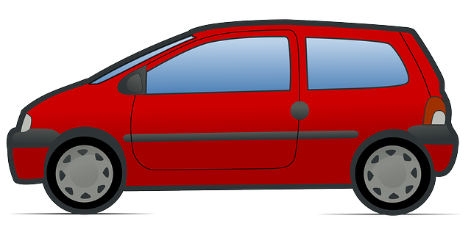
Cars depreciate in value every year. A car was bought for $\$29 150$ and the following year the value depreciated by 25%. What would be the new selling price using the depreciation amount of $25\%$?
Step 1: Calculate the loss. In this case it is $25\%$ of the cost price.
$$25\% of \$29 150=25÷100×\$29 150$$
$$30\% of \$5=\$7287.50$$
Step 2: Calculate the selling price by subtracting the loss from the cost price.
$$Selling price=cost price-loss$$
$$Selling price=\$29 150-\$7287.50$$
$$Selling price=\$21 862.50$$
$∴$ The car would have to be re-sold for $\$21 862.50$.

Calculating the cost price
Sometimes businesses find products and then based on the cost price will determine the selling price. On other occasions businesses will think about what the selling price will be and work backwards to determine what the cost price will need to be in order for them to make a profit.

Example 3
On average the selling price of a $700g$ tin of Milo is approximately$\$10$. If supermarkets want to make 20% profit on this product how much would they need to buy it from the warehouse for?
Remember:
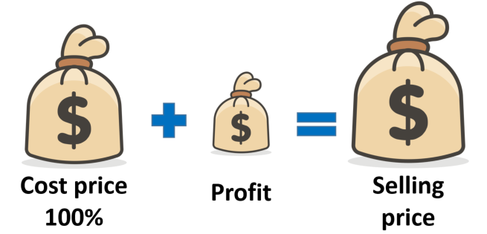
Step 1: Determine what percentage the selling price is of the cost price.
$$Selling price=100\%+20\%$$
$$Selling price=120\%$$
This means that:
$$120\% of the cost price=\$10$$
Step 2: Calculate the cost price.
From Step 1:
$$120\% of the cost price=\$10$$
$120\% ×cost price=\$10$ (Remember the inverse of multiplication is division)
$$Cost price=\$10÷120\%$$
$Cost price=\$10÷1.2$ (Remember to convert percentages into decimals you need to $÷100$)
$Cost price=\$8.33$ (Correct to two decimal places)

$∴$ The milo would have to be purchased by the supermarket for $\$8.33$ in order for them to sell it to their customers for $\$10$ and be able to make a profit of $20\%$
Profit and Loss worksheet
- Complete the following table:

Item | Cost price | Selling price | Profit or Loss | Amount | Profit/loss as a percentage of cost price
Microwave | $120 | $150
Shoes | $100 | $90
TV | $350 | $700
Mobile phone | $358.62 | $520

- Meagan buys netballs for $24 each. What would she need to sell them for if she wants to earn a 45% profit?

- Daniel buys surf boards for $350 each. What would he need to sell them for if he want to earn a 32% profit?

- It costs Matthew $6 in ingredients to make a pizza. How much would he need to sell a pizza for if he wants to earn profit of 100%?

- Jackie wants to sell glasses for $120 each. What price would her cost price need to be if she wants to earn a 60% profit?

- Sarah wants to make and sell baby quilts for $80 each. What would she have to keep her costs to if she want to earn a 28% profit?

- Michelle wants to sell calculators for $18 each. She wants to earn a profit of 20% and can buy them from the warehouse for $16. Will she earn a 20% profit at this price?
Lamington Drive

Background
Many sporting clubs rely on fundraising to buy new equipment, build new facilities and to keep membership costs down. As such, clubs are always on the lookout for new and creative fundraising ideas.
Your sporting club has decided to hold a Lamington Drive as a fundraiser. The ingredients for the recipe you will use are listed below.

Ingredients (makes 15 lamingtons)
- 125g butter
- 1 cup caster sugar
- ½ teaspoon vanilla extract
- 3 eggs
- 1¾ cups self raising flour
- ½ cup milk
- 2 cups desiccated coconut

Icing
- 3½ cups icing sugar
- ¼ cup cocoa powder
- 1 tablespoon butter
- ½ cup boiling water

Preparation: 35 minutes Cooking time: 30 minutes Cooling time: 1 hour
Recipe for Lamingtons from Taste.com

Part A: Planning the event
- You must decide how many lamingtons you will make (keep in mind that the recipe makes 15). Justify your answer by talking about how many people are at your sporting club and how many lamingtons each person will be expected to sell.
- Adjust the given recipe to cater for the required number of lamingtons. List each ingredient, the required quantity and the calculation you used to find this amount.

Ingredient | Calculation | Quantity required
Butter
Castor sugar
Vanilla extract
Eggs
Self-raising flour
Milk
Coconut
Icing sugar
Cocoa powder
Water

Part B: Going shopping
- Visit a supermarket (or use an online website if you have access). For each ingredient listed above, choose a suitable brand and size and list the details in a table similar to the one below. (You may use a spreadsheet if you have access to technology).

Ingredient | Brand | Size | Purchase price | Quantity needed | Price per quantity
Butter | Devondale | 250g | $4.30 | 2 kg | $4.30 x 8 = $34.40
Castor sugar
Vanilla extract
Eggs
Self-raising flour
Milk
Coconut
Icing sugar
Cocoa powder
Water

- Where options were available, justify why you chose the brand and size you did ie buying 1kg packet of flour rather than 2 x 500g
- What is the total cost of your ingredients?

Part C: Baking
- Decide how long it will take you to make all of the lamingtons necessary for the fundraiser? Consider whether you can make more than one batch at a time. Justify your answer.
- What if you had helpers, using their own kitchens, to help you make the lamingtons? What would be the optimum number of helpers? Justify your answer.

Part D: Preparing for sale
- Using the prices you collected from your shopping trip, calculate the price per lamington to produce.
- What price will you sell your lamingtons for? Justify your answer.
- How much profit will your sporting club make?
- Investigate the effect of raising or lowering the price of your lamingtons on your profit margin.
- Explain any other factors that you would need to consider if you were planning this fundraiser in real life.

Storage Hunters
Storage Hunters is a reality television series that ran in the US and UK. In the show, participants bid on abandoned shipping and storage containers without knowing the contents. There is big money to be made if the container houses the right items, but every buy is a gamble.
Determine the percentage profit or loss made on each container.
Container 1: Bought for $4300
Item | Sold for
2 Mountain bikes | $450 each
Dart Board | $50
4 tennis racquets | $26 each
Treadmill | $600
Rowing machine | $1200

Container 2: Bought for $6230
Item | Sold for
Fishing boat | $2400
Outboard engine | $3250
4 Life jackets | $65 each
Anchor | $120
6 Fishing rods | Average of $85 each
Tackle box filled with various items | $96
30m Maritime rope | $8 per metre
Inflatable dinghy | $2700

Container 3: Bought for $1200
Item | Sold for
5 rugs | Average of $230 each
Box of tiles | $320
2, 4L tins of unopened paint | $110 each
8 Paintbrushes of various sizes | $75
Ladder | $310

Container 4: Bought for $2300
Item | Sold for
Oven | $350
Microwave | $30
Dishwasher | $400
Kitchen sink | $150
6 kitchen cupboards | $200 each
Bench top | $650
Stove top | $320

Profit and Loss game
Equipment needed: 2 dice, calculator
This is a game for two or more players.
- Each player rolls the dice and forms a two digit number, this will be your cost price.
- Players roll the dice again and form another two digit number, this is the selling price.
- Players then work out their percentage profit or loss.
- Points are awarded according to the table below.
- At the end of ten rounds, the players with the largest score is declared the winner.

Percentage profit | Points
0 – 25% | 1 point
26% - 50% | 2 points
51% - 75% | 3 points
76% - 100% | 4 points
>100% | 5 points
Percentage loss | Points
0 – 25% | Lose 1 point
26% - 50% | Lose 2 points
51% - 75% | Lose 3 points
76% - 100% | Lose 4 points
>100% | Lose 5 points

Reflection questions
If you were teaching someone else how to play the game, what strategy would you suggest they use when:
- Forming their cost price?
- Forming their selling price?
Profit and Loss word search
Find each of the words listed in the word search below.
Note: this word search was created using The Word Search website.

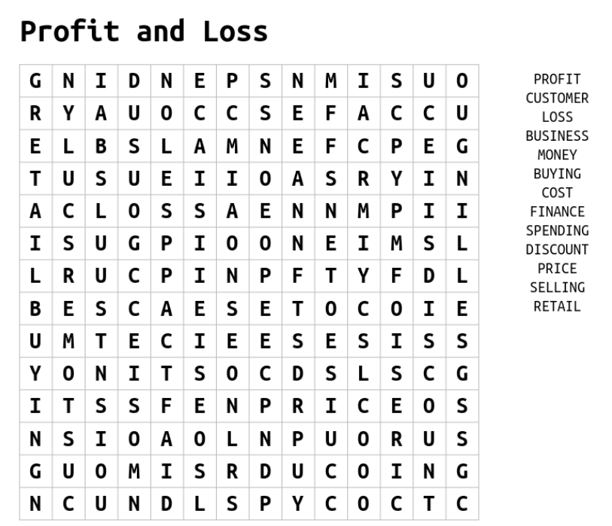
Problem map
Students are to write down a problem in the rhombus at the centre of the map. They are to then represent this problem in the four different sections of the map.

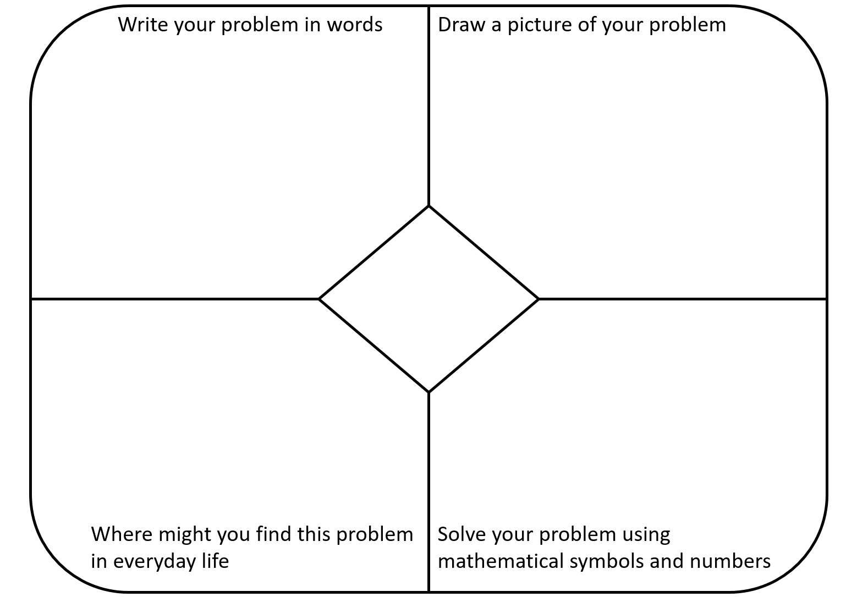

Profit and Loss acrostic poem
Write down a word related to mathematics that starts with each of the letters of the word PROFIT and LOSS. Provide a definition for each of your words.

Percentages | Word | Definition
P
R
O
F
I
T
L
O
S
S

