Week 1: Percentages (Offline learning)
You will not need to have access to any digital devices in order to complete the following activities. You will be required to keep a record of your learning and check in with your teacher at the end of the week via telephone. You may need a parent/carer to help facilitate some of the activities.

Lesson 1: Explicit learning
Students are to read through the ‘percentages of quantities examples’ on page 3 and 4 with a parent/carer. Students are to then complete the ‘percentages of quantities worksheet’ and make a list of all of the places where they have seen percentages being used in their day-to-day lives.
After some practice, student could then teach another family member how to calculate the percentage of a quantity and create their own set of 10 questions for their family member to complete. Once the family member has completed the 10 questions the student is to correct their work and provide feedback.

Lesson 2: Enrichment task
Students are to complete the attached enrichment task entitled ‘Do supermarkets lie?’ All instructions are included within the document. Students are required to provide evidence of the task’s completion to their classroom teacher. This could be done by dropping off a hard copy to their school or discussing the completed task with their teacher over the phone.

Lesson 3: Activity based consolidation
Students are to complete as many of the activities listed in the table below as they can. Copies of each of the activities are attached.
- 30% discount sale
- Percentages of a quantity jigsaw
- Equivalent fractions and percentages memory game
- Percentages word search
- Problem map
- Percentages acrostic map

Outcomes
A student:
- operates with fractions, decimals and percentages MA4-5NA
- selects and uses the appropriate unit and device to measure the masses of objects, and converts between units of mass

Percentages of quantities – examples
Being able to calculate the percentages of quantities is a useful skill in day-to-day life. There are many different written and mental strategies that can be used to calculate the percentage of a quantity.

Written Strategies
It is important to remember that ‘percent’ means ‘per 100’. Every time you see the percent symbol (%) you need to think of it as being ‘parts out of 100’ or mathematically as $÷100$. In a nut shell, in order to find the percentage of a quantity you need to convert the percentage into a decimal (or fraction) and multiply by the quantity. To convert a percentage into a decimal (or fraction) you simply need to divide by 100.
Examples
Calculate:
- 30% of $400

First step, change the % symbol to $÷100$ and the word ‘of’ to a multiplication ($×$)
$$30\% of \$400=30 ÷100 ×\$400$$

Final step, calculate using your calculator
$$30 ÷100 ×\$400=\$120$$

- 42% of 375mL
$$42 ÷100 ×375mL=120\text{mL}$$

- 25% of 1 hour (Remember 1 hour = 60 minutes)
$$25÷100×60 minutes=15 minutes$$

Mental Strategies
If you do have access to the internet, you may like to watch the following videos to see different types of mental strategies.
Percentage math trick 2
Eddie Woo

If not, that is ok, read through the following explanation.

Example: Calculate 12% of $130

Step 1 – 100% of $130 is the full amount. This means 100% = $130
Step 2 – You can find 10% of $130 by dividing by 10. This means 10% = $13
Step 3 – You can find 1% by dividing by 10 again. This means 1% = $1.30
Step 4 – 12% is made up of 10% + 1% + 1%. This means that:
12% of $130 = $13 + $1.30 + $1.30
12% of $130 = $15.60
Percentages of quantities worksheet
- Convert the following percentages into decimals by dividing by 100.
  - 15%

  - 67%

  - 24.8%

  - 42 ½ %

  - 108%

- Calculate the following by first dividing the percentage by 100 and then multiplying by the quantity.
  - 52% of 460 people

  - 36% of 375 mL

  - 72% of 180 kg

  - 19.7% of 500 cm

  - 120% of $890

- You may already realise that 30 minutes is half of an hour which is equivalent to 50%. What percentage of an hour is 12 minutes?

- Maris received her exam results and achieved 78% in Art, 19/25 in English and 32/40 in Maths. In which exam did she achieve the highest result?

- List 3 real-life scenarios where you have seen percentages being used.

Do supermarkets lie?

Part A: Measure weight of supermarket items
By law, the weight of an item must be recorded on its packaging, but is it correct?
- Choose 10 items that have not been opened. Ensure that the items are weighed in the same units, for example sugar and rice are weighed in kg.
- Use weighing scales to weigh each item and record them in the table below.
- Fill in a table similar to Table 2 below to show the listed and actual weight of each item
- Record using positive and negative numbers to show whether the actual weight was above or below the listed weight

Table 1 - Listed and actual weight of each item

Item name | Listed weight | Actual weight | Difference
Peanut Butter | 250g | 240g | -10g
Sugar | 1kg=1000g | 1.01kg=1010g | +10g

Part B: Validating weight of supermarket items
Legally a product is allowed to be slightly over or slightly under its listed weight. Table 2 below shows the percentage over or under allowed for items by weight
Table 2 – Percentage over or under allowed for items by weight

Weight | Percentage over or under
0 – 100g | 9%
100 – 300g | 4.5%
300 – 500g | 3%
500 – 1 000g | 2%
1 000 – 15 000g | 1.5%

Source: Australian Government; Industries
Example: What is the range of legal weights for a 75g packet of chips?

Since the weight is between 0 and 100 g, it can be over or under by 9% according to the table.

- Convert 9% to a decimal = 9 $÷$ 100 = 0.09
- 75 x 0.09 = 6.75 (greatest possible error)
- Minimum weight = 75 – 6.75 = 68.25g
- Maximum weight = 75 +6.25 = 81.75g

- For each of your items chosen, calculate the minimum and maximum weights that are allowed (use the example above for help with the calculations). Create a table using the column headings as shown in Table 3 below to record your results.

Table 3 – Percentage over or under allowed for items by weight

Item name | Listed weight | Percentage over or under | Decimal over or under | Greatest possible error | Minimum weight | Maximum weight
Chips | 75g | 9% | 0.09 | 0.09 x 75  = 6.75 | 75 – 6.75  = 68.25g | 75 + 6.75  = 81.75g

- List the items that are:
  - within the legal limits
  - outside of the legal limits
- Write a response to “Do supermarkets lie?” using evidence from your investigation

Outcomes
- MA4-2WM applies appropriate mathematical techniques to solve problems
- MA4-3WM recognises and explains mathematical relationships using reasoning
- MA4-4NA compares, orders and calculates with integers, applying a range of strategies to aid computation
- MA4-5NA operates with fractions, decimals and percentages
- MA3-12MG selects and uses the appropriate unit and device to measure the masses of objects, and converts between units of mass

$30\%$ discount sale!
Students are to use a catalogue and determine what the new prices of products would be if there was a further 30% discount applied.
Students are to create and complete a table similar to the one shown below.

Item name | Catalogue price | 30% discount | Sales price
E.g. Board game | $$\$25$$ | $$30\% of \$25$$  $$30÷100×25=\$7.50$$ | $$\$25-\$7.50=\$17.50$$

Percentages of a quantity jigsaw
Cut out each of the triangles. Shuffle the pieces and match the sides of the triangles by calculating the percentages of the given quantities.
Note: this resource was created using Tarsia software. You can create your own similar resources by downloading the Tarsia software.
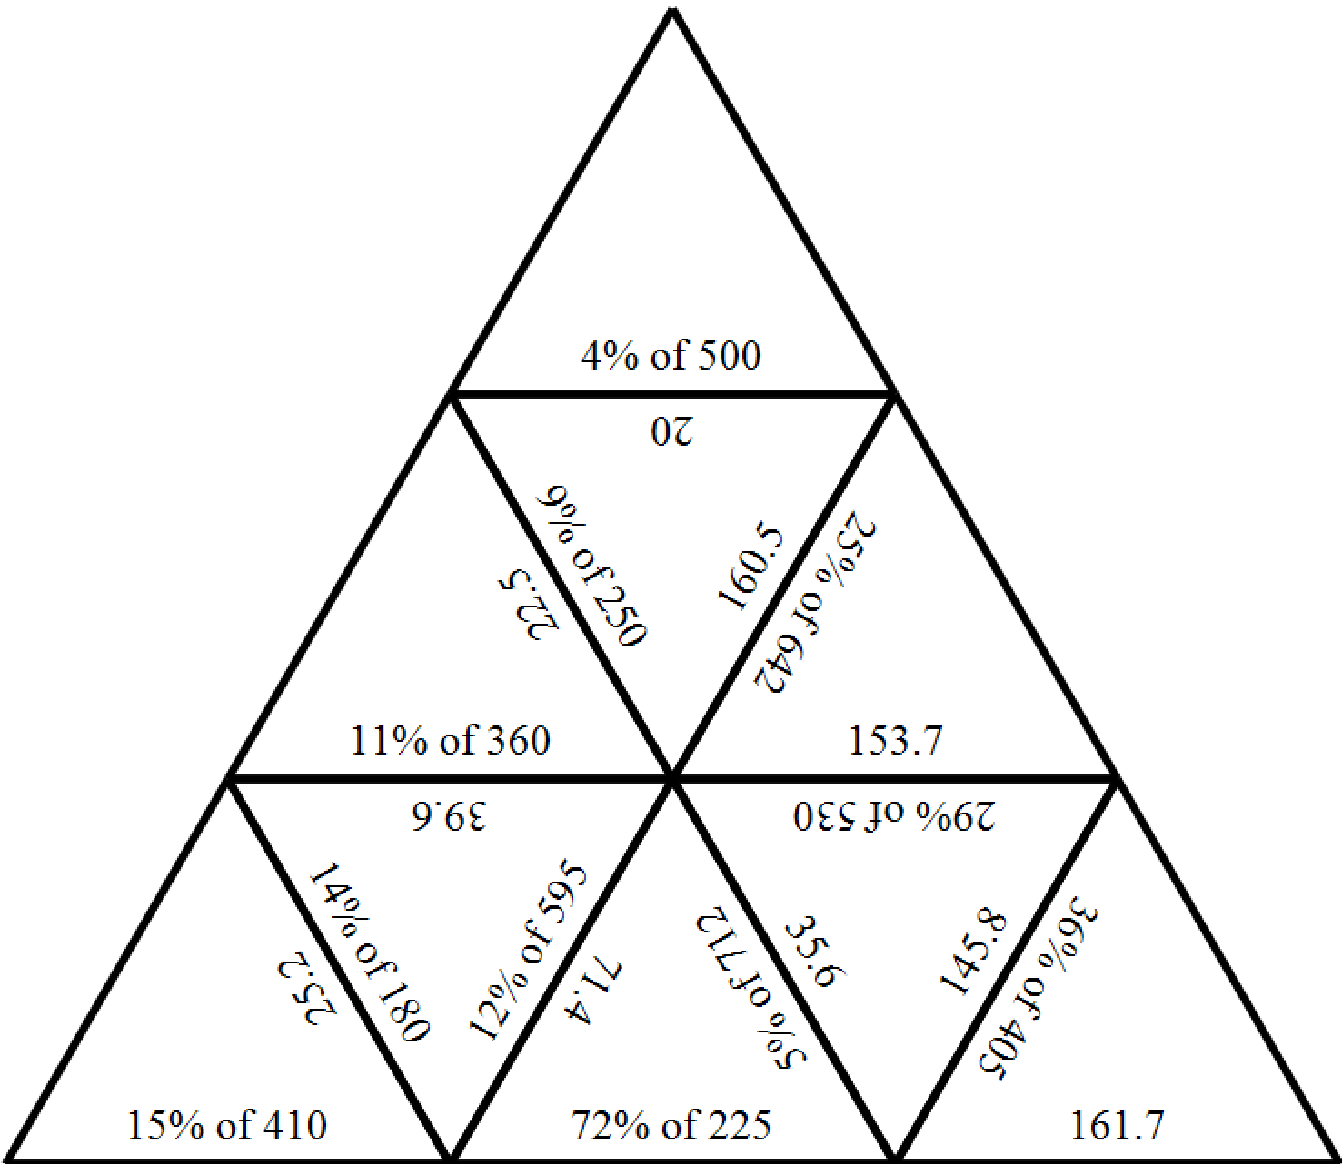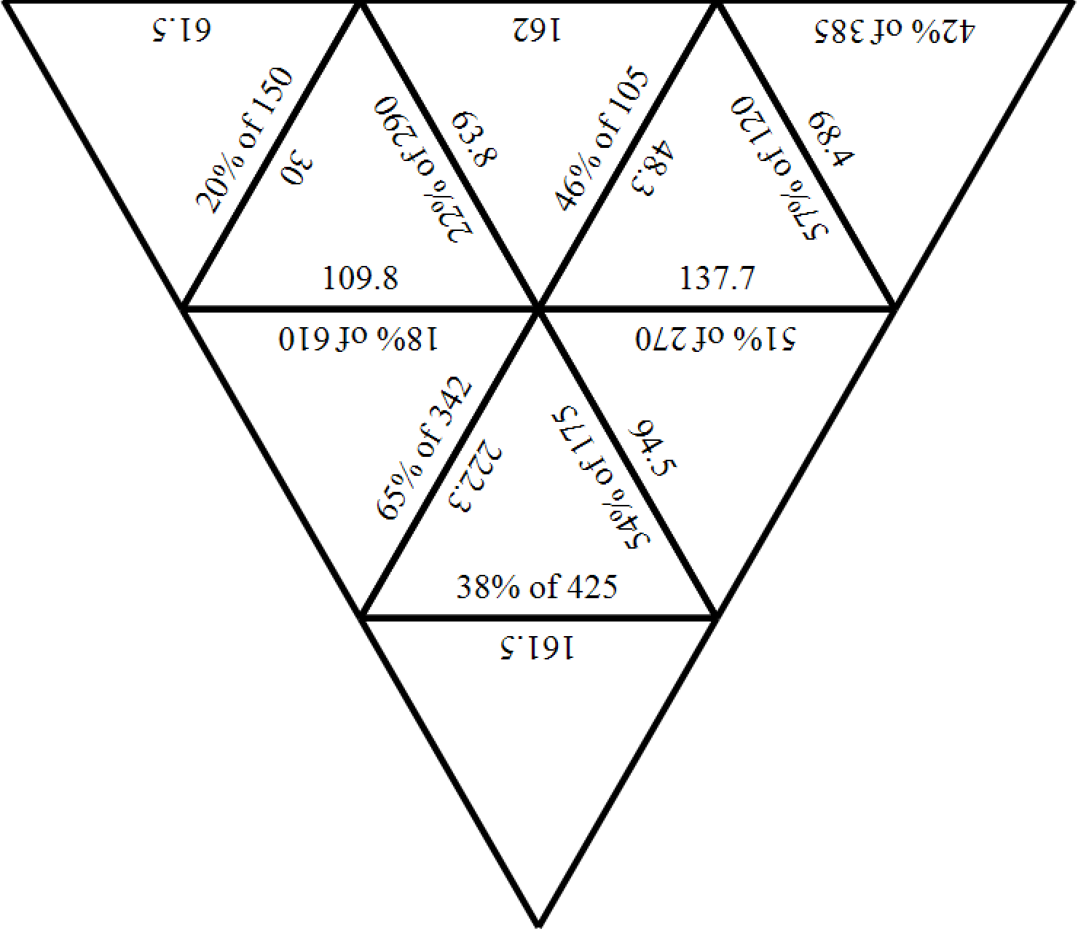
Fractions and percentages memory game
Cut out each of the rectangles, shuffle the cards and place them face down. Flip two cards over at a time with the aim of matching the fraction with the equivalent percentage.

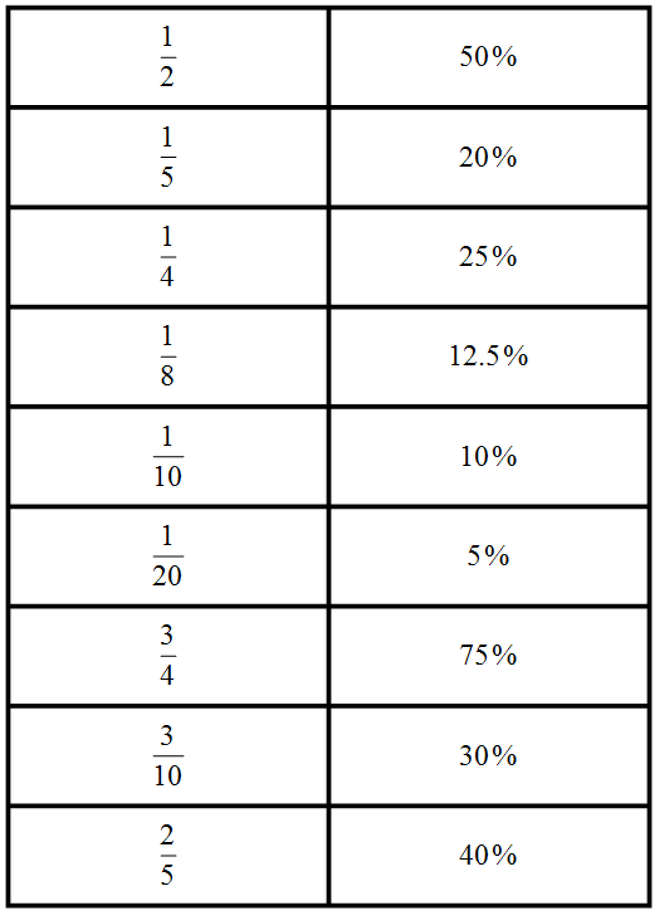
Percentages word search
Find each of the words listed in the word search below.
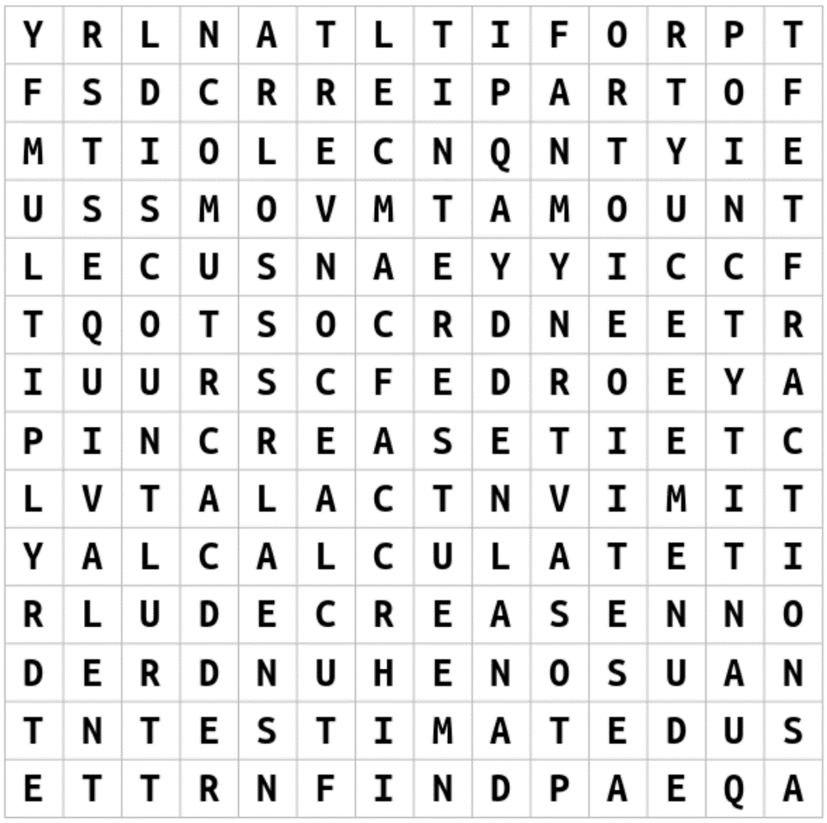
Note: this word search was created using The Word Search website.
fractions | convert | increase | calculate
profit | interest | find | quantity
one hundred | decrease | estimate | multiply
discount | loss | equivalent | amount

Problem map
Students are to write down a problem in the rhombus at the centre of the map. They are to then represent this problem in the four different sections of the map.

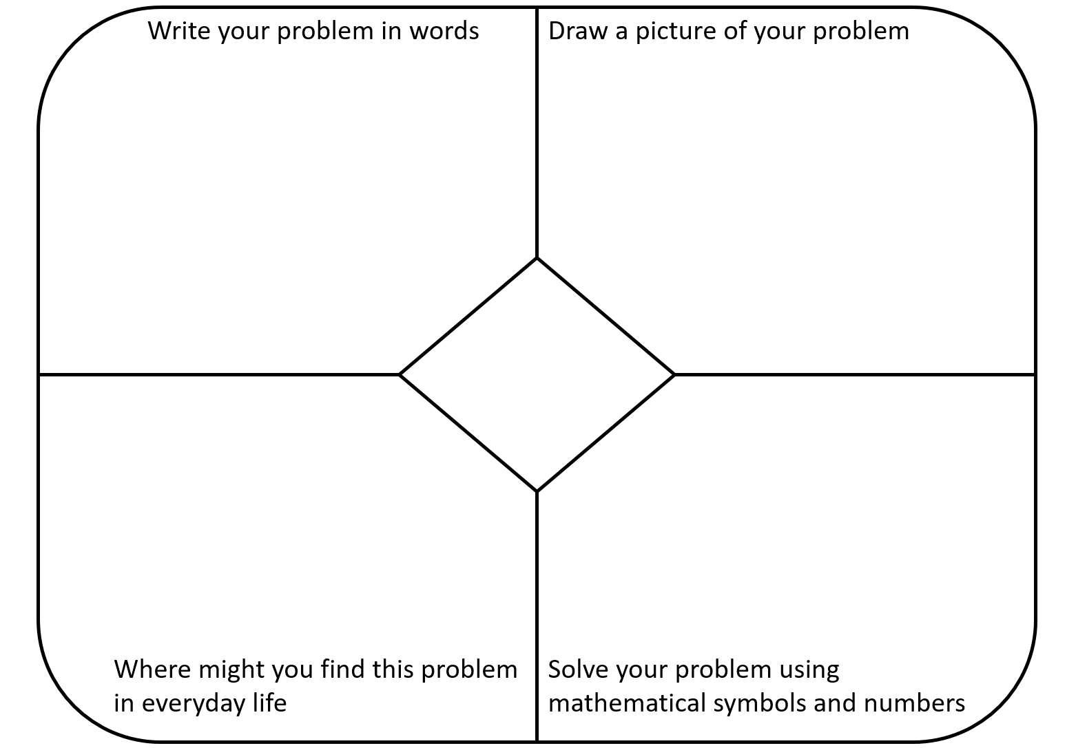

Percentages acrostic poem
Write down a word related to mathematics that starts with each of the letters of the word PERCENTAGES. Provide a definition for each of your words.

Percentages | Word | Definition
P
E
R
C
E
N
T
A
G
E
S

