Week 2: Goods and Services Tax (GST) (Offline learning)
Students will not need to have access to any digital devices in order to complete the following activities. Students will be required to keep a record of their learning and are encouraged to check in with their teacher at the end of the week via telephone or other means. Students may need a parent/carer to help facilitate some of the activities.

Lesson 1: Explicit learning
Students are to read through the information and examples entitled ‘Goods and Services Tax (GST)’ on page 2 and 3 with a parent/carer. Students are to then complete the ‘GST worksheet’. If students do have access to technology, the following video provides a basic introduction to what the GST is, however, the students can still complete all of the activities outlined in this work package without it.
ABC Education: 'What is the GST?'

Lesson 2: Enrichment task
Students are to complete the attached enrichment task entitled ‘Raising the GST’. All instructions are included within the document. Students are required to provide evidence of the completion of the task to their classroom teacher. This could be done by dropping off a hard copy to their school or discussing the completed task with their teacher over the phone.
NOTE: In the enrichment task there is an option for students to use spreadsheet software. If students do not have access to this form of technology the task can still be completed with the aid of a calculator.

Lesson 3: Activity based consolidation
Students are to complete as many of the activities listed in the table below. Copies of each of the activities are attached.
- GST or no GST?
- GST jigsaw
- GST word search
- Problem map
- Taxation acrostic map

Outcomes
A student:
- Communicates and connects mathematical ideas using appropriate terminology, diagrams and symbols MA4-1WM
- Applies appropriate mathematical techniques to solve problems MA4-2WM
- Recognises and explains mathematical relationships using reasoning MA4-3WM
- Solves financial problems involving purchasing goods MA4-6NA

Related Life Skills outcomes: MALS-12NA, MALS-13NA, MALS-14NA, MALS-15NA, MALS-16NA

Content
Students:
Investigate and calculate the Goods and Services Tax (GST), with and without the use of digital technologies
- calculate GST and GST-inclusive prices for goods purchased in Australia, given the pre-GST price
  - interpret GST information contained on receipts (Communicating)
  - investigate efficient methods of computing the GST and GST-inclusive prices (Problem Solving)
  - explain why the value of the GST itself is not equivalent to 10% of the GST-inclusive price (Communicating, Reasoning)
- determine the pre-GST prices for goods, given the GST-inclusive price
  - explain why the pre-GST price is not equivalent to 10% off the GST-inclusive price (Communicating, Reasoning)
Legend: Outcomes coloured red are not included in this package of work
Goods and Services Tax (GST)

Goods and Services Tax (GST)
Everyone at some stage in their life will have to pay tax. Below is a page from the ‘Tax in Australia – what you need to know’ document that was produced by The Australian Taxation Office (ATO) outlining why we pay tax.
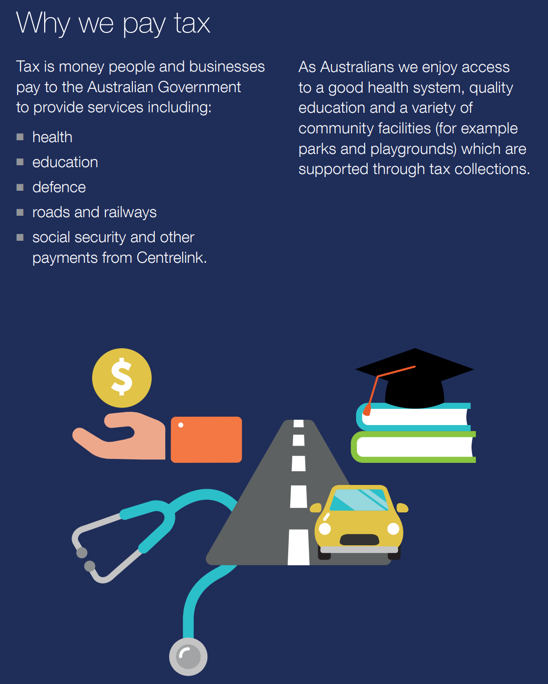
The Goods and Services Tax (GST) is a broad-based tax of 10% on most goods and services that are sold and consumed in Australia. Other countries have similar taxation systems. In the United Kingdom it is called a ‘Value Added Tax (VAT)’ and it is currently 20%.

Adding GST
In order to add GST onto the price of products we will need to use our skills in finding percentages of quantities. There are 2 methods that you can use to add GST onto a price.
Method 1
Calculate 10% of the pre-GST price and then add it on
Examples
Add 10% GST onto the following prices:
- $400
First step, calculate 10% of $400
$$10\% of \$400=10 ÷100 ×\$400$$
$10\% of \$400=\$40$

Final step, add the GST on to the original price
$$\$400+\$40=\$440$$

- $15.60
$$10 ÷100 ×\$15.60=\$1.56$$
$$\$15.60+\$1.56=\$17.16$$

Method 2
This method is quicker, however can be a little trickier to understand.
The pre-GST or original price represents 100%. It is the whole price. If we add 10% we will now have 110% of the original price. To calculate the sale price, which includes the GST, we need to calculate 110% of the original price.

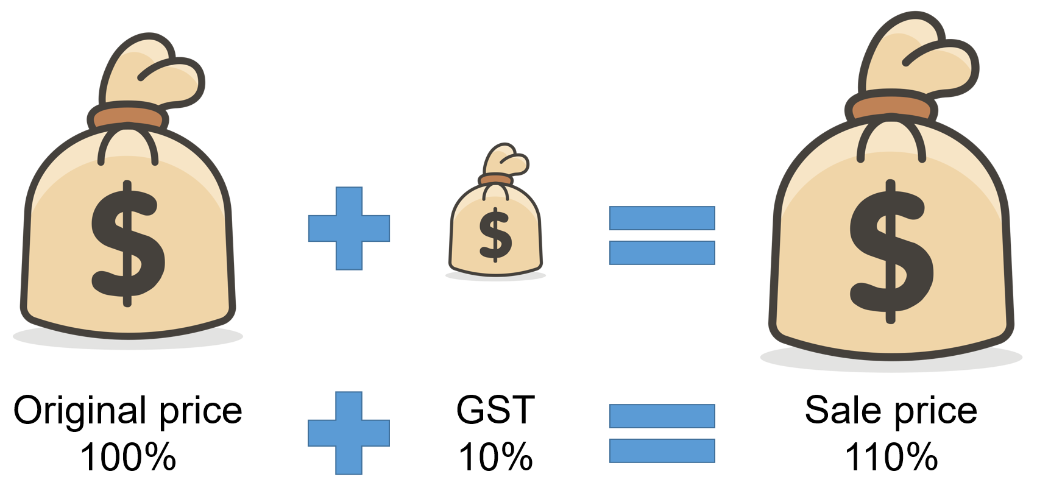

Examples
Add a 10% GST onto the following prices:
- $25
$$110\% of \$25=110 ÷100 ×\$25$$
$110\% of \$25=\$27.50$
This is only one step on your calculator, however trickier to do without the aid of a calculator.
- $84.20
$$110\% of \$84.50=110 ÷100 ×\$84.50$$
$110\% of \$84.50=\$92.95$

GST included
In Australia, the GST is usually already included in the price that you see advertised. This tells you exactly what you need to pay. Business owners however need to be able to determine how much of that price is GST so that they know how much money to give the government.
From the previous section you saw that the sale price is actually made up of 110% of the original price. To determine what amount the business has to pay the government we need to work out what 10% is of the original price. To do this we simply divide the sales price by 11 and here is why.
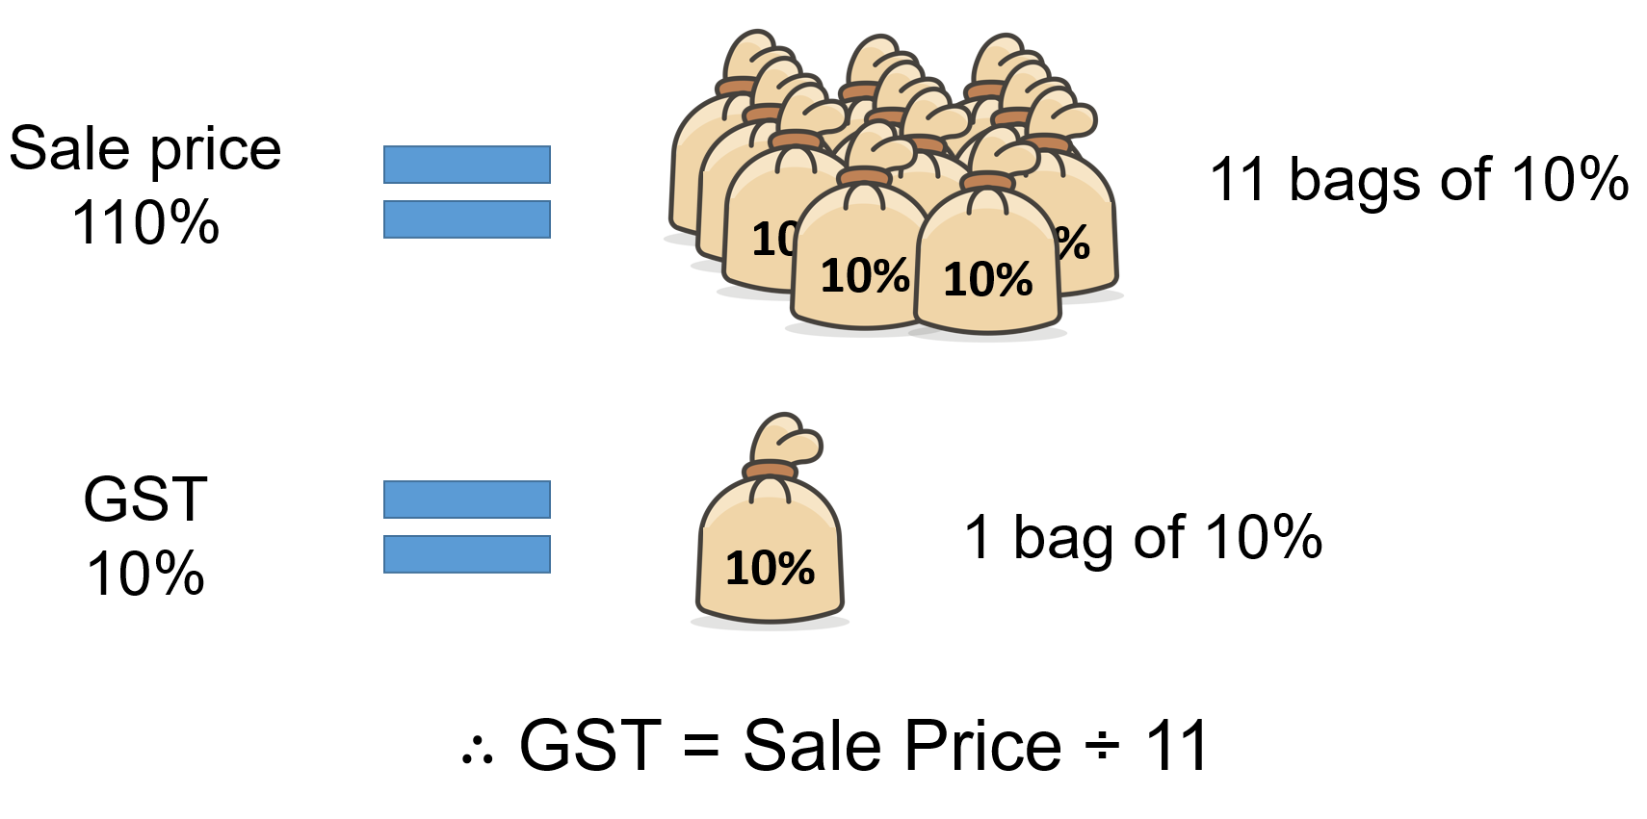
Examples
Calculate the GST and original price of each of the following sales prices.
- $99
First calculate the GST by dividing by 11
$$GST=\$99 ÷11$$
$$GST=\$9$$
To calculate the original price subtract the GST from the sales price
$$Original price=\$99-\$9$$
$$Original price=\$90$$
- $49.50
$$GST=\$49.50 ÷11$$
$$GST=\$4.50$$

$$Original price=\$49.50-\$4.50$$
$$Original price=\$45$$
This means that if a business sold an item for $49.50 they would need to give $4.50 to the government and they could keep $45 for themselves. This $45 would need to cover their costs and hopefully also provide them with a profit.
GST worksheet
- Calculate the 10% GST that would need to be added to the following pre-GST prices
  - $600

  - $85

  - $12.50

  - $245.20

- Using the answers from question 1, calculate the sales price for the following pre-GST prices
  - $600

  - $85

  - $12.50

  - $245.20

- Calculate the GST that has already been included in these sales prices
  - $220

  - $24.75

  - $81.40

  - $618.20

- Using the answers from question 3, calculate the pre-GST prices of the following sales prices
  - $220

  - $24.75

  - $81.40

  - $618.20

- List 3 examples of what the Australian government uses tax money for.
Raising the GST

Background
The GST was introduced in Australia 20 years ago on 1 July 2000. Since that time there has been some minor amendments to the tax, adjusting which items are taxed and which aren’t but it has never risen from 10%.
In this investigation you will consider what effect it would have on families if the GST rose to 12.5 or even 15%. What effect would it have if every item was subject to GST?

Part A: Raising the GST
- A 1.25L bottle of Coca-Cola costs $2.00 what was its price before GST was added?
- Using its original price, what would be the final price if:
  - 12.5% GST was added?
  - 15% GST was added?
- Find a receipt from your family’s last grocery shop. Make a list of which items contain GST in a table similar to the one below.
- For each item that contains GST:
  - Calculate its original price
  - Calculate what its new price would be if:
    - 12.5% GST was added
    - 15% GST was added
Record your results in a table similar to the one below
Table 1 – Pre and post GST prices
Item name | Original price | Pre GST price | 12.5% GST | 15% GST
Mars Bar | $1.00 | $0.91 | $1.02 | $1.05

- Recalculate your family’s grocery bill (including the non GST items) using:
  - the 12.5% GST prices
  - The 15% GST prices
- How does the total bill compare to the original total? How much extra does your family pay in each case? How much would this amount be over the course of a year?

Part B: Increasing the scope of the GST
What effect would it have on your grocery bill if every item contained GST?
- Using a table similar to the one in Part A, list all of the items that do not currently contain GST
- As before, calculate their new price if 12.5% and 15% GST was added.
Table 2 – Including GST
Item name | Original price | 12.5% GST | 15% GST
Milk 3L | $3.59 | $4.04 | $4.13

- Recalculate your family’s grocery bill now for both the 12.%% and 15% GST options. Don’t forget to include your items from Table 1
- How much extra does your family pay in each case now.

Part C: Justifying a GST increase
During the COVID-19 pandemic the government introduced financial schemes to help support individuals and businesses. Tax experts are now calling for the government to raise the GST to help pay for the debt incurred by these financial schemes.

Do you think the GST should be increased?
Justify your decision by referring to your calculations. Remember, you have only considered how an increase in GST would affect grocery prices. You may like to consider the effect that an increase on GST would have on other items such as cars and televisions.

Using a spreadsheet
If you have access to technology, you may like to consider using a spreadsheet to perform the calculations for you.

- Begin by typing in the headings, item names and price paid for each item that contains GST
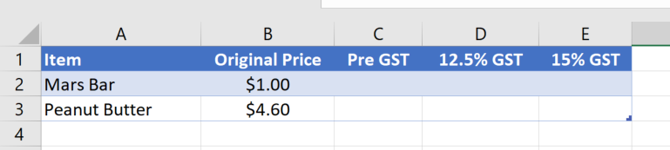

Finding the new prices
We will now use formulas to perform the calculations for us.
- In cell C2 type in =B2/1.1 and press Enter. (we use / to represent ÷ on a computer)

- Click back on cell C2 and click and drag the little square in the bottom right corner to copy (fill-down) your formula to the cells below.

- In cell D2 type in =C2*112.5% or =C2*1.125 and press Enter (* represents multiplication on a computer). Use the square to copy (fill-down) your formula to the cells below

- In cell E2 type in =C2*115% or =C2*1.15 and press Enter. Again, use the square to copy (fill-down) your formula to the cells below.

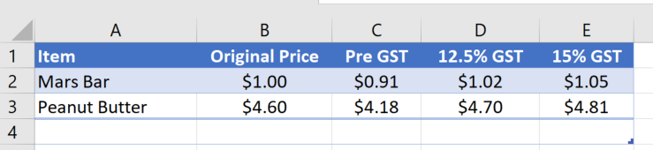

Calculating the totals
Again, we will use formulas to find the totals of our shopping bill.

Method 1
- Highlight all of the numbers in your original price column, including a blank cell below.
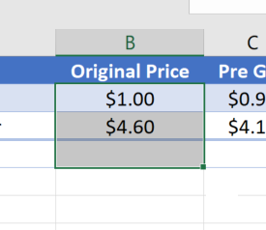

- Click on the button which can be found under the Home tab. This will automatically add up all of the numbers you have highlighted. (This is the uppercase Greek letter sigma and is used to mean ‘sum’)

Method 2
- In the cell below your numbers in column B, type in =SUM( and then click and drag over all of the numbers in column B that you want to add up.
- Press Enter.

Repeat either method to find totals for your 12.5% GST and 15% GST columns.

GST or no GST?
Some food products are not taxable and thus do not require the consumer to pay GST. Try and find at least 10 food products that you do have to pay GST on and at least 10 that are GST – free foods. Write your answers in the table below.
HINT: You may find a supermarket receipt a useful source of information.

Taxable food | GST – free food

GST jigsaw
Cut out each of the triangles and squares. Shuffle the pieces and match the sides of the shapes by calculating 10% of each of the prices.
Note: this resource was created using Tarsia software. You can create similar resources by downloading the Tarsia software.
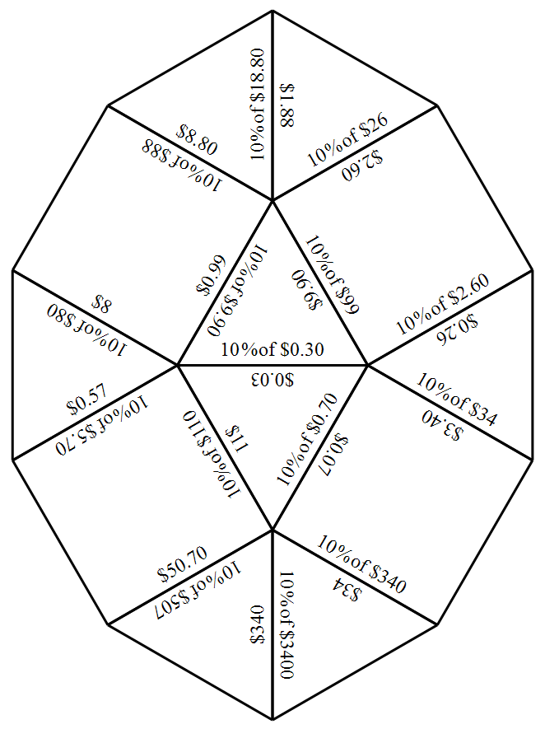
GST word search
Find each of the words listed in the word search below.
Note: this word search was created using The Word Search website.
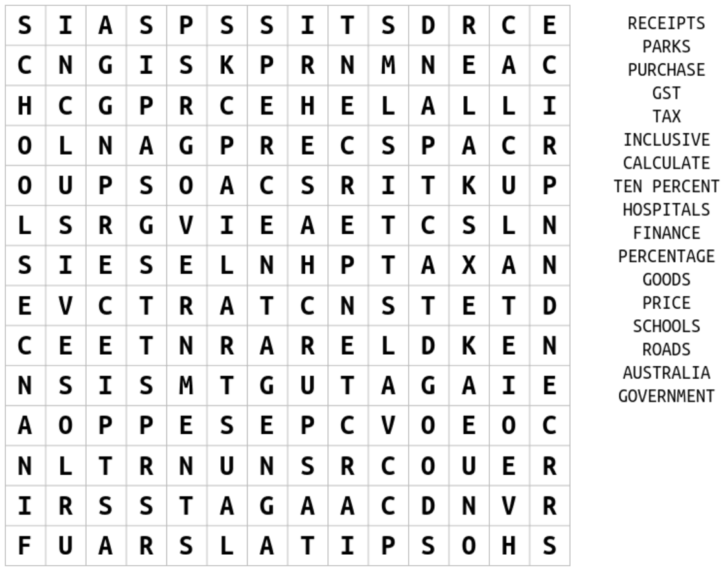

Problem map
Students are to write down a problem in the rhombus at the centre of the map. They are to then represent this problem in the four different sections of the map.

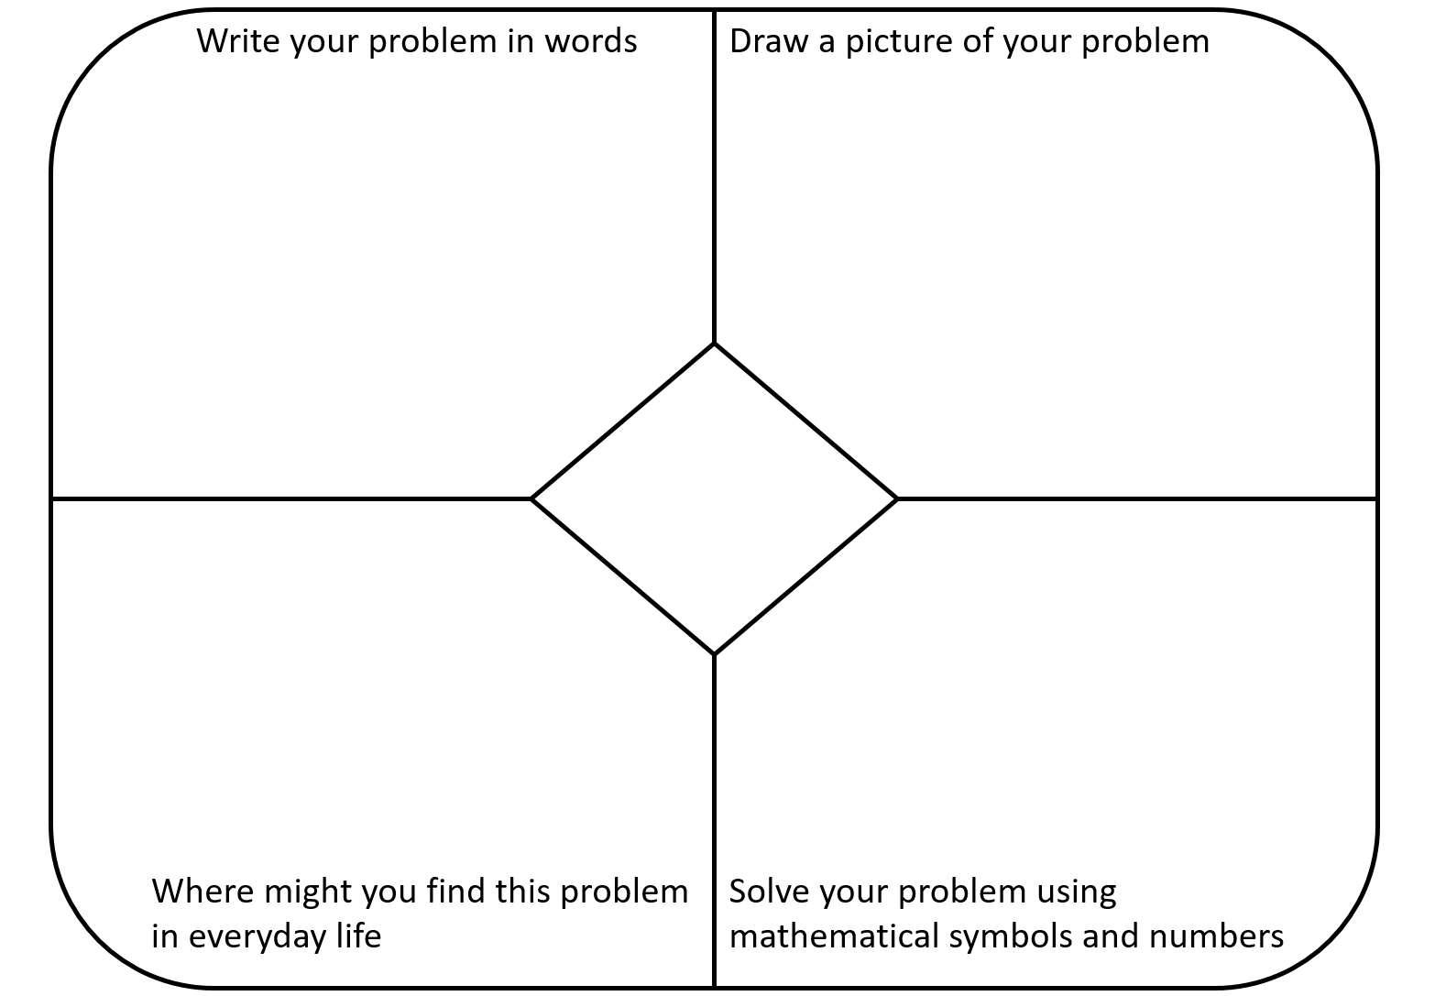

Taxation acrostic poem
Write down a word related to mathematics that starts with each of the letters of the word TAXATION. Provide a definition for each of your words.

Percentages | Word | Definition
T
A
X
A
T
I
O
N

