Week 7: Collecting data (offline learning)
Students will not need to have access to any digital devices in order to complete the following activities. Students will be required to keep a record of their learning and check in with their teacher at the end of the week via telephone. Students may need a parent/carer to help facilitate some of the activities.

Lesson 1: Explicit learning
Students are to read through ‘collecting data’ on pages 5 to 9 with a parent/carer. Students are to then complete the ‘collecting data worksheets’ on pages 10 to 11.

Lesson 2: Enrichment task
Students are to complete the attached enrichment task entitled ‘Breaking the code’. All instructions are included within the document. Students are required to provide evidence of the task’s completion to their classroom teacher. This could be done by dropping off a hard copy to their school or discussing the completed task with their teacher over the phone.

Lesson 3: Activity based consolidation
Students are to complete as many of the activities listed below as they can. Copies of each of the activities are attached.
- Design a survey
- Data truths and lies
- Data memory game
- Collecting data word search
- Problem map
- Collecting data acrostic map

Outcomes
A student:
- MA4-1WM communicates and connects mathematical ideas using appropriate terminology, diagrams and symbols
- MA4-3WM recognises and explains mathematical relationships using reasoning
- MA4-19SP collects, represents and interprets single sets of data, using appropriate statistical displays

Related Life Skills outcomes: MALS-35SP, MALS-36SP, MALS-37SP

Content
Investigate techniques for collecting data, including census, sampling and observation (ACMSP284)
- define 'variable' in the context of statistics as something measurable or observable that is expected to change over time or between individual observations
- recognise variables as categorical or numerical (either discrete or continuous)
- identify examples of categorical variables (eg colour, gender), discrete numerical variables (eg number of students, shoe size) and continuous numerical variables (eg height, weight) (Communicating)
- recognise that data collected on a rating scale (Likert-type scale) is categorical, eg 1 = dislike, 2 = neutral, 3 = like (Communicating)
- recognise and explain the difference between a 'population' and a 'sample' selected from a population when collecting data
- investigate and determine the differences between collecting data by observation, census and sampling
- identify examples of variables for which data could be collected by observation, eg direction travelled by vehicles arriving at an intersection, native animals in a local area (Communicating)
- identify examples of variables for which data could be collected by a census or by a sample, eg a census to collect data about the income of Australians, a sample for TV ratings (Communicating)
- discuss the practicalities of collecting data through a census compared to a sample, including limitations due to population size, eg in countries such as China and India, a census is conducted only once per decade (Communicating, Reasoning)
Explore the practicalities and implications of obtaining data through sampling using a variety of investigative processes (ACMSP206)
- collect data using a random process, eg numbers from a page in a phone book, or from a random number generator
- identify issues that may make it difficult to obtain representative data from either primary or secondary sources
- discuss constraints that may limit the collection of data or result in unreliable data, eg lack of proximity to the location where data could be collected, lack of access to digital technologies, or cultural sensitivities that may influence the results (Communicating, Reasoning)
- investigate and question the selection of data used to support a particular viewpoint, eg the selective use of data in product advertising
Identify and investigate issues involving numerical data collected from primary and secondary sources (ACMSP169)
- identify the difference between data collected from primary and secondary sources, eg data collected in the classroom compared with data drawn from a media source
- explore issues involved in constructing and conducting surveys, such as sample size, bias, type of data required, and ethics
- discuss the effect of different sample sizes (Communicating, Reasoning)
- describe, in practical terms, how a random sample may be selected in order to collect data about a matter of interest (Communicating, Problem Solving)
- detect and discuss bias, if any, in the selection of a sample (Communicating, Reasoning)
- construct appropriate survey questions and a related recording sheet in order to collect both numerical and categorical data about a matter of interest
- construct a recording sheet that allows efficient collection of the different types of data expected (Communicating, Problem Solving)
- refine questions in a survey after trialling the survey (Communicating)
- decide whether a census or a sample is more appropriate to collect the data required to investigate the matter of interest (Problem Solving) collect and interpret information from secondary sources, presented as tables and/or graphs, about a matter of interest, eg sporting data, information about the relationship between wealth or education and the health of populations of different countries
- interpret and use scales on graphs, including those where abbreviated measurements are used, eg '50' on a vertical axis representing thousands is interpreted as '50 000' (Reasoning)
- analyse a variety of data displays used in the print or digital media and in other school subject areas, eg share-movement graphs, data displays showing sustainable food production (Problem Solving)
- identify features on graphical displays that may mislead and result in incorrect interpretation, eg displaced zeros, the absence of labelling on one or both axes, potentially misleading units of measurement (Communicating, Reasoning)
- use spreadsheets or statistical software packages to tabulate and graph data
- discuss ethical issues that may arise from collecting and representing data (Reasoning)

Construct and compare a range of data displays, including stem-and-leaf plots and dot plots (ACMSP170)
- use a tally to organise data into a frequency distribution table
- construct and interpret frequency histograms and polygons
- select and use appropriate scales and labels on horizontal and vertical axes (Communicating, Problem Solving, Reasoning)
- recognise why a half-column-width space is necessary between the vertical axis and the first column of a histogram (Reasoning)
- construct dot plots
- explain the importance of aligning data points when constructing dot plots (Communicating, Reasoning)
- construct ordered stem-and-leaf plots, including stem-and-leaf plots with two-digit stems
- explain the importance of ordering and aligning data values when constructing stem-and-leaf plots (Communicating, Reasoning)
- construct divided bar graphs, sector graphs and line graphs, with and without the use of digital technologies
- calculate the length of bar required for each section of divided bar graphs and the angle at the centre required for each sector of sector graphs (Problem Solving)
- interpret a variety of graphs, including dot plots, stem-and-leaf plots, divided bar graphs, sector graphs and line graphs
- calculate the percentage of the whole represented by different categories in a divided bar graph or sector graph (Problem Solving)
- compare the strengths and weaknesses of different forms of data display (Reasoning)
- identify and explain which graph types are suitable for the type of data being considered, eg sector graphs and divided bar graphs are suitable for categorical data, but not for numerical data (Communicating, Reasoning)
- draw conclusions from data displayed in a graph, eg 'The graph shows that the majority of Year 8 students who play a musical instrument play a string instrument' (Communicating, Reasoning)

Legend: content coloured red is not included in this work package
Collecting data

Surveys
Surveys are an important way of gathering data to help people make decisions.
There are four steps to a successful survey:

1. Create the questions and design the survey
- Keep questions short and simple
- Provide options for people to select from, where possible. These are called closed questions.

2. Conduct your survey
- How many people will you ask?
  - Surveying everyone in your whole school would be an example of a census.
  - Surveying just Year 7, or 20 people from each year level would be a sample.
- Who will you ask?
- How will you ask them? Will they record their results or will you? Will you use a computer survey?

3. Tally the results
- Use a frequency distribution table to record the different types of answers given and the frequency (how many people) picked each answer
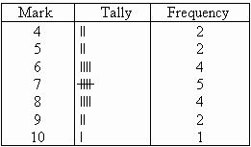
Figure 1
- Answers that can be divided into specific groups such as favourite colour, age group, type of food, sport etc are called categorical data.
- Answers that are given as numbers, where you might want to average the numbers, are called numerical data.
- Discrete numerical data are whole numbers (eg number of students) and continuous numerical data are recorded as decimals or fractions (eg height, weight)

4. Present the results
- Choose how you will share your results with other people.
- This could involve:
  - Tables
  - Statistics – mean, median, mode, range
  - Graphs

Types of graphs

Frequency histograms and polygons
Frequency histograms are used for continuous data and use vertical columns to show how many times answers in that range occurred. Note:
- There are no gaps in between the columns.
- There is a half column gap before the first column
The histogram below shows the heights (in cm) of a sample of 42 people. You can see that there were 3 people who had a height between 155 and 160 cm.
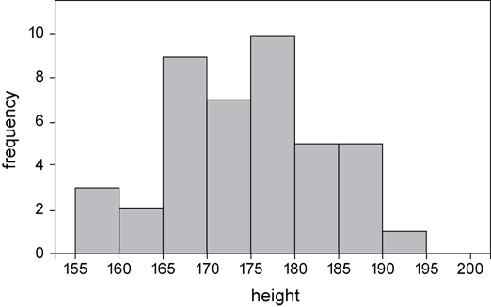
Figure 2

Dot plot
A dot plot is similar to a column graph, except it uses a dot to represent each piece of data.
The dot plot below shows the number of passengers in cars stopped at a traffic light. You can see that there were 8 cars that had one passenger (as well as the driver).
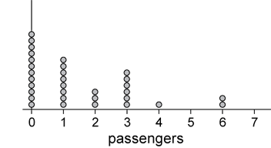
Figure 3

Stem and leaf plot
In a stem and leaf plot, each value is split into two parts, a stem and a leaf. Most commonly, the stem is the ‘tens’ place and the leaf is the ‘units’.
The stem and leaf plot below represents the resting pulse rates of 19 students.
The top row of 6 | 8 8 8 9 represents the numbers 68, 68, 68 and 69
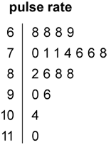
Figure 4

Sector graph
A sector graph is another name for a pie chart. In a sector graph is sector shows the relative size of the data. Frequencies are converted to percentages of the circle.
In the graph below, you can see that Apple Pie was the most popular flavour with 20.6% of people choosing it.
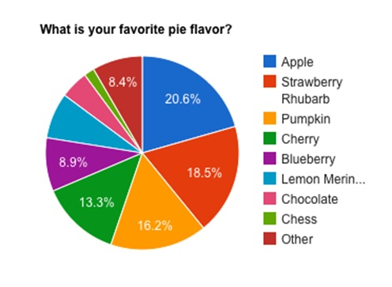
Figure 5

Divided bar graph
A divided bar graph is similar to a sector graph, except that it uses a rectangle which is divided up into smaller rectangles.

Line graph
Line graphs are useful for showing how something has changed over time.
They are useful for determining trends ie whether something is becoming more popular or less popular.
In the graph below, you can see that Facebook became more popular during the time span, whereas, Twitter remained fairly stable.
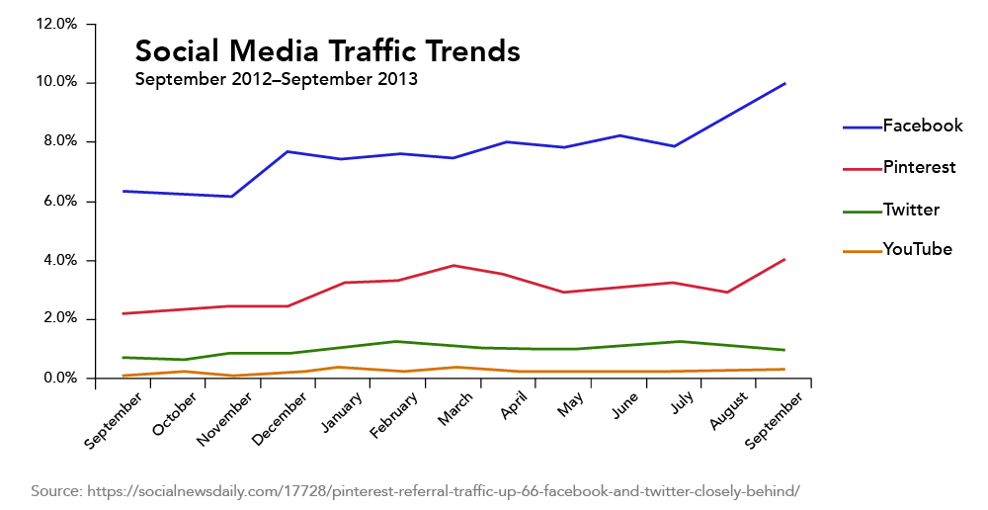
Collecting data worksheet
A class of 30 students was shown a list of 8 Australian marsupials and was asked which one was their favourite. The list included:
Bilbies | Kangaroos | Koalas | Numbats
Possums | Tasmanian devils | Wallabies | Wombats

The results are recorded in the table below:
Kangaroos | Wombats | Possums | Possums | Koalas
Wombats | Wallabies | Numbats | Numbats | Kangaroos
Numbats | Bilbies | Tasmanian devils | Possums | Wombats
Numbats | Numbats | Koalas | Koalas | Koalas

Complete the following frequency distribution table using the above data.
Marsupial | Tally | Frequency
Bilbies
Kangaroos
Koalas
Numbats
Possums
Tasmanian devils
Wallabies
Wombats
 | Total

Construct a frequency histogram using the above data. Give the graph an appropriate title and add numbers to the vertical axis.

Title:
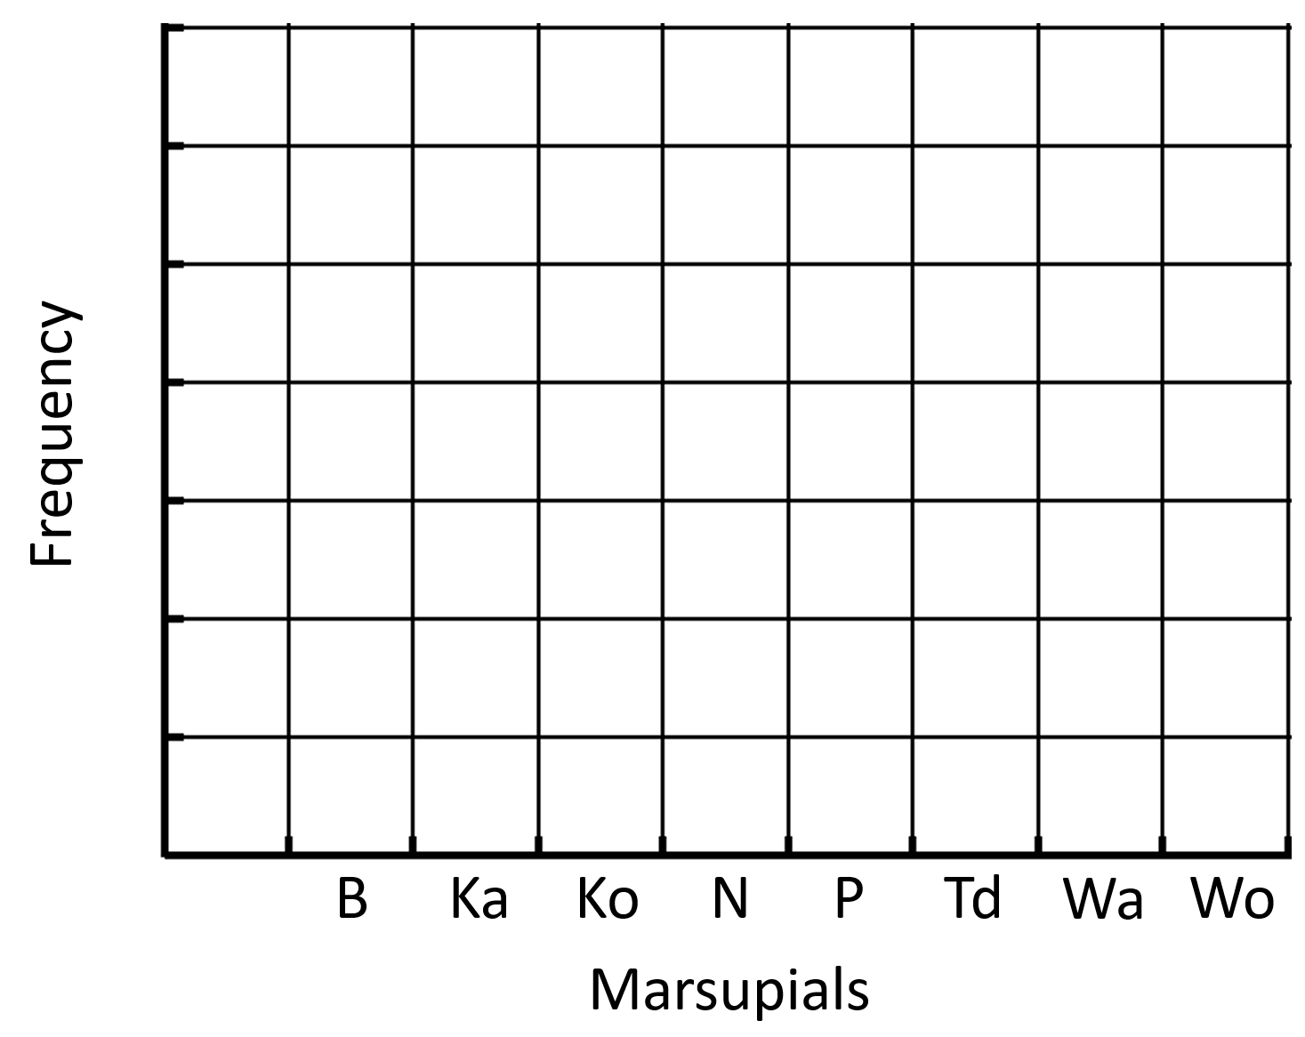

Breaking the code
“HSOGQZWJR WV ZDH LJVZ TJMHUCOF MHQTJR MDWGD PJO GQR OVH GDQRIH ZDH MJUFS”
The phrase above is a quote from a famous person. Each of the letters has been replaced by another letter to create a code.
The aim of this activity is to break the code and reveal the quote.
Except TWO WORDS are missing in the original that was to be 'translated' to get your correct quote. Which two? and what should they have been?

Analysing the frequency of letters
Using a page of a newspaper or a book, complete the frequency table below. For each letter record its frequency on the page.
Letter | Tally | Frequency
A
B
C
D
E
F
G
H
I
J
K
L
M
N
O
P
Q
R
S
T
U
V
W
X
Y
Z
Represent the information in the frequency table above as a histogram.

Analysing small words
Using the same page of the newspaper or book, list all of the two and three lettered words in the frequency table below and complete the frequency table. For each word record its frequency on the page.

Word | Tally | Frequency
as
is
to
the

Using the analysis
Using the insights gained from the analysis above, break the code to reveal the famous quote.

Design a survey
- Design a survey to determine how much your friends earn per week either through pocket money or their part-time jobs.​
- Distribute the survey to as many people as possible.
- Record your responses to each question in a suitable format.​
- Draw suitable graphs to show your findings.
- What would you say is the average amount earnt per week?
- Is it different for different age groups?​
- If you conducted this survey again, what would you do differently? Would you change any questions? Would you change who you surveyed or how you surveyed them? Why?

Figure 6 http://2016.igem.org/wiki/images/d/d8/T--Manchester--surveypic1.png
Data truths and lies
Using newspapers or magazines, find at least 5 different graphs.
1. For each graph, write 3 facts. Two of these facts should be true and the third should be a lie. Try and make your lie as undetectable as possible.
2. Swap your work with a friend and have them try to determine the lie for each graph.

Figure 7

Data memory game
Match the picture to its correct name.

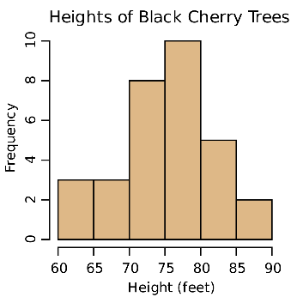 | Histogram
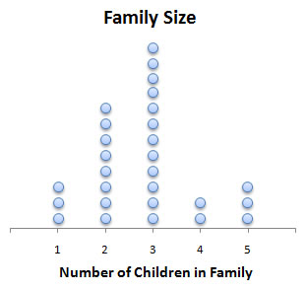 | Dot plot
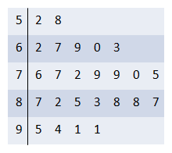 | Stem and Leaf plot
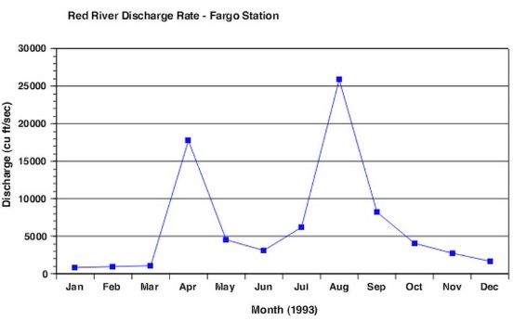 | Line graph
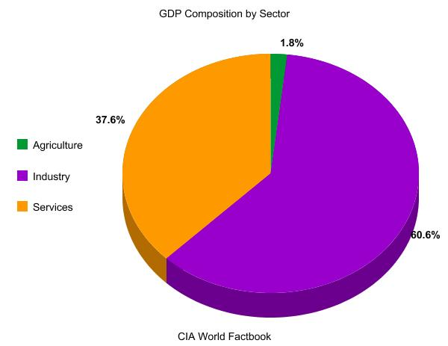 | Sector graph
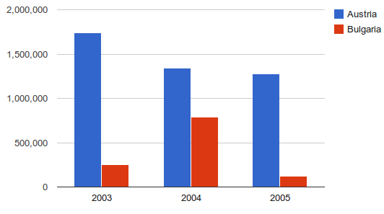 | Column graph
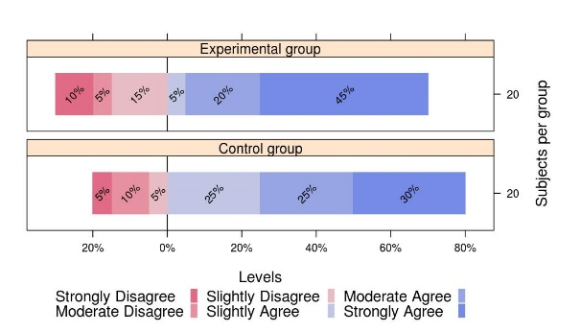 | Divided bar graph
 | Frequency table

Collecting data word search
Find each of the words listed in the word search below.
Note: this word search was created using The Word Search website.

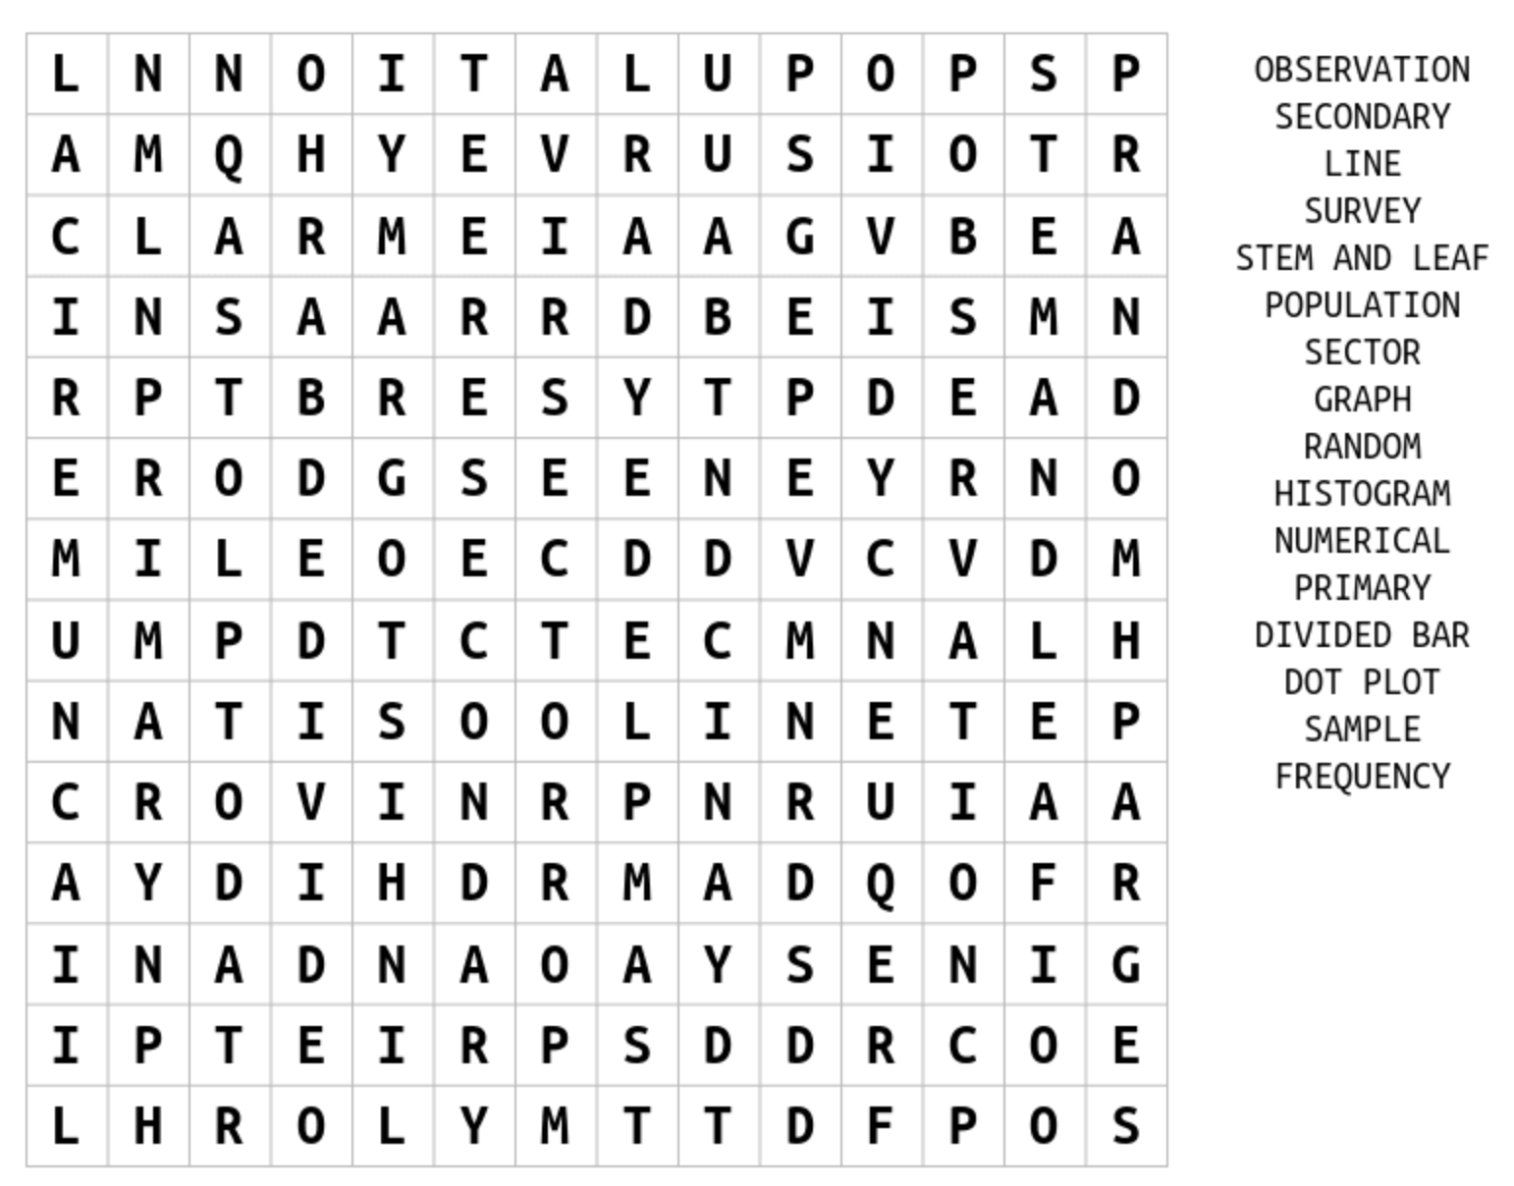

Problem map
Students are to write down a problem in the rhombus at the centre of the map. They are to then represent this problem in the four different sections of the map.

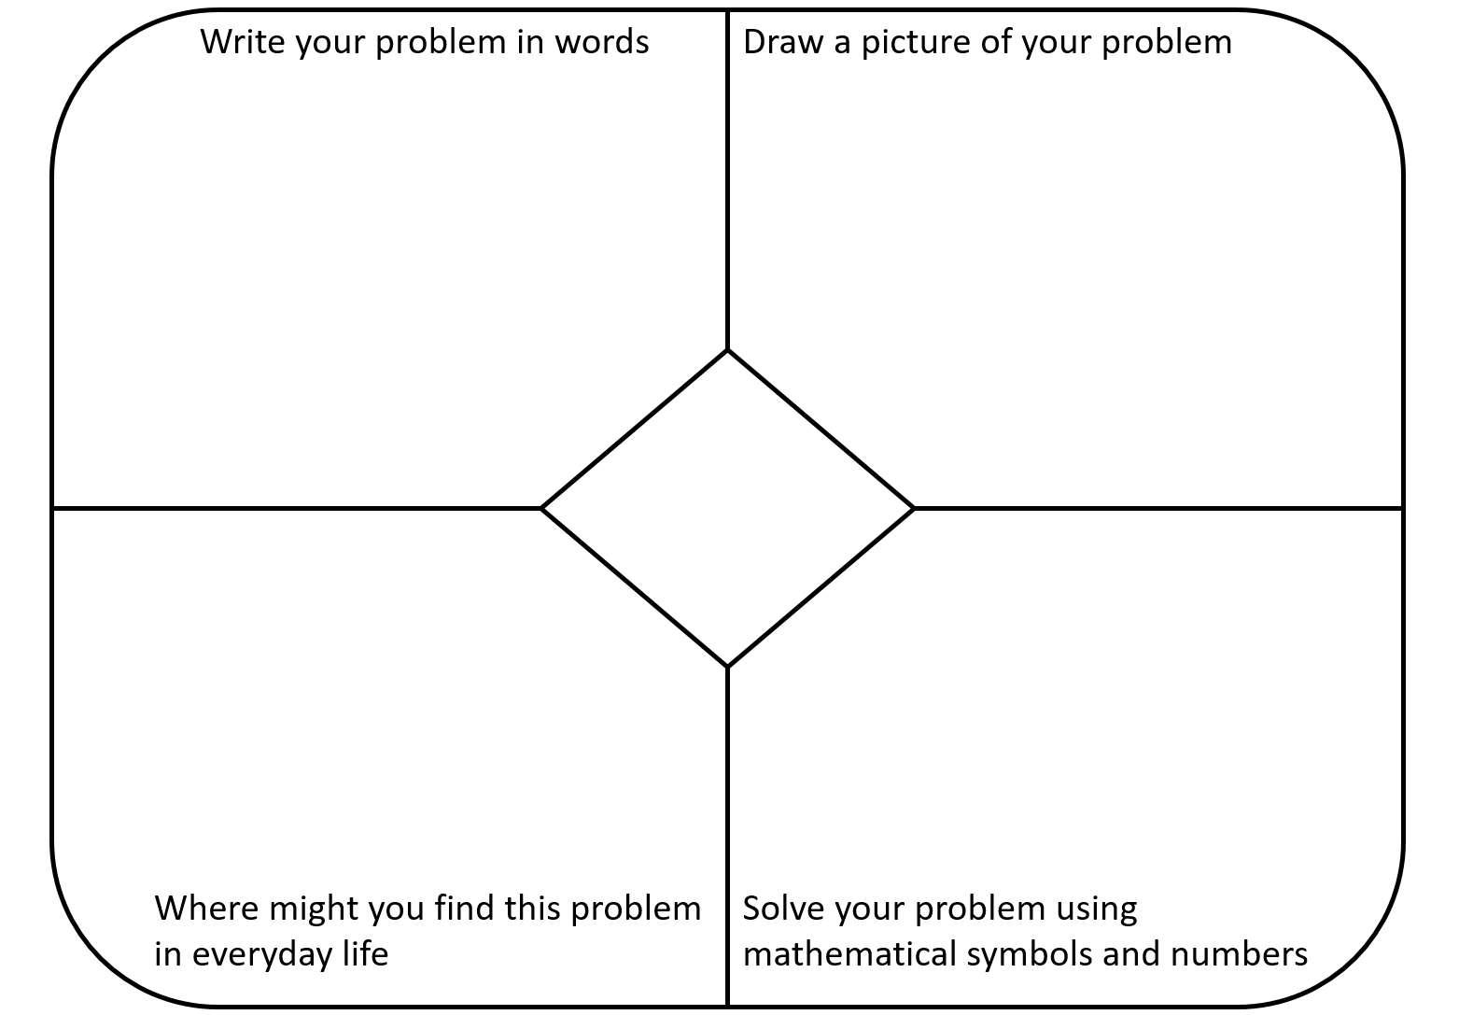

Collecting data acrostic poem
Write down a word, related to mathematics, which starts with each of the letters of the word COLLECTION. Provide a definition for each of your words.

Percentages | Word | Definition
C
O
L
L
E
C
T
I
O
N

