Week 6: Basic Probability (Offline learning)
Students will not need to have access to any digital devices in order to complete the following activities. Students will be required to keep a record of their learning and check in with their teacher at the end of the week via telephone. Students may need a parent/carer to help facilitate some of the activities.

Lesson 1: Explicit learning
Students are to read through ‘basic probability’ on page 4 and 5 with a parent/carer. Students are to then complete the ‘basic probability worksheets’ on pages 6 to 8.

Lesson 2: Enrichment task
Students are to complete the attached enrichment task entitled ‘Myths and misconceptions’. All instructions are included within the document. Students are required to provide evidence of the task’s completion to their classroom teacher. This could be done by dropping off a hard copy to their school or discussing the completed task with their teacher over the phone.

Lesson 3: Activity based consolidation
Students are to complete as many of the activities listed below as they can. Copies of each of the activities are attached.
- Bottle Toss
- Probability jigsaw
- Probability memory game
- Probability word search
- Problem map
- Probability acrostic map

Outcomes
A student:
- MA4-1WM communicates and connects mathematical ideas using appropriate terminology, diagrams and symbols
- MA4-2WM applies appropriate mathematical techniques to solve problems
- MA4-3WM recognises and explains mathematical relationships using reasoning
- MA4-21SP represents probabilities of simple and compound events

Related Life Skills outcomes: MALS-38SP, MALS-39SP

Content
Construct sample spaces for single-step experiments with equally likely outcomes(ACMSP167)
- use the term 'chance experiment' when referring to actions such as tossing a coin, rolling a die, or randomly selecting an object from a bag
- use the term 'outcome' to describe a possible result of a chance experiment and list all of the possible outcomes for a single-step experiment
- use the term 'sample space' to describe a list of all of the possible outcomes for a chance experiment, For example, if a standard six-sided die is rolled once, the sample space is {1,2,3,4,5,6}
- distinguish between equally likely outcomes and outcomes that are not equally likely in single-step chance experiments
  - describe single-step chance experiments in which the outcomes are equally likely, For example, the outcomes for a single toss of a fair coin (Communicating, Reasoning)
  - describe single-step chance experiments in which the outcomes are not equally likely, For example, the outcomes for a single roll of a die with six faces labelled 1, 2, 3, 4, 4, 4 are not equally likely since the outcome '4' is three times more likely to occur than any other outcome (Communicating, Reasoning)
  - design a spinner, given the relationships between the likelihood of each outcome, For example, design a spinner with three colours, red, white and blue, so that red is twice as likely to occur as blue, and blue is three times more likely to occur than white (Problem Solving)
Assign probabilities to the outcomes of events and determine probabilities for events (ACMSP168)
- use the term 'event' to describe either one outcome or a collection of outcomes in the sample space of a chance experiment, For example, in the experiment of rolling a standard six-sided die once, obtaining the number '1' is an 'event' and obtaining a number divisible by three is also an event
  - explain the difference between experiments, events, outcomes and the sample space in chance situations (Communicating)
- assign a probability of 0 to events that are impossible and a probability of 1 to events that are certain to occur
  - explain the meaning of the probabilities 0, $\frac{1}{2}$ and 1 in a given chance situation (Communicating)
- assign probabilities to simple events by reasoning about equally likely outcomes, For example, the probability of randomly drawing a card of the diamond suit from a standard pack of 52 playing cards is $\frac{13}{52}$ = $\frac{1}{4}$
- express the probability of an event, given a finite number of equally likely outcomes in the sample space, as P(event)= $\frac{\text{number of favourable outcomes}}{\text{total number of outcomes}}$
  - interpret and use probabilities expressed as fractions, percentages or decimals (Communicating, Reasoning)
- solve probability problems involving single-step experiments using cards, dice, spinners,
Basic probability

What is probability?
Probability describes how likely something is to happen. We can describe probability using words, fractions, decimals or percentages.

Language of chance
When describing the chance that something that something will happen, we use words such as certain, likely, even chance, 50-50, unlikely, impossible.

Tossing a coin

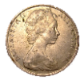
When a coin is tossed, there are two possible outcomes.
- Heads, or
- Tails
Each of these has an equal chance of occurring, so we say they are equally likely.

Throwing Dice

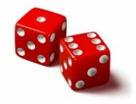
When a single die (dice is plural) is thrown, there are six possible outcomes: 1, 2, 3, 4, 5 and 6.
So, the sample space is {1, 2, 3, 4, 5, 6}
An event is one or more of the outcomes ie rolling a ‘5’ or rolling an ‘even number’ (2, 4, 6)

Calculating probability
The probability of an event occurring is given as a value between 0 and 1.
A value of 1 means that an event is certain to happen. A value of 0 means that the event is impossible and cannot happen. All other events will fall somewhere in between.
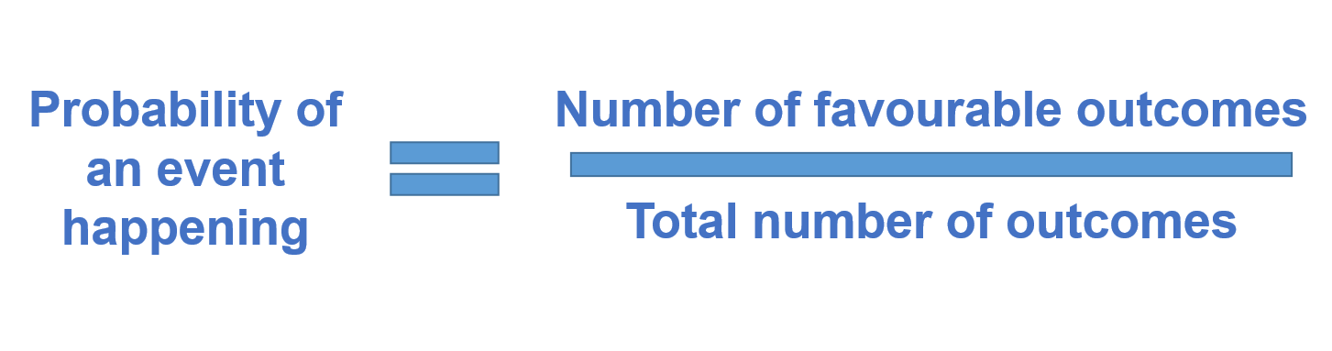

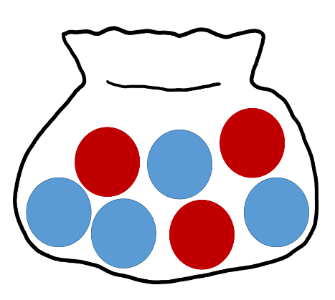

Example
There are 7 marbles in a bag; 4 are blue and 3 are red.
What is the probability that a blue marble gets picked?

Number of favourable outcomes: 4 (there are 4 blue marbles)
Total number of outcomes: 7 (there are 7 marbles in total)
$∴$ The probability of a blue marble $=\frac{4}{7}$
You could also write this answer as $0.5714$ (correct to 4 decimal places) or $57.14\%$.

Basic probability worksheet
- Use one of the words below to describe the probability of the following events occurring:
Note: you may use words more than once and not all words will necessarily be used.
  - Rolling a 7 on a standard die
  - It raining on Christmas day
  - You going to school tomorrow
  - It snowing where you live in July
  - April is followed by March
- List three events that are:
Probability | Event 1 | Event 2 | Event 3
Likely to happen
Unlikely to happen
Certain
Impossible
- Write down the sample space for the following spinners and calculate the probability of each outcome (as a fraction).

Spinner | Sample Space | Probabilities
Example:  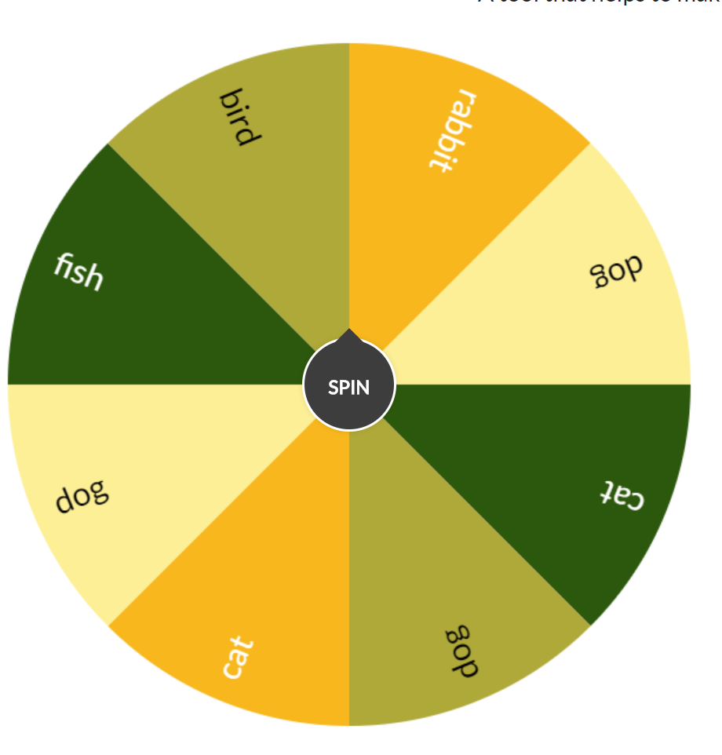 | Rabbit  Dog  Cat  Fish  Bird | P(Rabbit) $=\frac{1}{8}$  P(Dog) $=$  P(Cat) $=$  P(Fish) $=$  P(Bird) $=$
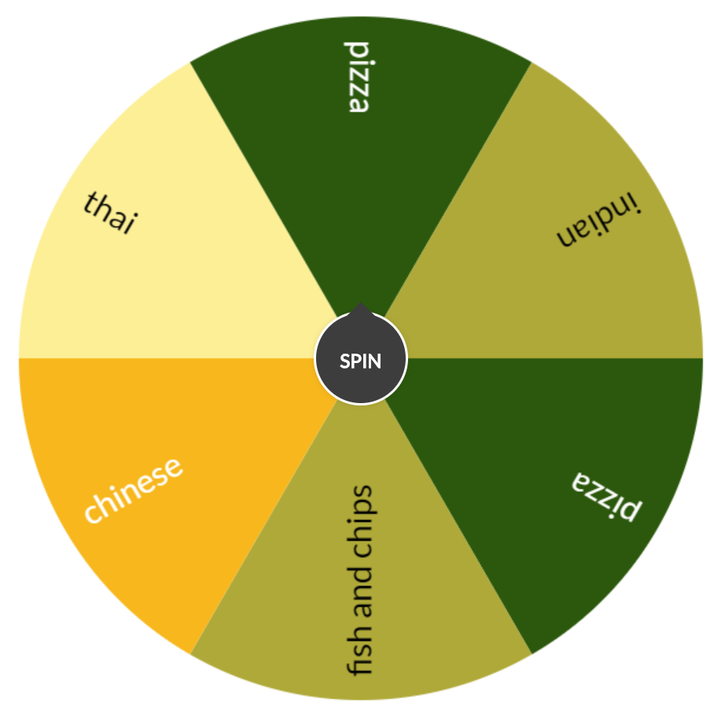
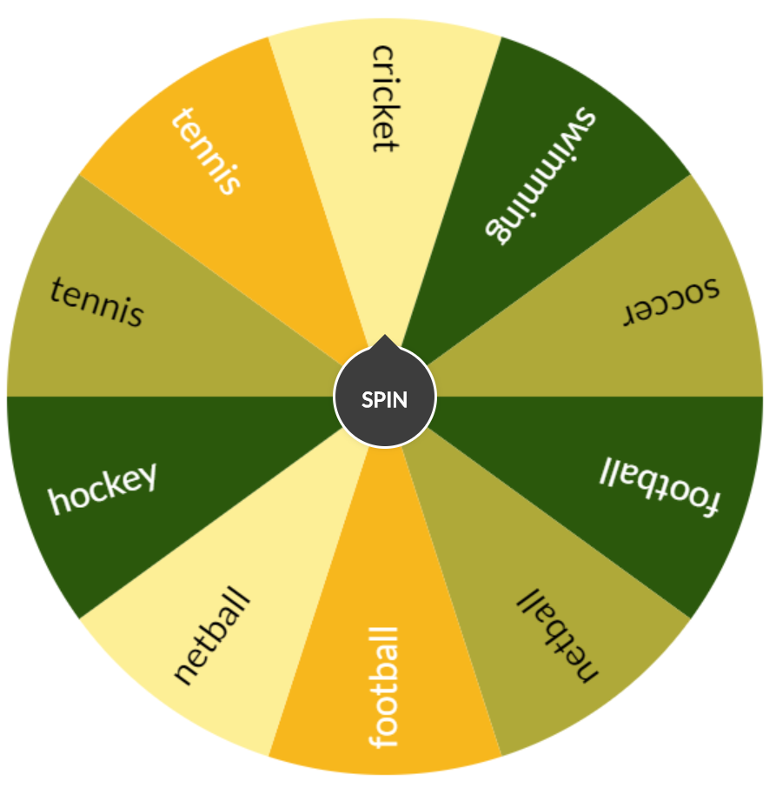

- Find at least 3 board games or card games you have at home (or you have played).
  - Write down how chance is built into the game. For example does the game use a die, spinner, cards .
  - Work out the sample space for each one
  - Calculate the probability of each outcome

Name of Game | Chance element | Sample Space | Probability
Example:  Snakes and ladders | 1 die | 1, 2, 3, 4, 5, 6 | P(1) $=\frac{1}{6}$ P(2) $=\frac{1}{6}$  P(3) $=\frac{1}{6}$ P(4) $=\frac{1}{6}$  P(5) $=\frac{1}{6}$ P(6) $=\frac{1}{6}$
Myths and misconceptions

The problem
The probability of a coin landing on heads is ½ or 0.5, similarly the probability of a coin landing on tails is ½ or 0.5.
- If I toss a coin 20 times what would you expect to get?
- Suppose that the first four tosses have been heads. That’s four heads and no tails so far. What do you expect from the next 16 tosses?
- Two different views from two different students are shown below. Who do you agree with?
Student A: I still expect 10 heads and 10 tails, and since I’ve already got 4 heads, I now expect 10 tails and 6 heads from the remaining 16 tosses. So in the next few tosses I expect more tails than heads.
Student B: There are 16 tosses to go. For these 16 tosses, I expect 8 heads and 8 tails. This means I now expect 12 heads and 8 tails from my original 20 throws.
- Determine what other people think. Show the above two arguments to 5 people and write down which student they agree with.

Experiment

Aim:
To prove which student is correct, A or B.

Method:
- Toss a coin until you have 4 heads in a row (it might take a while)
- Keep track, in the table below, what you get on the next 16 throws.
- Repeat the experiment 5 times.
- Calculate the mean for the number of heads you got over the five experiments, and the mean for the number of tails.
Note: To calculate the mean: Add up the number of heads and divide by 5

Trials | Next 16 throws | Number of H’s | Number of T’s
Example | H H T H T T H H H T T H T H T T | 8 | 8
Trial 1
Trial 2
Trial 3
Trial 4
Trial 5
 | Total
 | Mean

Conclusions:
- Which student’s theory do your results support?
- Ask 4 friends for their averages. Write these down and then find the average for the number of heads and the number of tails.
- Which student’s theory do these results support?
- If we repeated the experiment 1000 times, which theory would you support?
- Can you explain why people get confused and why the theory you have chosen is actually the correct one?
Bottle toss
Bottle flipping was a trend in 2016 that involved throwing a plastic bottle, typically partially full of liquid, into the air so that it rotates, in an attempt to land it upright on its base. You are going to investigate the probability of achieving a successful ‘flip’.

The experiment
- Fill an empty bottle about half full of water.
- Flip the bottle 20 times, trying to make it stand upright when it lands.
- Count how many successful flips that you produce, out of the 20.
- Calculate the probability of a successful flip and record your answer in the table below as a fraction, decimal and percentage.
- Alter the amount of water in the bottle and repeat the experiment.
- Calculate the probability again.
  - Did it change?
  - Did you have more or less chance of a successful flip?
- Alter the amount of water in the bottle, twice more, calculating the probability of a successful flip each time.

The results
Record you results in the table below and calculate the probability of a successful bottle toss.
Water Level | Number of successful flips | Probability as a FRACTION | Probability as a DECIMAL | Probability as a PERCENTAGE
Half

Analysing the results
- Write your probabilities in order from smallest to largest and mark them on the number line below.
- Write either impossible, unlikely, even chance, likely or certain below each of your probabilities. You can use each word more than once if you need to.
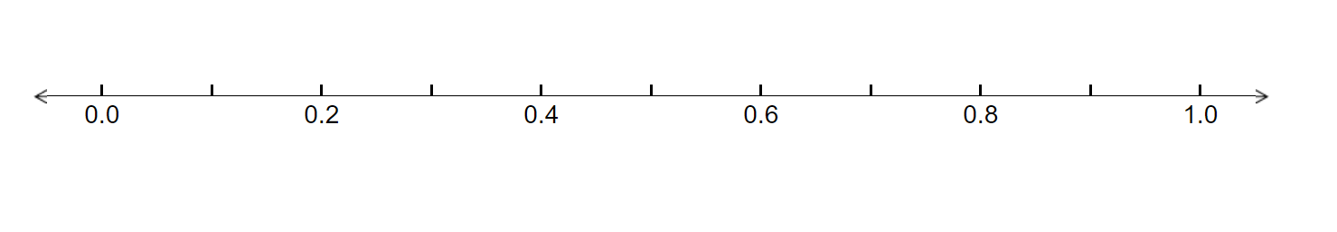What do you notice about your results? Were you more or less successful when the water level was higher?
Probability jigsaw
Cut out each of the triangles. Shuffle the pieces and match the fractions with the equivalent percentages on the sides of each of the triangles.
Note: this resource was created using Tarsia software. You can download the free software using the following link: http://www.mmlsoft.com/index.php/products/tarsia
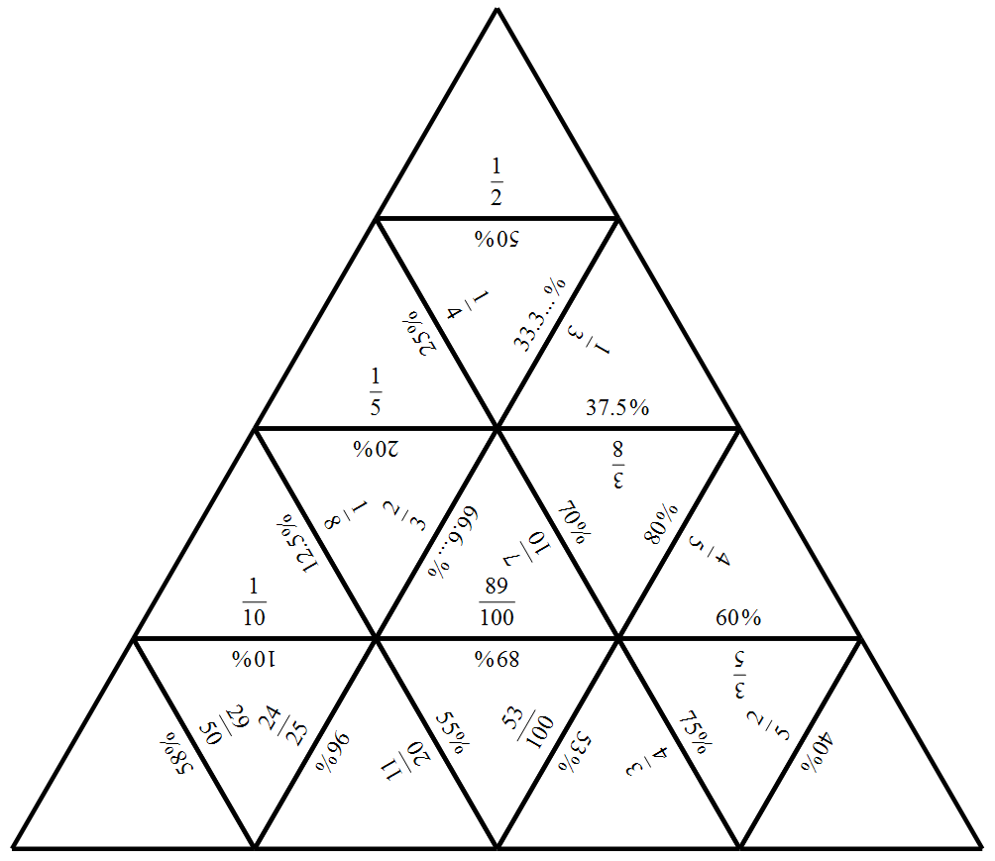
Probability memory game
Instructions:
- Cut out the cards and arrange them face down
- Turn over two cards at a time.
- If the word matches its definitions, the player gets to keep the pair and turns over two more cards.
- If the two cards don’t match, they are turned face down again and Player 2 takes their turn.

Sample space | All of the possible outcomes of an experiment
Experiment | A repeatable procedure with a set of possible results For example, throwing a dice
Outcome | A possible result of an experiment
Event | One or more outcomes of an experiment For example, rolling a 5
Probability | Indicates the chance of something happening
Likely | Event has more than a 50% chance of occurring
Unlikely | Event has less than a 50% chance of occurring
Certain | An event will happen without any doubt P(event)=1
Impossible | An event definitely won’t happen P(event)=0

Basic probability word search
Find each of the words listed in the word search below.
Note: this word search was created using https://thewordsearch.com/maker/.

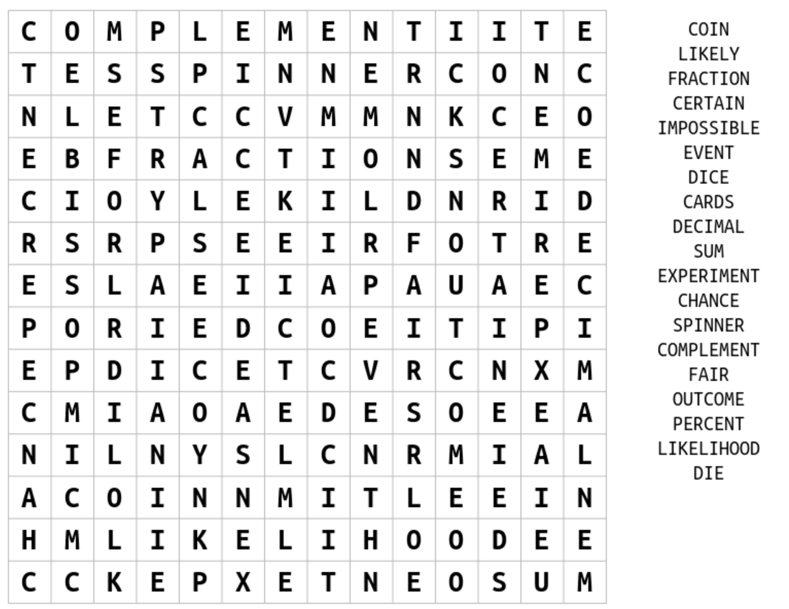

Problem map
Students are to write down a problem in the rhombus at the centre of the map. They are to then represent this problem in the four different sections of the map.

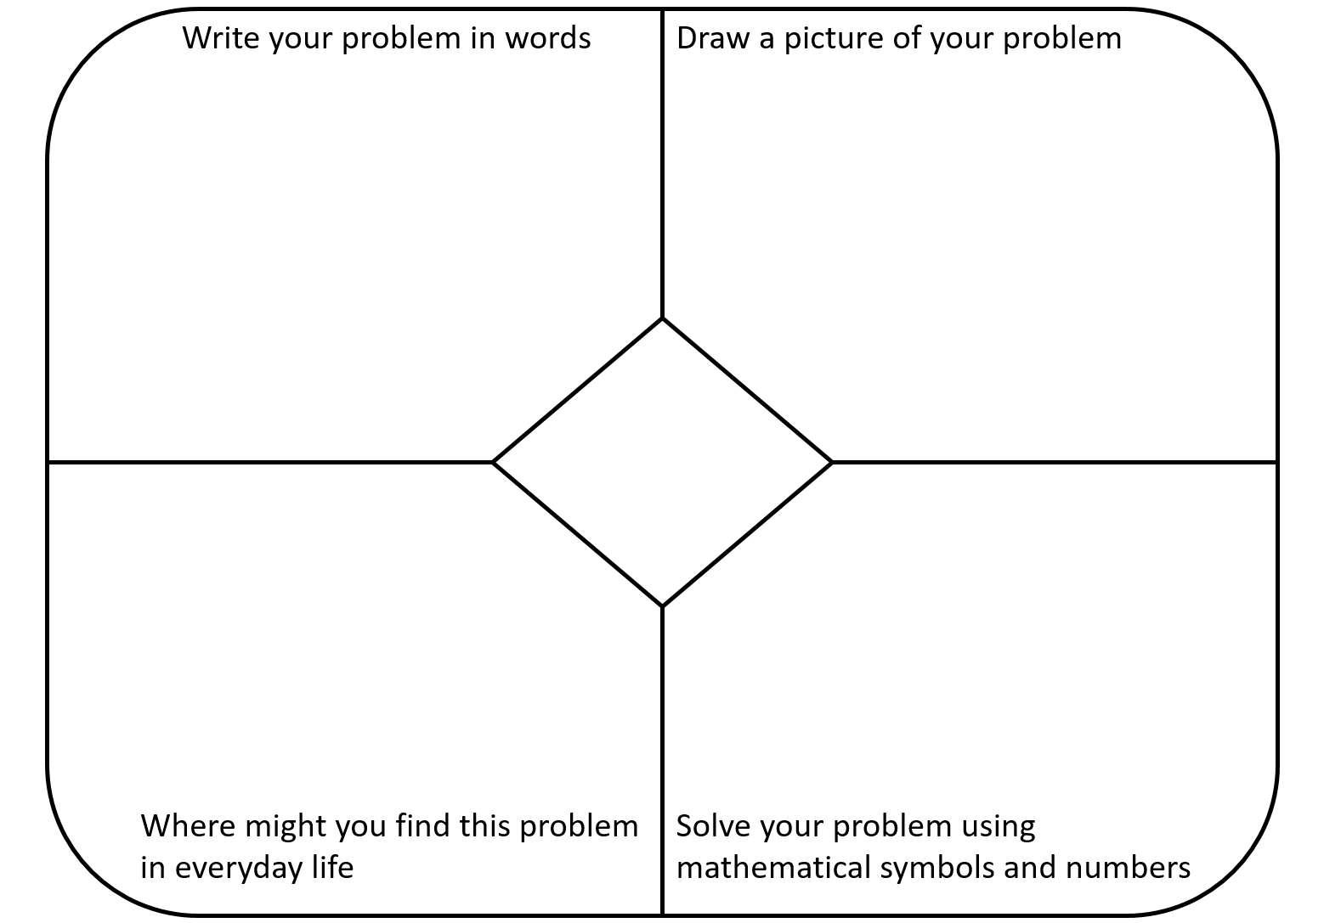

Basic probability acrostic poem
Write down a word related to mathematics that starts with each of the letters of the word PROBABILITY. Provide a definition for each of your words.

Percentages | Word | Definition
P
R
O
B
A
B
I
L
I
T
Y

