Pythagoras practice
Use Pythagoras’ Theorem and your knowledge of triangles, to help you answer the following questions.

- What is the length of side a?  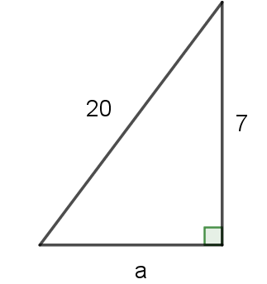 | - What is the perimeter of the triangle? | - What is the area of the triangle?  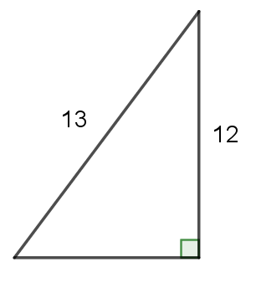 | - What is the area of the triangle?  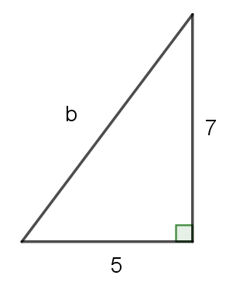

- What is the perimeter of the triangle? | - What is the area of the triangle? | - The area of the triangle is 120 $cm^{2}$, what is its height? | - The area of the triangle is 120 $cm^{2}$, what is its perimeter?

Outcomes
- MA4-1WM communicates and connects mathematical ideas using appropriate terminology, diagrams and symbols
- MA4-2WM applies appropriate mathematical techniques to solve problems
- MA4-16MG applies Pythagoras’ theorem to calculate side lengths in right-angled triangles, and solves related problems

