Designing a clock

Your task
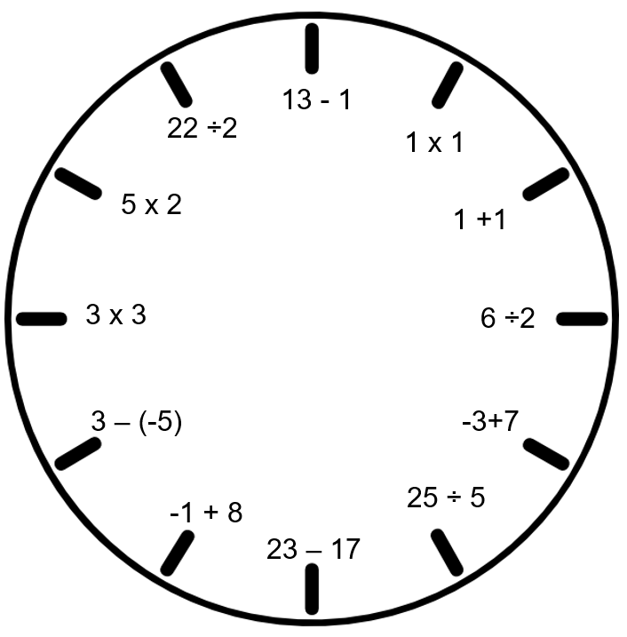
The example above shows a clock face, with each number represented by a very simple mathematical question. Each question has only one operation. Your task is to design a clock so that each number from 1 to 12 is represented by a question involving integers, using two or more operations. For example, 13 – 6 x 2 could be used for the number 1.
To design the best possible clock, you should:
- Make sure your questions give the correct answer
- Use a variety of question types
- Use at least two operations in each question, but these should not be only + and –
- Include negative numbers in at least half of your questions
- Use each operation + − × ÷ at least twice throughout the task
- Include some questions that use grouping symbols ( ) effectively
- Include at least one question that uses grouping symbols and all four operations
- Use at least six examples where applying the order of operations correctly would affect the final answer. For example, without applying the order of operations, 13 – 6 x 2 would be equal to 14. The correct order of operations is x then – , so the correct answer is 1.

Working out space
1 | 2
3 | 4
5 | 6
7 | 8
9 | 10
11 | 12

Student self-assessment
I have:
- checked that my questions give the correct answer
- used a variety of question types
- used two or more operations in each question, including more than just + and –
- used negative numbers in some questions
- used each operation + − × ÷ more than once
- effectively used grouping symbols ( ) in some questions
- one or more questions that use grouping symbols and all four operations
- used at least six questions where applying the order of operations correctly would affect the final answer

Final product

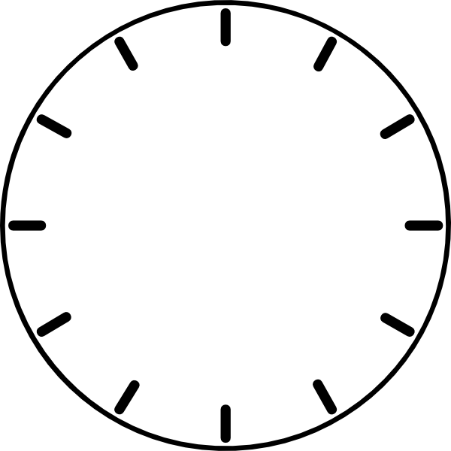

Outcome
Compares, orders and calculates with integers, applying a range of strategies to aid computation MA4-4NA

Content
Carry out the four operations with rational numbers and integers, using efficient mental and written strategies and appropriate digital technologies (ACMNA183)
- apply the order of operations to mentally evaluate expressions involving integers, including where an operator is contained within the numerator or denominator of a fraction.

Student work sample
