Multiplying directed numbers

Modelling with counters
We can use counters to help us work with directed numbers.
To represent the number 5 (or +5) we can use 5, +1 counters:
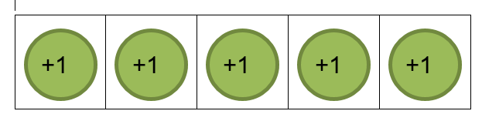
To represent the number -3, we can use 3, -1 counters:
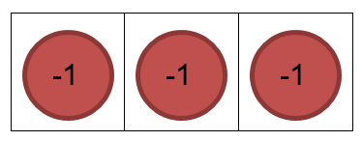

Multiplying with counters

Example 1
3 x 4 can be interpreted as 3 groups (or rows) of four, +1 counters
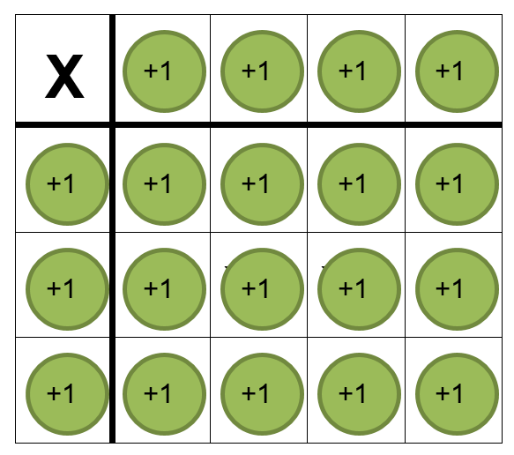
All together we have twelve, +1 counters, so 3 x 4 = 12

Example 2
What about 2 x (-3)?
This can be interpreted as 2 groups (rows) of three, -1 counters
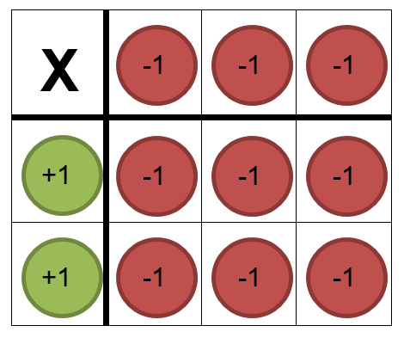
All together we have six, -1 counters, so 2 x (-3) = -6

Task 1
- Represent 4 x 3 with counters. How does this compare to the model we built for 3 x 4 in Example 1? Does this always work? How do you know?
- Represent these questions with counters before writing your final answer.
  - 2 x 4
  - 3 x (-4)
  - 4 x (-1)
  - 2 x (-5)
  - 1 x (-10)
- How many sums can you find with an answer of (-24)?
- What do you notice? What do you wonder?

What does a negative row look like?
Negative numbers are considered to be the opposite of positive numbers, just as subtracting is the opposite of adding and dividing is the opposite of multiplying.
Consider 10ºC and -10ºC, both of these numbers are the same distance from 0ºC but are in the opposite directions on a thermometer.
100m above sea level and 100m below sea level are the same distance from the water level but in opposite directions.
If walking to the East was considered positive, then walking to the West would be considered negative.

Example 3
So what does (-3) x 2 look like?
Let’s look at 3 x 2 first. We are adding 3 rows of 2 +1 counters
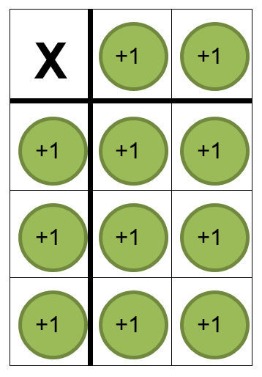
Let’s go back to the original problem, (-3) x 2.
Since (-3) is the opposite of (+3), instead of adding 3 rows, we want to remove 3 rows. How do we remove 3 rows of 2 when we don’t have any rows to start with? We can add zero pairs!
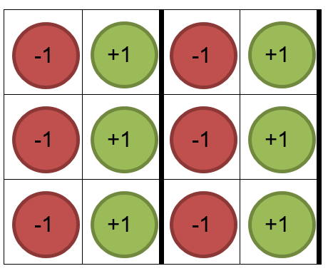
We now have 3 rows with two +1 counters in each row that we can remove.
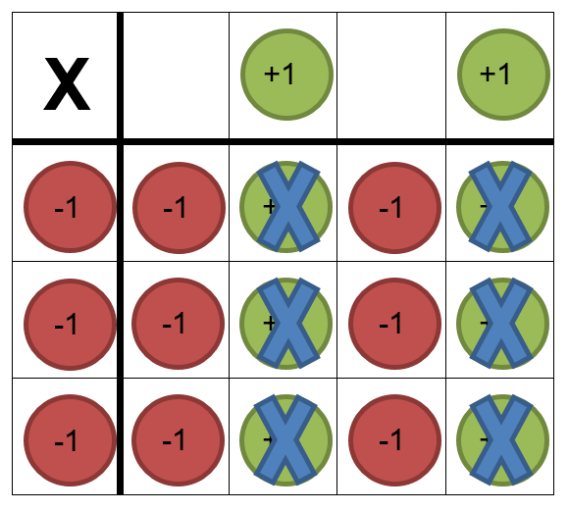

So (-3) x 2 = (-6)
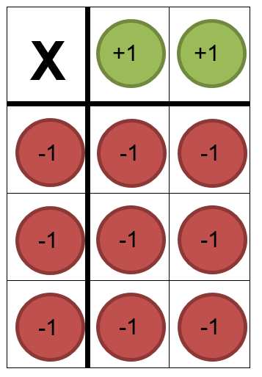
How does this compare to the model we made for 2 x (-3) in Example 2?

Task 2
- Represent these questions with counters before writing your final answer.
- (-1) x 5
  - (-3) x 1
  - (-2) x 4
  - (-2) x 2
  - (-4) x 3
- How could you write each of the sums above in a different way?
- How many sums can you find now with an answer of (-24)?
- What do you notice? What do you wonder?

Negative rows and columns
What would (-3) x (-2) look like?
This means we want to remove 3 rows of (-2) counters.
We will need to use zero pairs again to create some rows, since we don’t have any counters to remove yet.
This time we want to remove 3 rows of (-2) counters.
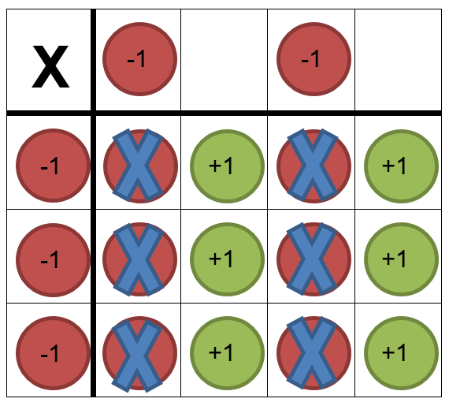
So, (-3) x (-2) = 6
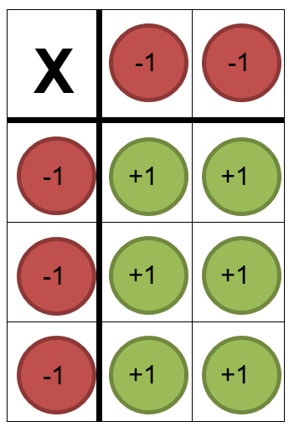

Task 3
- Represent these questions with counters before writing your final answer.
  - (-1) x (-5)
  - (-2) x (-4)
  - (-4) x (-3)
  - (-6) x (-1)
  - (-3) x (-3)
- How could you write each of the sums in a different way?
- How many sums can you now find with an answer of 24?
- Of all the types of sums you have done, what do you notice, what do you wonder?

Task 4
Create a summary of how to multiply negative numbers (with or without counters). It should be in your own words and can use pictures or diagrams to help you.

Outcomes
- MA4-4NA compares, orders and calculates with integers, applying a range of strategies to aid computation

Note to teacher
- Questions could be completed with online algebra tiles
- Interactive practice

