Investigating perfect numbers
A perfect number is a whole number greater than zero. When you add up all of the factors less than that number, you get that number.
For example: The factors of 6 are 1,2,3,6. So the factors less than 6 are 1,2 and 3. So….
6=1+2+3. Hence 6 is a perfect number.

Task
Is 28 a perfect number? The factors of 28 are ___________________________
The numbers less than 28 are _________________________.
So… 28 = ___+____+………………..

Challenge
Find all of the perfect numbers less than 100.
Fun Fact Number One
Did you know all perfect numbers are triangular!
A triangular number makes a triangular dot pattern.
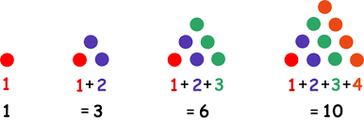
Draw a dot pattern, to represent the other perfect numbers less than 100.

Fun Fact Number Two
Every perfect number, apart from 6, is the sum of a series of odd cubes.
Example: 28=$1^{3}+3^{3}$
496=$1^{3}+3^{3}+5^{3}+7^{3}$

Task
8128 is a perfect number.
Can you write 8128 as a sum of consecutive odd cubes?

