How do I stay connected? – Numeracy support package

About the numeracy support package
This resource is designed to support mathematics and numeracy development in, ‘How can data empower me to make informed decisions?’ from the Stage 4 - PDHPE learning sequence, ‘Connect me, include me, empower me. How do I stay connected?’

Related mathematics outcomes
This document references the Mathematics K-10 Syllabus © NSW Education Standards Authority (NESA) for and on behalf of the Crown in the right of the State of New South Wales, 2012
- communicates and connects mathematical ideas using appropriate terminology, diagrams and symbols MA4-1WM
- recognises and explains mathematical relationships using reasoning MA4-3WM
- collects, represents and interprets single sets of data, using appropriate statistical displays MA4-19SP
- analyses single sets of data using measures of location, and range MA4-20SP

Learning across the curriculum

General capabilities
- Critical and creative thinking
- Ethical understanding
- Information and communication technology capability
- Intercultural understanding
- Literacy
- Numeracy
- Personal and social capability

Other areas of learning
- Civics and citizenship
- Difference and diversity
- Work and enterprise

Task 1 – Coronavirus data reveals how COVID-19 is spreading in Australia
Students are to go to the website Coronavirus data reveals how COVID-19 is spreading in Australia.
- What is this data showing us?
- Why are visual representations like these important in a global health crisis?
- What can it tell us?
- How can it empower or support our next steps as a country?
- How can it empower you as an individual to change what you are doing or not doing?

Confirmed cases – cumulative count vs daily count
Note: This is a screenshot at a particular point in time for reference purposes only. Use the live website with the students for up-to-date data.
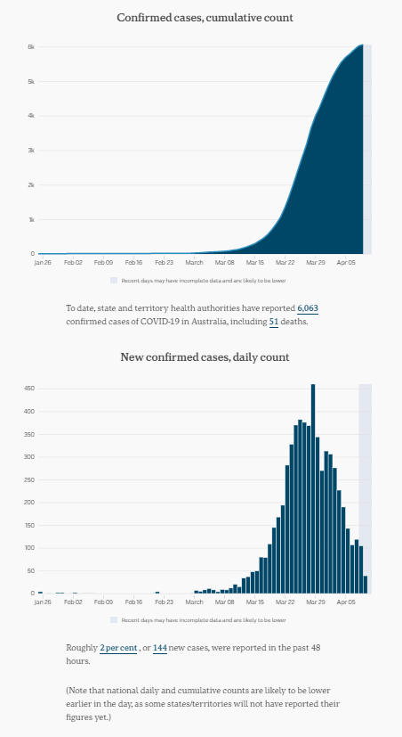

Notes for the teacher
- Stage 4 mathematics does not include cumulative graphs. However, it will be important to discuss what ‘cumulative’ means and that these two graphs present the same information in two different ways. The bottom graph is a column graph and represents the number of new cases for each day. The top graph is a special type of line graph called an ogive and shows the total number of cases up until that particular day. Representing the data this way is a visual way of showing growth patterns. Students will learn more about ogives in Stage 5.
- A column graph can also sometimes be called a bar graph or bar chart.

Suggested questions for students
- What types of graphs are shown in this section and why has the data been represented in this way?
- Look at the ‘daily count’ graph at the bottom. What do you notice? What do you wonder?
- The pattern appears to show that the number of cases each day was very small initially, it then increases quite quickly, peaks and then the number of cases generally appears to be going down each day. What factors do you think have influenced this pattern?

Confirmed cases – by state and territory
Note: This is a screenshot at a particular point in time for reference purposes only. Use the live website with the students for up-to-date data.
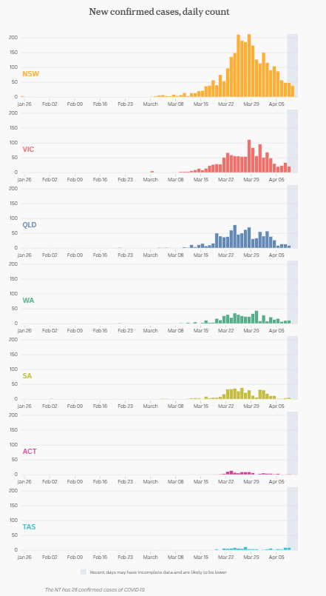

Notes for the teacher
- In Stage 4 mathematics, students learn to identify the key features of a graph. These include the title, axes, labels and scale. Students should be encouraged to check the features of the graph to help them understand what information they can interpret from the data representations.
  - The title gives us a summary of what information the graph is displaying.
  - The axes and labels provide important information about the data we have recorded.
  - The scale used on the axes is an important check-point because it can be manipulated to mislead the reader by exaggerating growth or declines. When students are constructing graphs, they should ensure the scale uses equal intervals.
- If the scales are the same across a set of graphs, we can make easy comparisons across the data displays. We can immediately see, for example, that NSW has the highest numbers of cases and that Tasmania has the least. If each graph used a different scale we would need to check the graphs more thoroughly to know how the data compared.
- Remember that a column graph can also sometimes be called a bar graph or bar chart.

Suggested questions for students
- Examine the features of each graph. What information are these graphs displaying? Check the scales on the graphs. Are they equal intervals? Are the scales the same for each state or territory?
- Compare the graphs by state and territory. What do you notice? What do you wonder?
- In the larger states, the pattern appears to be similar i.e. that the number of cases each day was very small initially, it then increases quite quickly, peaks and then the number of cases generally appears to be going down each day. What factors do you think have influenced this pattern?
- Which state has the largest numbers of cases? The least? Why might this be the case?
- Look at a map of Australia. Would you expect these numbers to be the case when you compare how large the different states and territories are? What other factors might impact the numbers? e.g. Flights directly to Sydney from overseas, total population of each state as opposed to land mass, distribution of populations across the state.

Cases per 100 000 residents – by state and territory
Note: This is a screenshot at a particular point in time for reference purposes only. Use the live website with the students for up-to-date data.
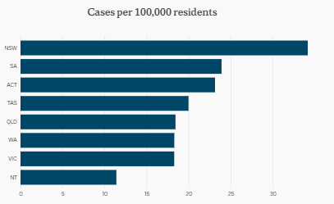

Notes for the teacher
- The NSW mathematics syllabus refers to these graphs as bar charts or bar graphs.
- This particular graph has taken the raw data about the number of cases in each state and adjusted it to compare the prevalence per 100 000 residents in the state. This means it looks at the proportion of the population in each state and not just the raw numbers. You may notice, for example, that NSW and VIC have the highest number of cases in earlier graphs but when you compare it as a portion of the total population of the state, VIC has the second least number of cases. In other words, the graph shows how the states would compare if every state had the same number of people.

Suggested questions for students
- Examine the features of the graph. What information is it displaying? Check the scale along the horizontal axis. Are there equal intervals?
- Complete the sentence: In <state or territory>, for every 100 000 residents, there are _____ cases of coronavirus.
- Compare the columns of each state and territory. What do you notice? What do you wonder? Some prompts might include:
  - Are the proportions the same in any state or territory? Which ones? Why might this be the case?
  - Which state has the largest numbers of cases per 100 000 residents? The least? Why might this be the case?
- Compare this graph with the earlier graphs about the confirmed number of cases of coronavirus. What do you notice? What do you wonder? Some prompts might include:
  - Are the states ranked in the same order? What are some possible reasons for any differences?
  - Are these rankings what you would expect?

Recoveries and deaths
Note: This is a screenshot at a particular point in time for reference purposes only. Use the live website with the students for up-to-date data.
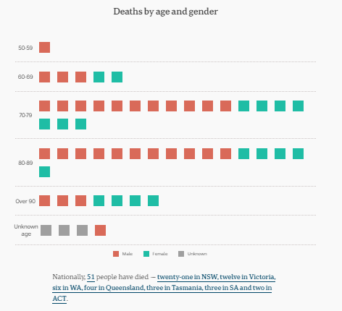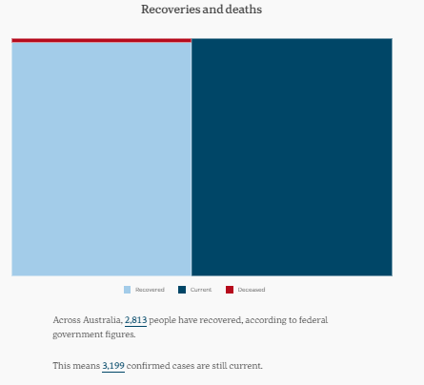

Notes for the teacher
- The NSW mathematics syllabus would refer to the left hand graph as a picture graph. The graph on the right is an area graph.
- The picture graph uses one square for each death and the colours are used to display the gender of those who have died.
- Area graphs are not covered in Stage 4 mathematics. The purpose of area graphs is to show comparative proportions of each category. For example, we can see that the proportion of the number of deaths is very small compared to the total number of current cases and recoveries.

Suggested questions for students
- Examine the features of each graph. What information are they displaying?
- How could you represent the data in the picture graph using a side-by-side column graph?
- A picture graph can use one picture to represent more than one person or item. Construct a different picture graph for the data by age only, using one square to represent two people.
- What do you notice and wonder about the ages of those who passed away from coronavirus in Australia? Some prompts might include:
  - How does the data compare for males and females?
  - What age group has been most severely affected by coronavirus?

Cases by age group
Note: This is a screenshot at a particular point in time for reference purposes only. Use the live website with the students for up-to-date data.
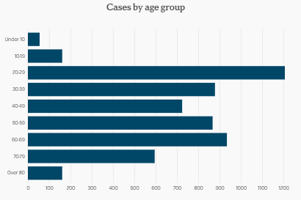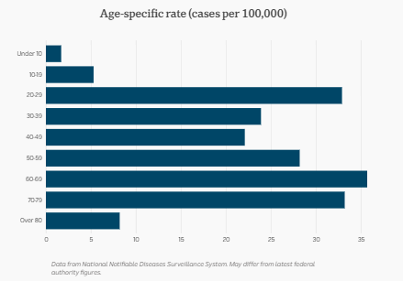

Notes for the teacher
- The NSW mathematics syllabus refers to these graphs as bar charts or bar graphs.
- The second graph has taken the raw data on the left and adjusted it to compare the age groups for cases per 100 000 people. In other words, the graph shows how the age groups would compare if every age group had the same number of people. For example, although the highest number of cases is shown in the left graph as 20-29 age bracket, the second graph shows that if there were the same number of people in each age category, more 60-69 and 70-79 year olds have contracted the virus than 20-29 year olds.

Suggested questions for students
- Examine the features of each graph. What information are they displaying? What do you notice and wonder about the graphs? Some prompts might include:
  - Which age group has the highest (modal) number of cases? Lowest?
  - Why do you think under 10 and over 80 have lower numbers?
  - What other factors might you consider about how dangerous this virus is for different age groups? For example, the majority of deaths have actually been for people over 70.

Sources of infection
Note: This is a screenshot at a particular point in time for reference purposes only. Use the live website with the students for up-to-date data.
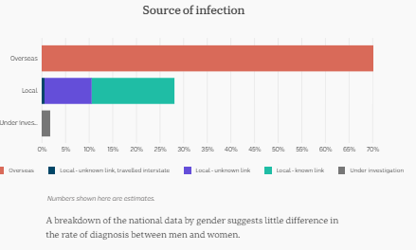

Notes for the teacher
- The NSW mathematics syllabus refers to these graphs as bar charts or bar graphs.
- The middle bar is also a divided bar graph. The local infections have been further categorised and this column shows the proportion of each category of local infection.

Suggested questions for students
- Examine the features of the graph. What type of graph is it? What information is it displaying? What do you notice and wonder about the graph? Some prompts might include:
  - What is the source of most infections? What percentage?
  - What are the categories within the local infections? Which is most/least source?
  - What sorts of measures has the Government put in place to address these sources of infection?

Confirmed cases by sex
Note: This is a screenshot at a particular point in time for reference purposes only. Use the live website with the students for up-to-date data.
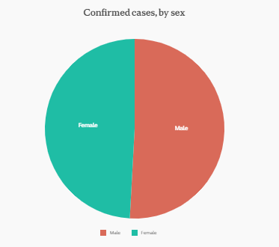

Notes for the teacher
- The NSW mathematics syllabus refers to these graphs as sector graphs. They are commonly called pie charts.

Suggested questions for students
- Examine the features of the graph. What type of graph is it? What information is it displaying? What do you notice and wonder about the graph?
- How does this graph compare to the graph comparing the number of deaths by gender for coronavirus? Are the proportions similar or different? Why might this be the case?

Task 2 – Coronavirus cases by country
Compare these two graphs Grattan Institute. Number of confirmed cases by country. 9 March 2020 versus Number of confirmed cases updated 17 March 2020
- What are the main messages in these two graphs (and their readings)?
- What did you find out, what is new?
- What can you take away from these graphs to empower what you do to manage the current health crisis?
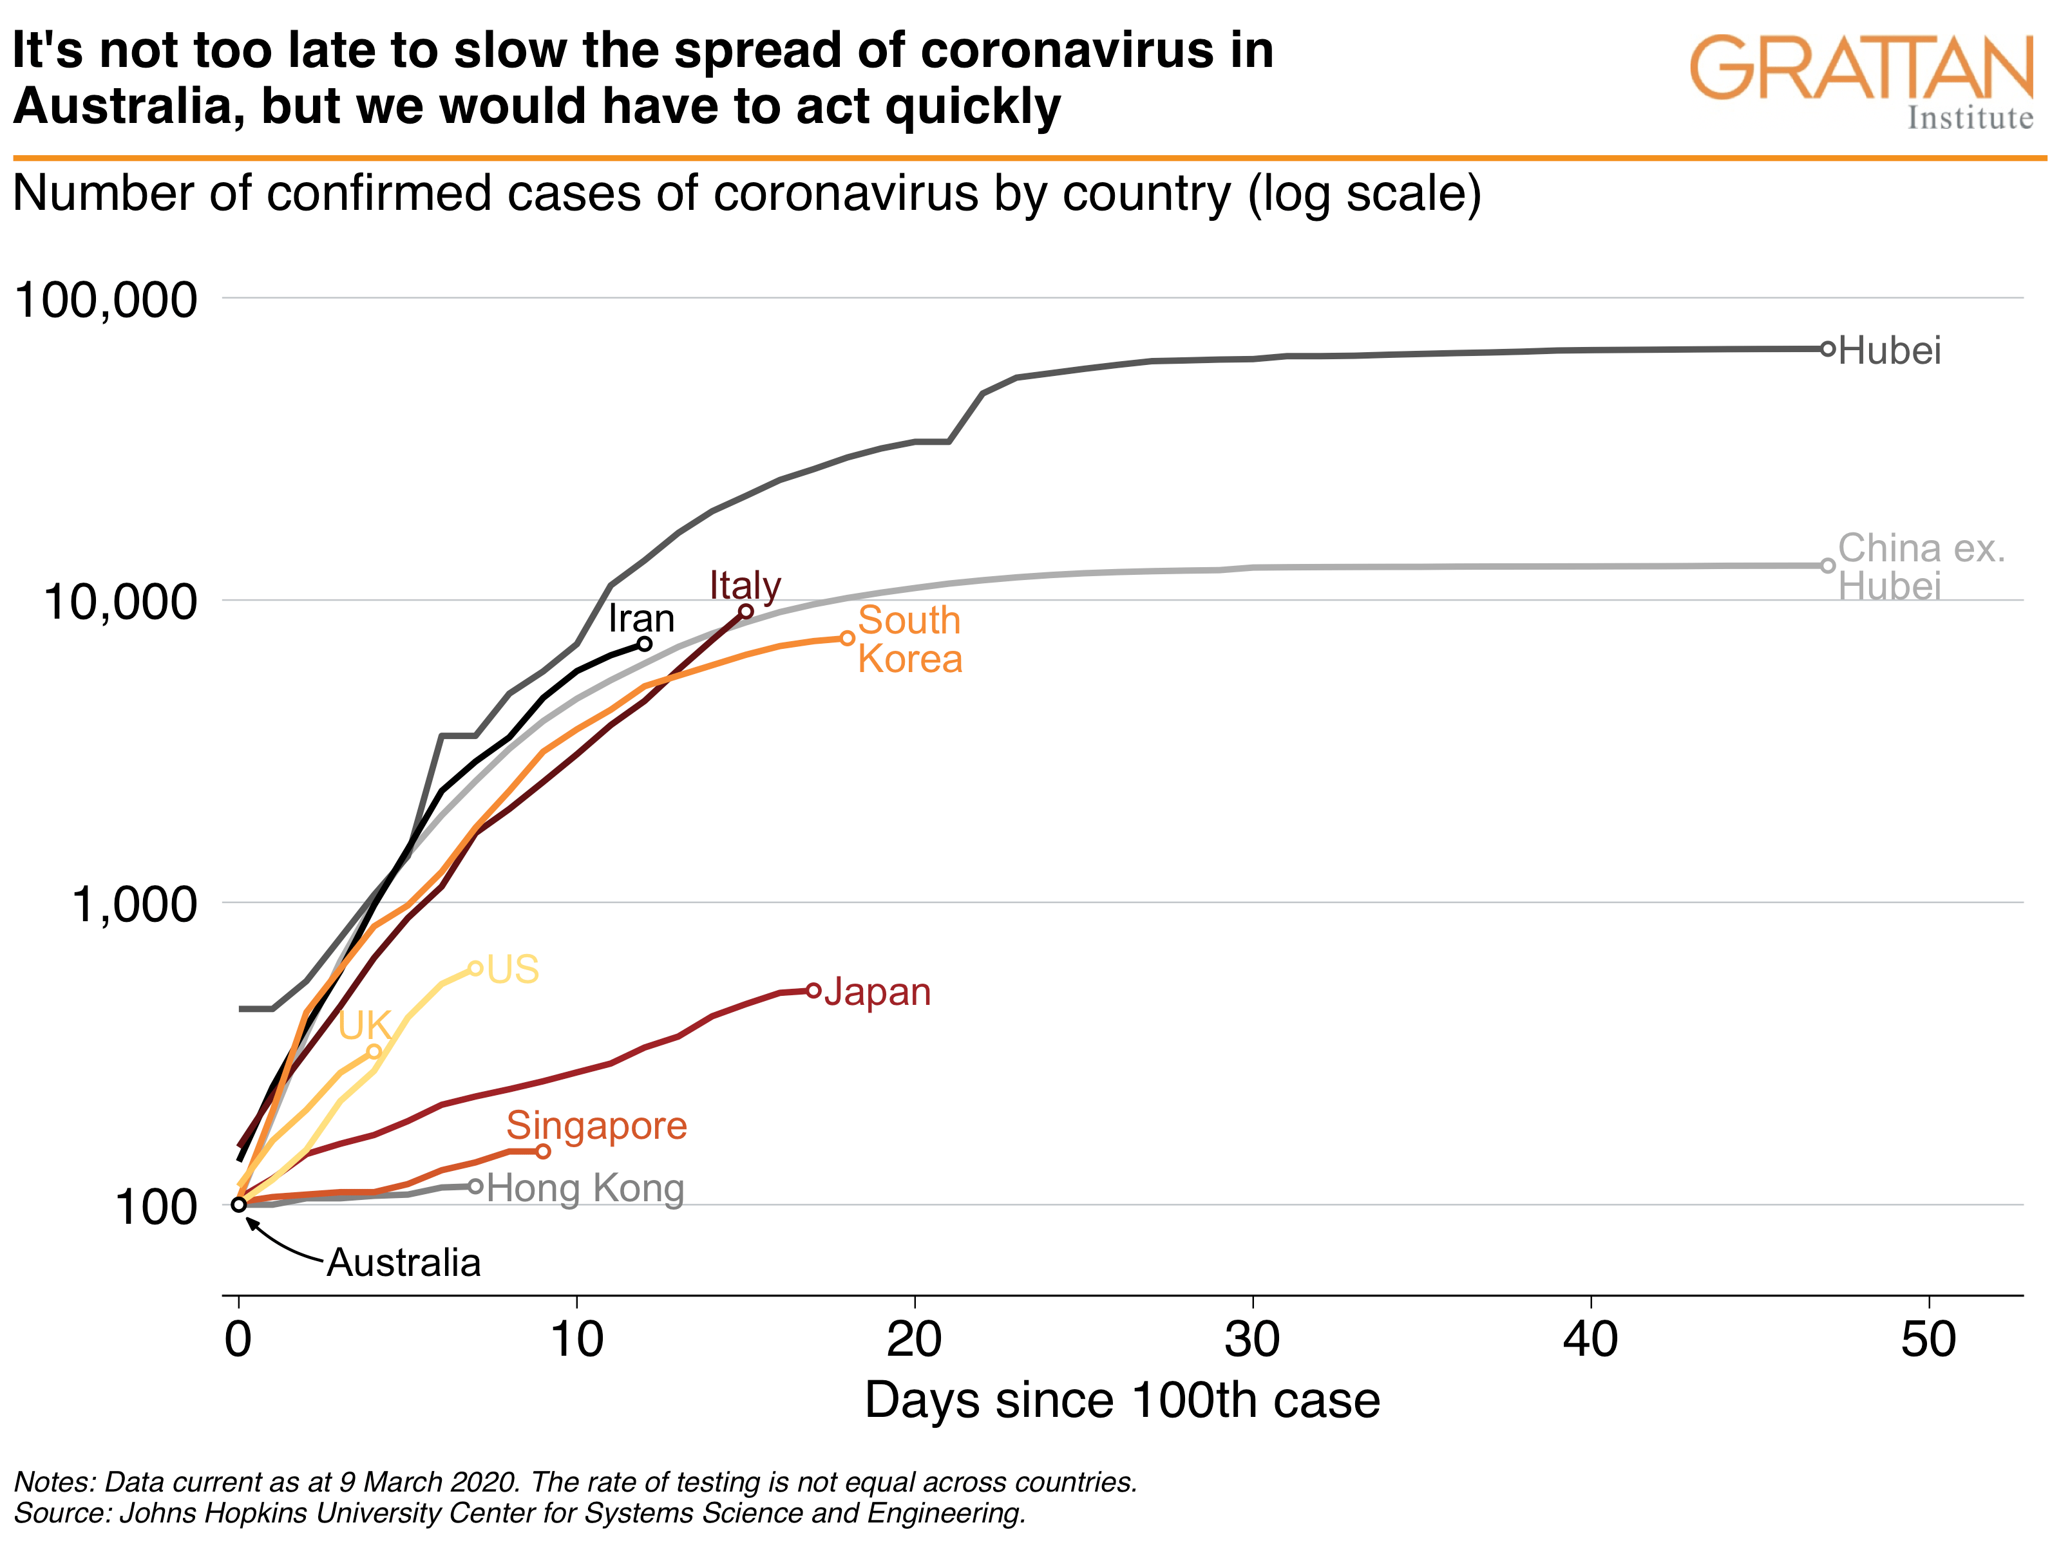
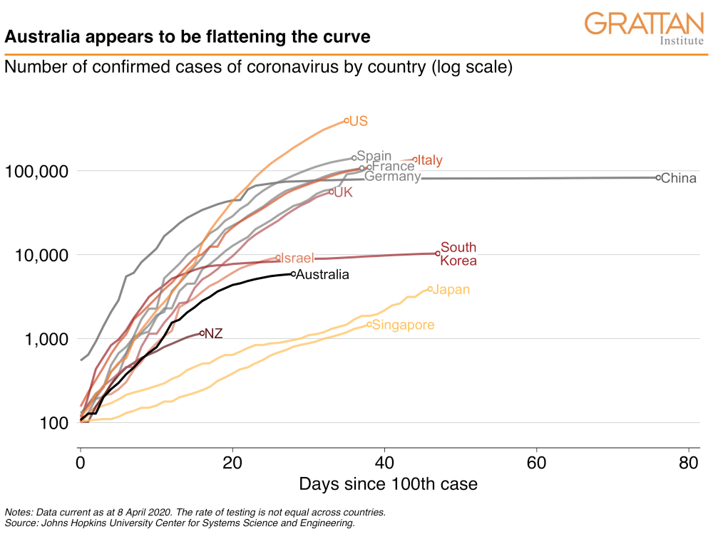

Notes for the teacher
- A line graph is the appropriate type of graph to show changes in a population over time.
- When a line is ‘steep’ it means the number of cases are growing quickly. When the line is ‘flat’ it means the number of cases are growing more slowly.
- These graphs will never slope downwards because each line shows the total or cumulative number of cases. If no more people in that country contract the virus, the graph will just stop.
- Both of these graphs both represent the number of confirmed cases of coronavirus by country.
- Each graph begins at the point where the country had its 100th confirmed case. This means both are illustrating the patterns of growth since the 100th case.
- Some countries (such as China, South Korea and Japan) finish at a later point than other countries because the virus has been active for longer in these countries.
- Notice that the scale of the horizontal axis in the top graph is 10 days, whereas the bottom graph is 20 days.
- Notice that the scale along the vertical axis has unequal intervals. The same distance on the scale jumps from 100 to 1 000 to 10 000 to 100 000. Usually the scale on a graph should jump in equal amounts, for example, from 100 to 200 to 300. This could just be to emphasise how quickly the cases of the virus have grown. However, it is important to notice these features in any graph because sometimes the media misleads the public by using this technique.
- Notice that Australia is just a dot on the first graph. This tells us that the 100th case of coronavirus in Australia occurred when this graph was published on the 9th March.
- Hubei is a province in China. Notice that the first graph has a separate line for Hubei and another line for China except Hubei. The second graph has just one line for all of China. This is to emphasise that the very significant majority of cases in China have occurred in one province. Cases in the rest of China are similar to countries such as Italy and South Korea.
- Some key messages we could take from these two graphs:
  - Each country seems to have similar patterns of fast growth initially, which means countries who have been impacted later can assume a similar rate of growth if they do not act. This means they can act earlier to prevent these growth patterns.
  - If a country does not respond with an appropriate action, such as social distancing, the virus continues to spread.
  - It seems as though the curve is flattening in Australia. How can individuals help keep the curve flat in Australia?

Suggested questions for students
- Compare the scales on the horizontal axis of each graph. How are they different?
- Notice that the scale along the vertical axis has unequal intervals. Why might this be the case? What does it emphasise?
- It is important to notice the scale on any graph because sometimes the media misleads the public by using this technique. Think about what the graph might look like if it did jump up in equal intervals of 100. What would it look like? Would it fit on the page?
- Why is Australia just a dot in the first graph? What information does that tell you happened on the 9th March in Australia?
- Hubei is a province in China. Notice that the first graph has a separate line for Hubei and another line for China except Hubei. The second graph has just one line for all of China. What is the first graph trying to emphasise by splitting these two lines?
- Focus on Singapore. In the first graph it looks as though Singapore was relatively flat. How does that compare to the second graph?
- Japan and Singapore have less cases than Australia in the second graph even though it has been about 40 – 50 days since the 100th case and it has been less than 30 days since the 100th case in Australia. However, look at the shape of the lines for Australia, Japan and Singapore. What does it look like is happening for each country?
- What are some of the key messages we could take from these two graphs?
- It seems as though the curve is flattening in Australia. How can individuals help keep the curve flat in Australia?

